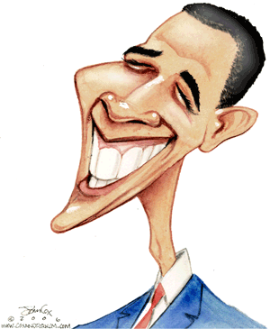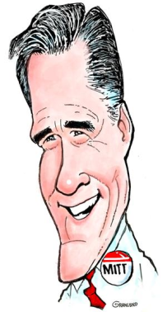

**Assignment Overview**

☺In order to meet the objectives of this assignment, you will need to do the following:

* View the debate in its entirety
* Read the supplementary material
* Write a 2 page rhetorical analysis focusing on the following question: who won the debate? (PLEASE TYPE)
* Write a declarative thesis
* Proceed through your argument syllogistically
* Provide sufficient textual support and analysis