[NPR](http://www.npr.org/)

**Public Radio Finances**

This page offers an overview of the funding story behind NPR and our Member stations. While NPR shares a mission with our stations, we are funded in significantly different ways. Get a glimpse of the funding profile for our [Member stations](http://www.npr.org/about/aboutnpr/publicradiofinances.html#stations), then take a look at [NPR's overall revenue](http://www.npr.org/about/aboutnpr/publicradiofinances.html#npr) picture. If you are looking for specific financial records, we offer our [audited financial statements and 990s](http://www.npr.org/about/aboutnpr/publicradiofinances.html#statements) on this page as well.

**Member Station Finances**

Stations receive support from several sources - listener contributions, corporate sponsorship, in-kind and direct support from universities (for those licensed to a college or university), foundation grants and major gifts, grants from the Corporation for Public Broadcasting, and in some cases state and local governments.   
  
Contributions from listeners have been the largest source of revenue for many years, and generally are the most reliable revenue source regardless of the economic climate. Sponsorship from local companies and organizations (also known as Corporate Sponsorship or Business Support) is the second largest source.   
  
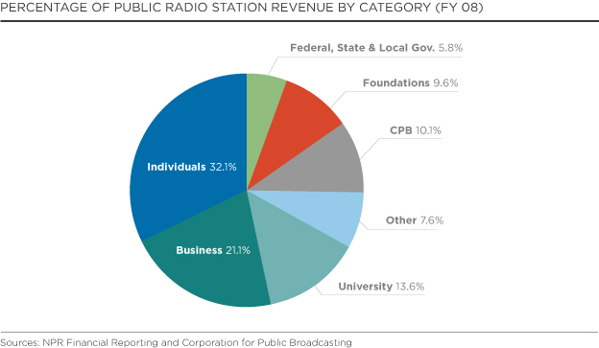

**NPR Finances**

NPR is an independent, self-supporting media organization. We are also a membership organization of separately licensed and operated public radio stations across the United States. *(Read more about NPR's* [*mission and operations*](http://www.npr.org/about/aboutnpr/mission.html)*.)*  
  
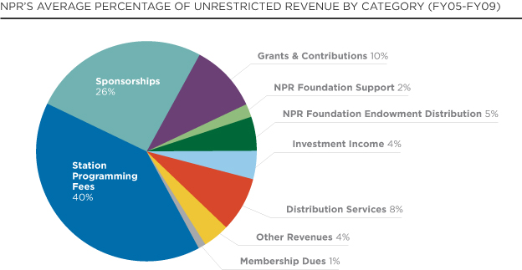  
  
NPR's revenue comes primarily from fees paid by our member stations, contributions from corporate sponsors, institutional foundation grants, gifts from major donors, and fees paid by users of The Public Radio Satellite System. We receive no direct federal funding for operations. The largest share of NPR's revenue comes from program fees and station dues paid by member stations that broadcast NPR programs.   
  
**Program Fees and Dues from Member Stations**  
  
Program fees and dues paid by our member stations are the largest portion of NPR's revenue. This includes fees paid to air the NPR newsmagazines, other programming we produce and distribute, and annual member dues. Historically, program fees and dues have grown steadily as audiences for NPR programs increased, and the number of stations presenting NPR programming grew.  
  
About 79% of our program fees and dues revenue is made up of fees for our premier newsmagazines - *Morning Edition* and *All Things Considered, Weekend Edition*, and *All Things Considered Weekend*. These programs are priced based on the amount of listening per station times a common unit price. We charge more as the volume of listening increases, and stations in turn are able to raise more funds from their supporters and communities.   
  
Non-newsmagazine program fees (for example *Car Talk, Fresh Air, Talk of the Nation*) make up about 18% of total program fees and dues revenue. These programs are priced on a rate that is tiered in proportion to the station's total revenue (meaning that a very large station will pay more for these programs than a very small station.   
  
Annual member dues make up the balance of program fees and dues, contributing about 3% of the total program fee and dues; this is set at a flat rate. Payment of dues entitles stations to be represented by NPR before Congress and regulators, and extends to them rights to NPR programming, digital distribution, and other services.  
  
**Sponsorships**  
  
Corporate sponsors are interested in exposure to the well-educated, relatively affluent NPR audience, both on-air and online, which can be difficult to reach through other media. Selective sponsors also value association with the NPR brand. Messages acknowledging our sponsors are presented on-air in short announcements, and are presented visually and in audio on NPR.org and other digital services. Over the last ten years, NPR's sponsorship program has enjoyed strong growth.   
  
NPR's digital sponsorship revenue continues to grow in spite of the weakened advertising and sponsorship market.   
  
Corporate sponsors tend to stick with NPR as they find value in the "halo effect" of a positive association with the NPR brand.   
  
**Grants and Contributions**  
  
*Institutional Support*   
Grants from institutions such as the Ford and MacArthur Foundations, and non-profits such as the Corporation for Public Broadcasting (CPB) have made it possible for NPR to maintain its current programming and to launch new programs and initiatives. We've also expanded coverage of news topics such as the environment and economy. Many of these grants directly and indirectly benefit member stations too.   
  
*Major Gifts from Individuals*   
NPR and our member stations share a common mission and many strategic goals, and are increasingly engaging philanthropic partners at a high levels. These individuals and families are interested in supporting transformational, strategic advancements in public media's capacity to meet major societal needs. The NPR Foundation, working in collaboration with Member stations, is poised to make a significant contribution to the individual giving fundraising capacity of public media to the benefit of all.   
  
*NPR Foundation Endowment Distribution*  
The NPR Foundation provides funding for NPR operations, drawing on earnings from the Kroc endowment and other funds. In addition, NPR earns revenue on its short and long term investments.   
  
*Distribution Services*  
NPR's Distribution Division operates the Public Radio Satellite System. They collect revenue from stations and producers that use its platform for broadcast distribution, (nearly every organization in the public radio community). In addition, the PRSS offers excess capacity to both public radio and non-public radio users for private networks to keep the cost of distribution as low as possible.   
  
**Other Revenues**  
Other revenues include facility rental income, NPR-branded consumer products, and license fees.   
  
**NPR Expenses**  
  
The vast majority (75% on average) of NPR's expenses are devoted to producing and presenting news, technical support for radio programs and journalists, distribution of programs to stations and digital media services, such as NPR.org and NPR Mobile. About 6% goes to supporting and servicing member stations.   
  
The balance (19%) is spent on facilities and information services, corporate sponsorship and fundraising, legal services, human resources, marketing and communications and overall management of NPR.  
  
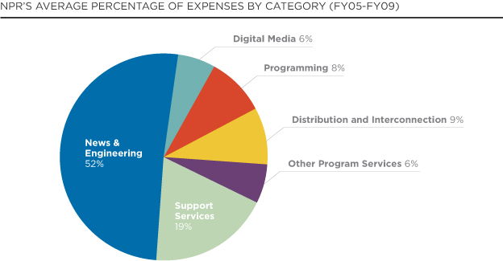  
  
Year to year, our expenses are affected by major news events, particularly those that require extraordinary reporting and operational support. For example, when a natural disaster strikes, we must move staff and equipment into areas that lack transportation or basic communication channels in order to cover the story. Foreign coverage costs have increased over the years to keep pace with war on two fronts and an ever more complex international scene. NPR invested in coverage from Iraq and Afghanistan, including reporters embedded with the U.S. military; a fulltime bureau in Kabul; and coverage of the impact of war on the domestic front.   
  
Special series and projects are another typical investment: for example, we launched Planet Money, an award-winning, multi-platform explanatory journalism project focused on demystifying the economy, and an extensive series on global warming, and coverage of the Olympics. The extensive presidential primaries and the general election were a major focus in FY08-FY09. For all of these reasons our News and Engineering costs generally increase year to year.   
  
Investment in digital media has also been on the increase. NPR provided extensive digital media training for its entire pool of journalists (partially covered by a grant from the Knight Foundation). An upgrade of NPR.org, the introduction of the NPR API (application program interface), and the launch of podcasting and mobile products to reach more people in more places represent several recent strategic investments of note.  
  
In Spring of 2008, we saw early indicators of the economic decline to come and began to strategically contain expenses, and to constantly monitor revenues that were particularly susceptible to the poor financial climate (such as sponsorship). As the crisis showed signs of deepening, NPR reduced its operating costs by eliminating positions and constraining discretionary spending. We worked with our represented workforce to negotiate temporary cost reductions to reduce the expected deficit for FY09 and FY10. Fortunately, in FY10, NPR's financial condition improved.