Agness Times

##### September 2018

*Leary Elementary School (585 ) 359-5490*

# What’s Been Happening in the Classroom

###### Our Class Schedule

###### A–Day PE

###### B–Day ART/Music

###### C–Day PE

###### D–Day ART/Music

**Lunch 11:03 -11:33**

**It has been a great start back to school. We’ve tried to keep cool with fans and popsicles! Our days have been full of new routines and expectations, MAP assessments in reading and math along with fact fluency benchmarks in addition and subtraction. We are all learning how to be a good citizen in 2nd grade. Here is a quick recap of some of the learning that happened here at school.**

**Reading:** Students are reading fiction and nonfiction text as we enjoy our classroom newspaper *Scholastic News.* We are learning about how to have a growth mind set and use tips when faced with challenges. We are getting to know one another as students share our “Me Bags” with classmates. **Remember** to read nightly for enjoyment (about 20 minutes).

**Writing:**

Students are learning about sentences and the parts of a paragraph. First, they brainstormed ideas about their summer. Using one of their ideas, they then completed a graphic organizer which included a topic sentence, 3 details about their topic and a conclusion. Students will use this graphic organizer to help them write a paragraph about their chosen main idea of summer. They enjoyed drawing and coloring an illustration to match their writing. This paragraph about summer will be on display during open house, October 3rd.

**Mathematics:** We have been busy developing the foundations for fluency with sums and differences within 100. Students are using a variety of strategies such as counting on; making ten; decomposing a number leading to a ten; and using the relationship between addition and subtraction to solve problems. We are reviewing the *commutative property of addition* and understanding that changing the order of addends does not affect the sum. Please review and practice math facts regularly for fact fluency. Subtraction practice appears to be most needed by many students.

**Social Studies:** We have begun Unit 1: ***Active Citizenship***. Students are learning how citizens are responsible at home, school and in their community. Our focus for this unit will be centered around *what kinds of things* ***“good”*** *citizens do?*

**Have a relaxing weekend!**

###### **E-Mail:**

[bagness@RHNET.org](mailto:bagness@RHNET.org)

***Voice Mail***

***359-5183***

***Mailbox 1650***

### For Your Information

**Upcoming Events:**

9/24 *Mon. -*  Save Around Orders due *(or book returned)*

9/28 *Fri.* - Ice Cream Social @ 6:30

10/3 *Wed.* - Open House -- 6:30-7:30

10/8 *Mon.* - Columbus Day – No School

10/12 *Fri.* - Picture Day @ 9:15 a.m.

10/27 *Sat.* - Monster Bash @ Senior high @ 6:30 p.m.

**Phone:**

**(585)359-5490**

**E-Mail:**

**bagness@RHNET.org**

Voice Mail

359-5183

mailbox 1650

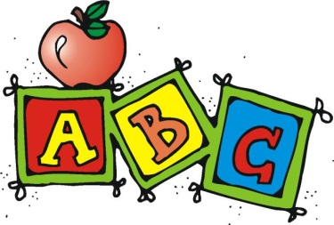

starfish2

**Winslow Elementary School**

**COMPANY NAME**

**Street Address**

**City, State, 00000**

##### Leary Elementary School