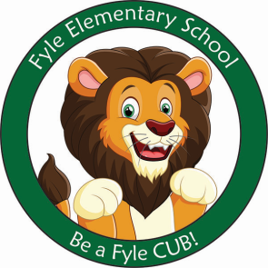

Mrs. Janofsky’s Weekly Update

March 29, 2019

Math

We are continuing to work to understand and solve story problems. Soon we will be mixing addition and subtraction problems. Right now we are focusing on listening to the problem and understanding the actions in the story. This will help us focus on operation later.

Be sure to continue to practice the addition and subtraction cards.

ELA

Quarter 3 assessments are underway! The children have done an amazing job with reading and writing. I am so proud of them and all of the hard work they have put into learning these skills. As I told them, our work will continue. They are eager to continue to move along and always show there best! Please continue to practice sight words, read and write at home! Practice makes us better!!!!!

In Fundations, we were introduced to digraphs this week. Digraphs are two consonants that go together but make one sound. Sh, Ch, Th, Wh, and CK are our focus sounds. The children are working to include them in there writing and are learning to tap them.

Science

Our focus this week has been on understanding liquids. We are working to understand properties of both solids and liquids. We had a fun morning in the cafeteria working on several different experiments.

Important Information

* Specials next week
  + Monday: D
  + Tuesday: A
  + Wednesday: B
  + Thursday: C
* Library on Wednesday. Please help your child remember their book!
* Reading bags come home every Tuesday, Wednesday, AND Thursday. Please be sure to return them completed the next day.

Sight Words

with

Review words: he, she, me, we, be

