Rise in teenage pregnancy rate spurs new debate on arresting it
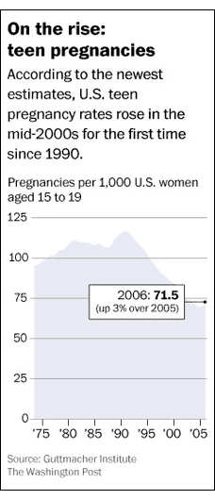

By Rob Stein
Washington Post Staff Writer
Tuesday, January 26, 2010
The pregnancy rate among teenage girls in the United States has jumped for the first time in more than a decade, raising alarm that the long campaign to reduce motherhood among adolescents is faltering, according to a report released Tuesday.
The pregnancy rate among 15-to-19-year-olds increased 3 percent between 2005 and 2006 -- the first jump since 1990, according to an analysis of the most recent data collected by the federal government and the nation's leading reproductive-health think tank.
Teen pregnancy has long been one of the most pressing social issues and has triggered intense political debate over sex education, particularly whether the federal government should fund programs that encourage abstinence until marriage or focus on birth control.
"The decline in teen pregnancy has stopped -- and in fact has turned around," said Lawrence Finer, director of domestic research for the Guttmacher Institute, the nonprofit, nonpartisan research group in New York that conducted the analysis. "These data are certainly cause for concern."
The abortion rate also inched up for the first time in more than a decade -- rising 1 percent -- intensifying concern across the ideological spectrum.
"One of the nation's shining success stories of the past two decades is in danger of unraveling," said Sarah Brown of the National Campaign to Prevent Teen and Unplanned Pregnancy. "Clearly, the nation's collective efforts to convince teens to postpone childbearing must be more creative and more intense, and they must begin today."
The cause of the increase is the subject of debate. Several experts blamed the increase in teen pregnancies on sex-education programs that focus on encouraging abstinence. Others said the reversal could be due to a variety of factors, including an increase in poverty, an influx of Hispanics and complacency about AIDS, prompting lax use of birth control such as condoms.
"It could be a lot of things coming together," said Rebecca Maynard, a professor of economics and social policy at the University of Pennsylvania. "It could be we just bottomed out, and whenever you are at the bottom, it tends to wiggle around. This may or may not be a sustained rise."
The report comes as Congress might consider restoring federal funding to sex-education programs that focus on abstinence. The Obama administration eliminated more than $150 million in funds for such groups, but the Senate's health-care reform legislation would reinstate $50 million.
The new findings immediately set off a debate over funding. Critics argued that the disturbing new data were just the latest in a long series of indications that the focus on abstinence programs was a dismal failure.
"Now we know that after 10 years and over $1.5 billion in abstinence-only funding, the U.S. is lurching backwards on teen sexual health," said James Wagoner of Advocates for Youth, a Washington advocacy group.
Supporters of abstinence programs, however, said the findings provided powerful evidence of the need to continue to encourage delayed sexual activity, not only to avoid pregnancy but also to reduce the risk for AIDS and other sexually transmitted diseases.

