Biπer’s Breakdown-Where to find things

Everyday

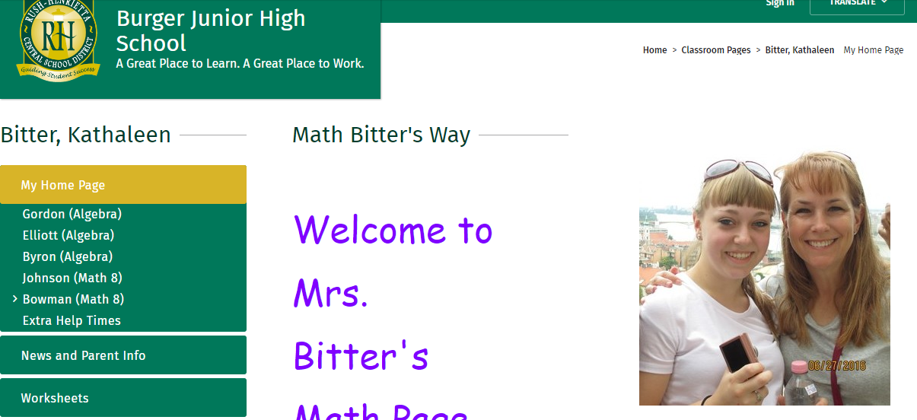Go to my webpage on the District’s webpage. You should have it bookmarked.

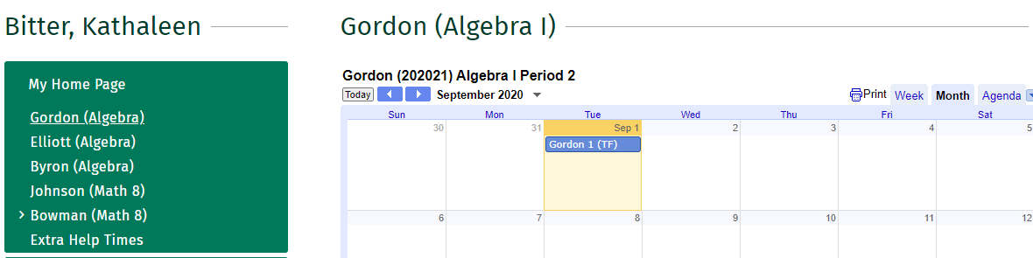Click on your class name. (The example is Gordon.)

Click on the day.

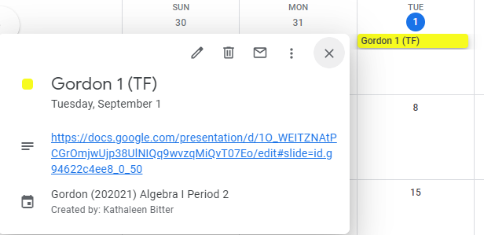Click on “description” link.

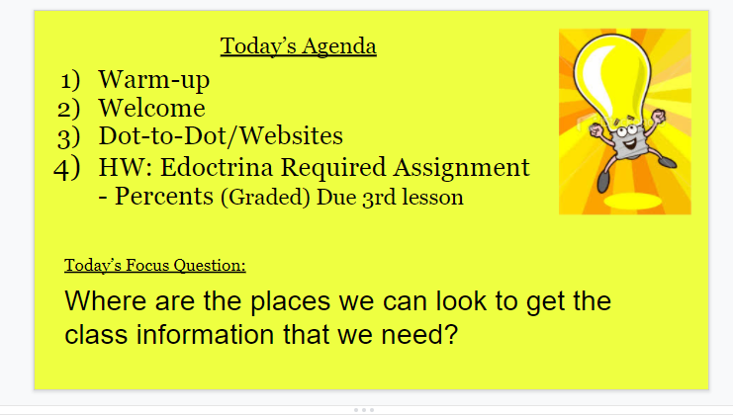

This is a daily agenda slide. It tells you the warm-up, the lesson, and the homework. Unless stated, the homework is due the next class.

**You MUST access the slides from the calendar. Please don’t click through the slides as they may be out of order.

**HOMEWORK**

**ALL HOMEWORK IS ACCOUNTED FOR.**

* If the homework is (Graded) it needs to be turned in either by paper copy or electronically. (20%)
* If the homework is not labeled (Graded) it is checked in daily. (Category in School Tool: Non-graded Required Homework) These assignments will only show in School Tool.

How do you do this?

* Answer keys to most of the nightly homework can be found by searching

“Eureka Grade 8 Module #” for Math 8 or “Eureka Algebra Module #” for Algebra. The Link can be found in Classroom.

Google Classroom (Using Elliott as example)

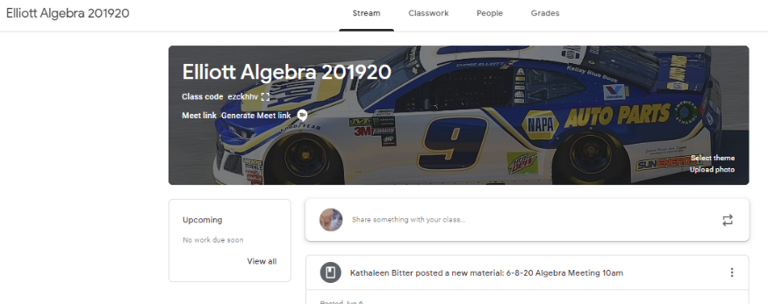Go to your google classroom. You were given the code in class. **Make sure to add your parents too if they would like to be added.**

Click on Classwork on the top menu.

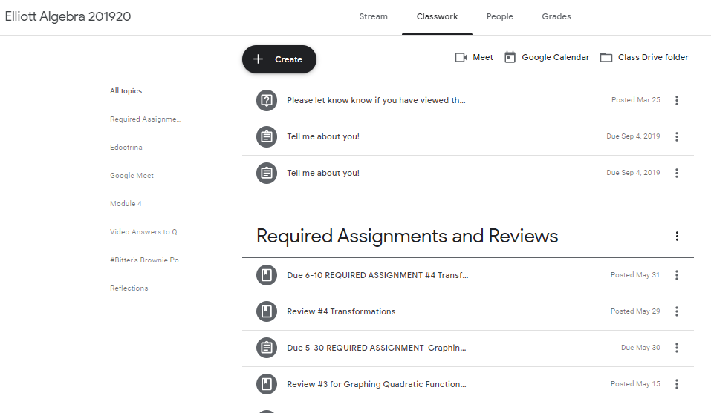

Choose the topic of choice from the menu on the left and then the assignment.

**Edoctrina**

All District Assessments (Unit tests, Quizzes, COUs-checks for understanding) are assigned and completed in Edoctrina. The Agenda slide will say “Edoctrina”. Please be patient with this system and learn the tools as they are the same ones that the State Assessments use.

**Remember that ALL work must be shown for full credit, NO SHORTCUTS.

