Using Google Docs

# Getting Started:

1. The first thing you need to do is either sign in to Google OR create an account if you do not have one. A Google account is essential to use Google Drive. Once you have signed in to your page should look like this:

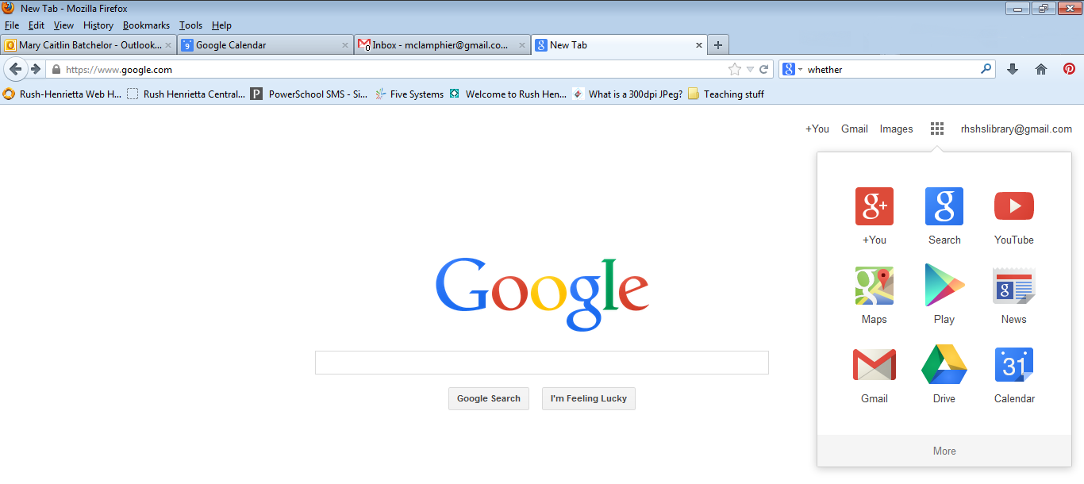

Click on the Apps option, which looks like a square box of other squares. Then, look for the DRIVE Tab and select it.

1. Once you are signed in and on the Google Drive page, your screen should look like this:

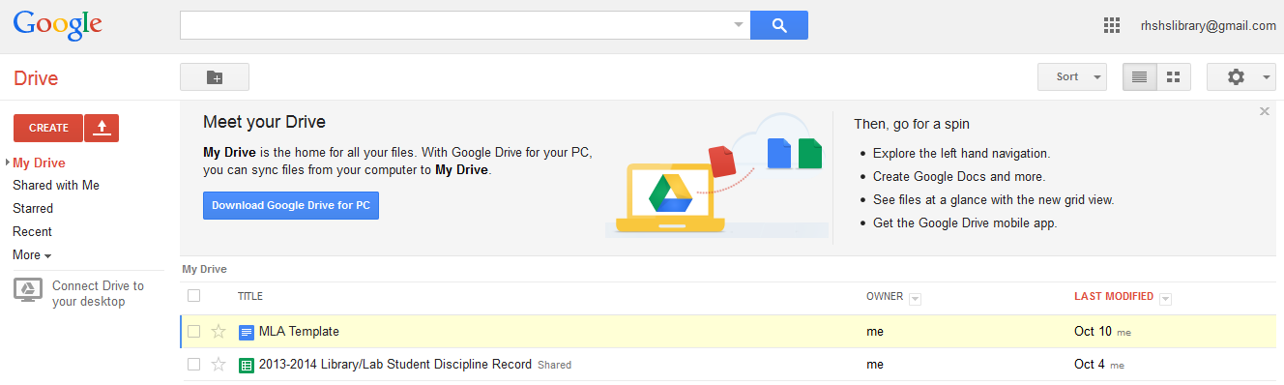

1. Drive is based off of Microsoft Office and has many of the same functions. Once you are in Drive, you have many options:
   1. You can upload a PowerPoint, Word or Excel Document
   2. You can create a new PowerPoint, Word or Excel Document
   3. You can edit or make a copy of an existing Document
   4. You can Share an existing document with other Goggle users

We will explore all of these options in turn, but remember that Google Docs is a “cloud” based program, anything that is saved in Drive will be available from any internet capable computer, as well as many smart phones.

**IMPORTANT POINT ON NAMING** – Because you will often being sharing these documents directly with your teachers, partners, and many other people you MUST name them all! The best thing to do is follow a naming convention for all your documents. Ask you teacher, but the recommended naming convention goes like this 🡪 **Block-Assignment-YourName** i.e **ACE1-SummerReading-Batchelor**

# Uploading a Document

1. Uploading a document is a good way of protecting your work. Since all your documents are stored in Drive they can never be lost, also because Drive and Word are compatible programs any document that you upload can be easily printed here at the Library.
2. 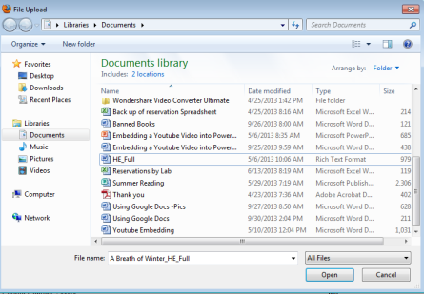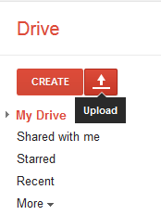To begin, sign into Google. Once you are on the Drive tab look for the Create Menu. You want to then click on the upload button.

1. This will pull up a separate menu that will allow you to choose a file to upload.
2. Choose a file and click “Open.” A window will pop up telling you how much data has been uploaded and when the upload is finished, once the upload has completed you should see the file in your drive menu.
3. To edit your document you need to right click on the document and choose “Open with” and then “Google Docs,” this will convert the document to a Google Doc and allow you to edit it.

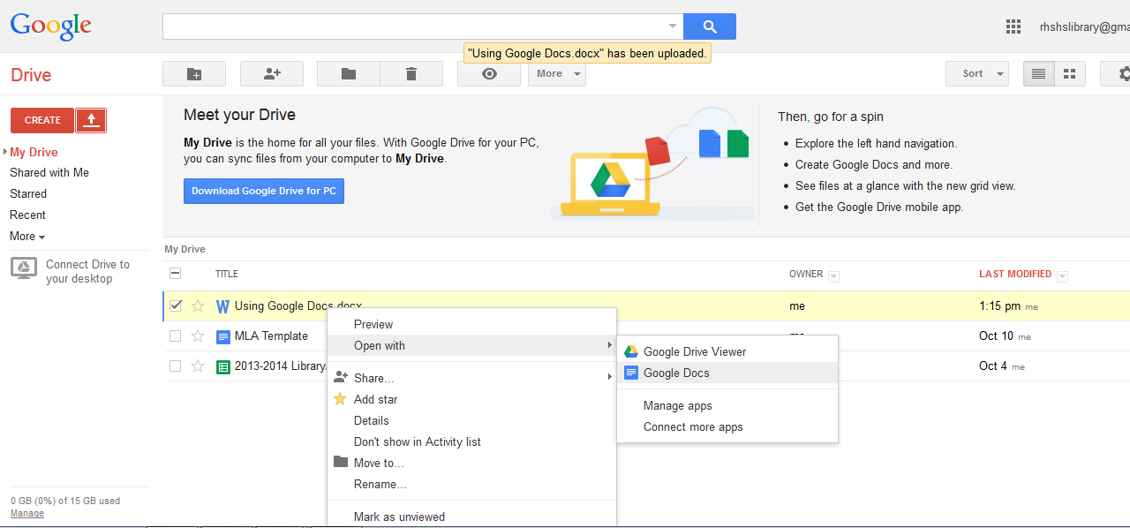

# Downloading a Document

1. You can also download Google Docs to Microsoft Office documents. This is helpful if for example your teacher wants you to turn in something as a drop box item. To download a document, open the document and go to the File command.

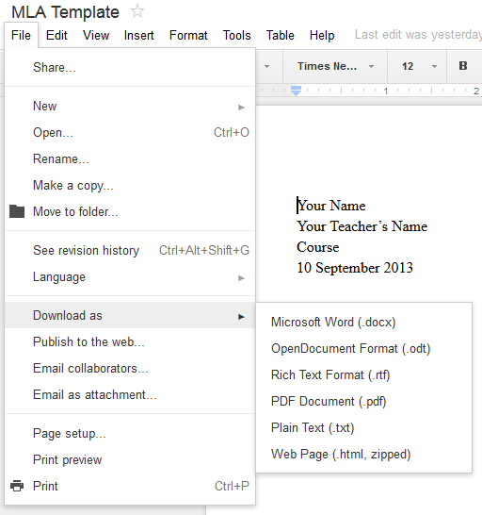

1. You can choose several different types of files to save your document as, pick the one that best fits your needs.

# Creating Folders

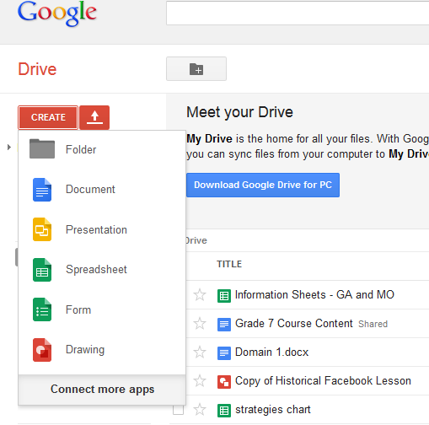When you create a folder, it will ask you to name your folder and then create it. Once it is made you can use it just like any Microsoft Folder, you can drag documents into it or open it and create documents directly in the folder.

# Creating an MLA Template

All teachers at the SHS use MLA formatting for their assignments, so it is helpful to have a template formatted in correct MLA style for writing papers and doing other typed assignments. Using Google Docs to do this is easy and will ensure that you always have a template available. The first thing you need to do is create a new document:

1. Open Google Drive and choose the “Create” tab. Once you click on the tab you will have a list of options. Choose the option for “Document”
2. After you have chosen this option a new tab or window will open in your browser. This will contain the document that we need to work on. You will notice that the document looks a lot like a standard Microsoft Word document. This is on purpose, Google Docs are meant to work with Microsoft Word. Let’s take a look at the controls.

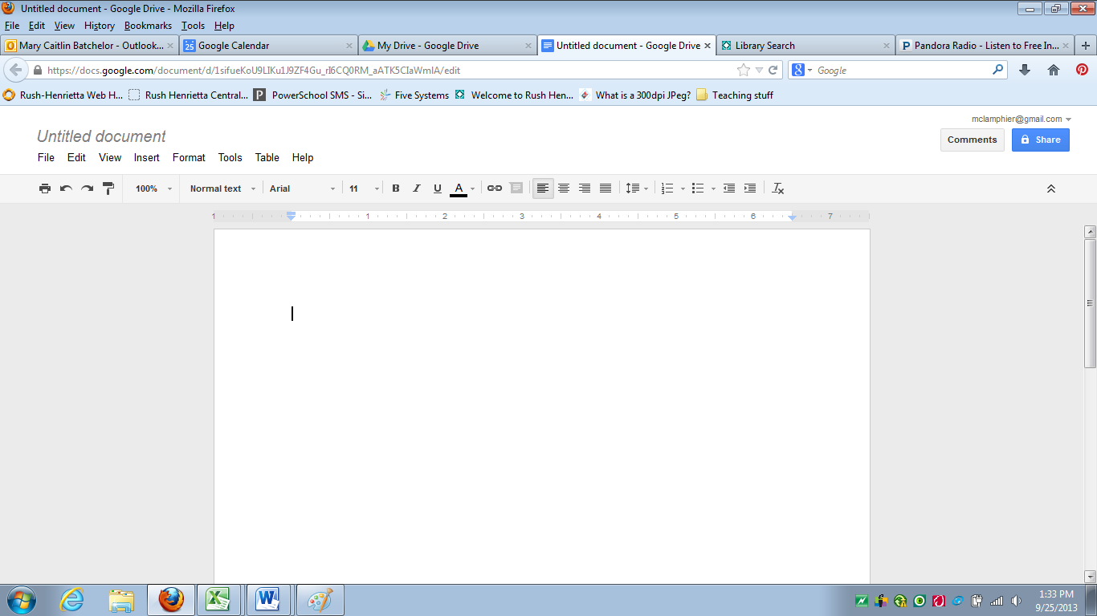

Print – Opens an Adobe Acrobat Document for printing purposes - Adobe Documents CAN NOT be altered but you can alter the Google Doc

Undo Comand

Redo Comand

View Size – Make the view larger or smaller

Formatting Templates

Font Name

Font size

Font Color

Hyperlink

Insert Comment – For formatting Shared Documents

Alignment

Line Spacing

Numbering



Bullets



Increase or Decrease Indentation



Clear All Formatting



Font Style

1. After you create a new document you should ALWAYS name it first! It is very important to name your documents so that you and your teachers can find them and know what they contain. We suggest name criteria such as: **Block-Assignment-YourName** i.e. **ACE1-SummerReading-Batchelor** so that you will never be scrambling to find what you need among a sea of untitled documents. To change the name:
   1. Open your new document – At the top of the page it will say *Untitled Document:*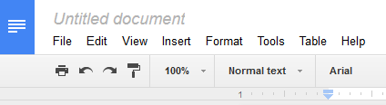
   2. Click on that and it will bring up a window that will allow you to rename your document: 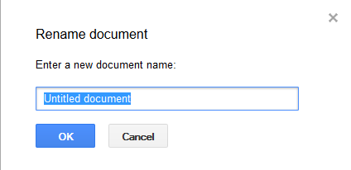
   3. For now name your new document MLA Template.
2. Once you have named your document it’s time to adjust the formatting. MLA standard formatting is a double spaced paper in Times New Roman 12 point font with 1” margins. Margins will be done for you automatically but everything else you will need to manually change. Google default looks like this: 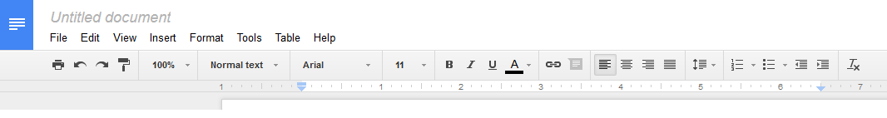

The arrowed items are the things that we need to change to correct the formatting.

* 1. First change the font name from Arial to Times New Roman
  2. Second change the font size from 11 to 12
  3. Lastly change the line spacing from 1.15 to double.

1. When you are done changing things it should look like this: 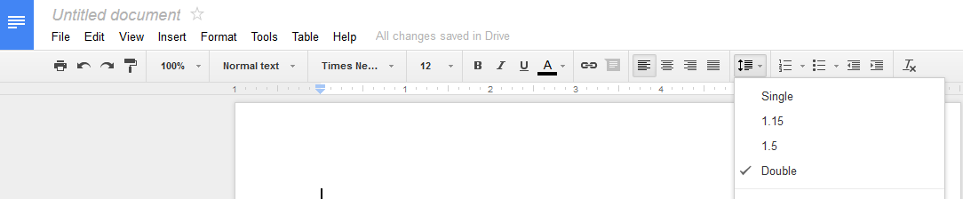
2. MLA formatting also requires Headers. Inserting headers is an easy task but it is a bit different than what you would do with a regular word document. To insert a header go to the Insert command on the drive’s file bar: 
3. 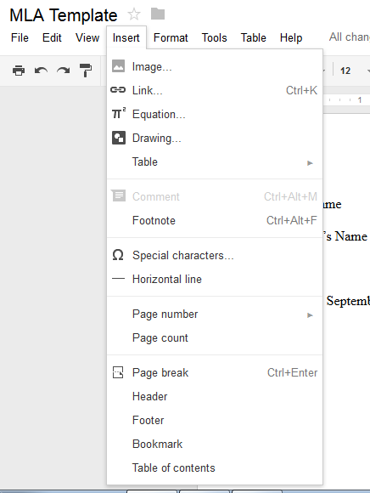That will bring up this menu:

Look for the Header command.

1. Once you choose this command your screen will look like this:

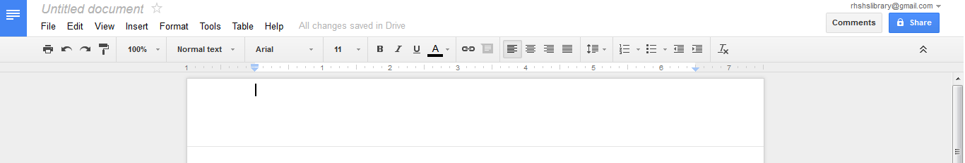

Note the very faint line that signifies that you are in the header. Also note that your formatting has reverted back to the Google default. So change your font name back to Times New Roman and your font size back to 12.

1. MLA Headers must include your last name and a page number. It must be right and not left justified.
2. Inserting a page number can be done by hand but it is easier to use the automated function that Google Drive provides as it will update your page numbers as you write. To do this you have to go back to the Insert menu and choose to insert a page number: 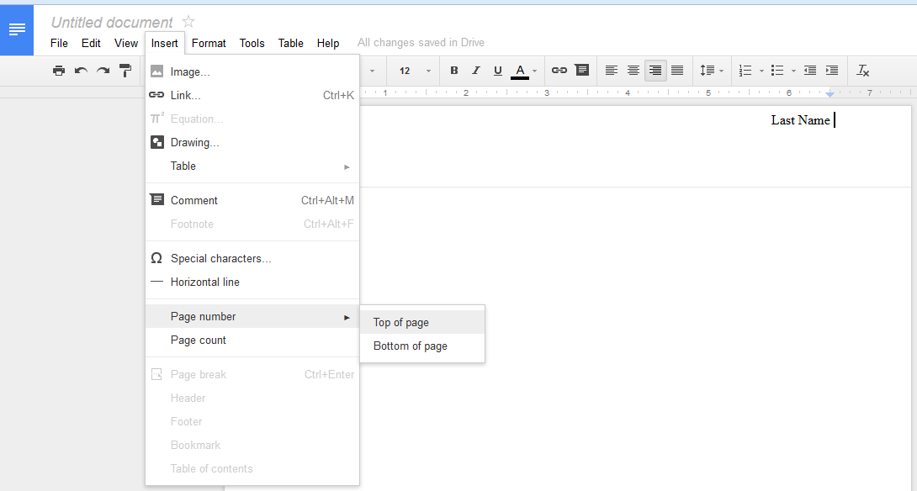
3. After you have done both these things your header should look like this: 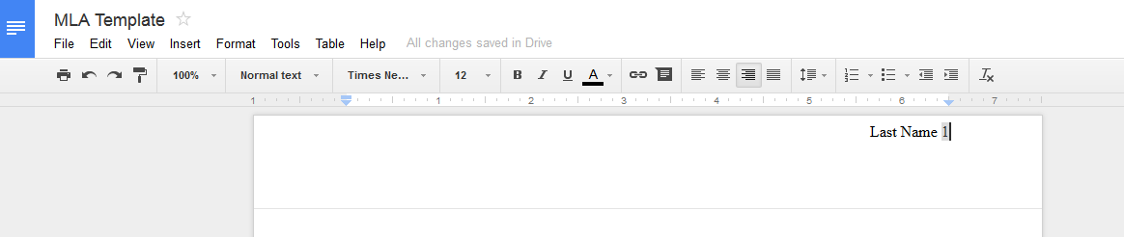
4. After inserting your running header, you also have to put in an MLA Heading that starts off your paper. MLA headings have your name, your teacher’s name, your class and the date of the assignment in **international dating** format. You should also have your title centered directly under your heading. It should look like this: 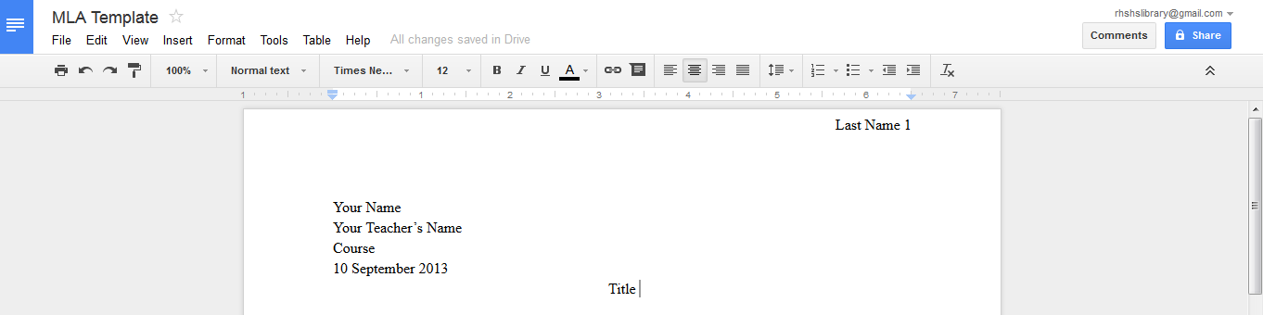

International Dating is the Day, then the Month, then the Year

# Using Your Template

Once you have your template you can use it to make new documents, each time you do it will keep your formatting so it will always be correct. Remember that in most classes, especially English, you are graded on your formatting as well as the content of your paper. To use your template you have to make a copy of it. Google makes this easy, first open your template. Then look at your file menu. You want to choose the “Make a Copy” option, when you do a box will appear asking you to name your new document.

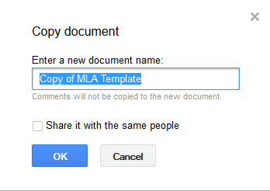

It will then bring up a new window that will have your document, with all of the formatting preserved. Be sure to change the teacher, class, date and title of your paper before you turn it in!

# Sharing your Document

One of the best features of Google Drive is the ability to share and collaborate with others without being in the same room as them. You do this by “sharing” your document with others, which allows everyone to see the document and edit it as they wish. Sharing is easy: 

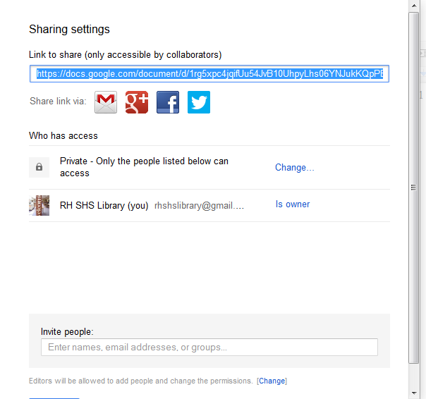First, open your document. Look for the share button:

This window will come up, to share with others enter their Gmail addresses:

This will allow others to both see and edit your document. Editing is especially helpful because it allows people to make comments as well as changes.

**If you have ANY further questions please come and ask your friendly neighborhood librarian.**