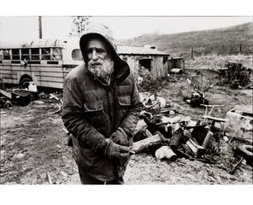

**Essential Question**

**☺What is the difference between what you have a right to do and what is right to do?**

**Task**

√ This essay of at least three pages in length will require you to explore the implications of our essential question as it pertains to the documentary as well as the accompanying four supplemental articles. As an argumentative synthesis essay, you will need to use *Brother’s Keepers* as your primary source and the remaining documents as supplementary sources.

√ Your argument should be central; the source material should be used to support your argument. Do not merely summarize the texts

√ Draw from at least three of the supplementary articles

**Learning Targets**



* I can write a declarative thesis
* I can write my body paragraphs syllogistically
* I can transition into and out of quotes
* I can prove my arguments with sufficient textual support and analysis