# In Social Studies

**October 1, 2018**

In Reading and Writing

This month, we have been working with the letters t, f, m and n in Fundations. Your child should be able to show you the correct sound and formation of these letters.

We have been writing about color themes, rules, and picture books. In addition, we are working to understand that a picture can tell a story. As we enjoy a variety of books, we are taking the time to notice and discuss how pictures help to tell the story. Our goal is to include at least three details in our pictures. In addition, the boys and girls are learning how to use basic shapes to create the people and objects in their pictures.

We have been discussing rules at school, home and in the community. This has been a great opportunity to connect these rules to our PBIS traits:

Be Respectful Be Responsible Be Caring

Be Ready to Learn Be Trustworthy

Reminders

**We go to the library every Thursday. Please help your child remember to bring his/her book.**

**DATES:**

* Superintendent Conference Day/Columbus Day- 10/5/18 and 10/8/18- No School
* Fyle Book Fair- 10/9/18 – 10/12/18
* School Pictures- 10/11/18
* Fyle Boo Bash- 10/26/18, 6:30-8:00

Please make sure that you are signed up to receive Fyle's newsletter that is sent out weekly by the building principal, Mrs. Mooney.  Each week Mrs. Mooney includes valuable information regarding the happenings in the building, upcoming events and Parent Group activities.

1.  Go to [rhnet.org](http://rhnet.org)

2. Click on Schools

3. Click on Fyle

4. Scroll down to "E-News Subscriptions"

5.  Fill out the form.

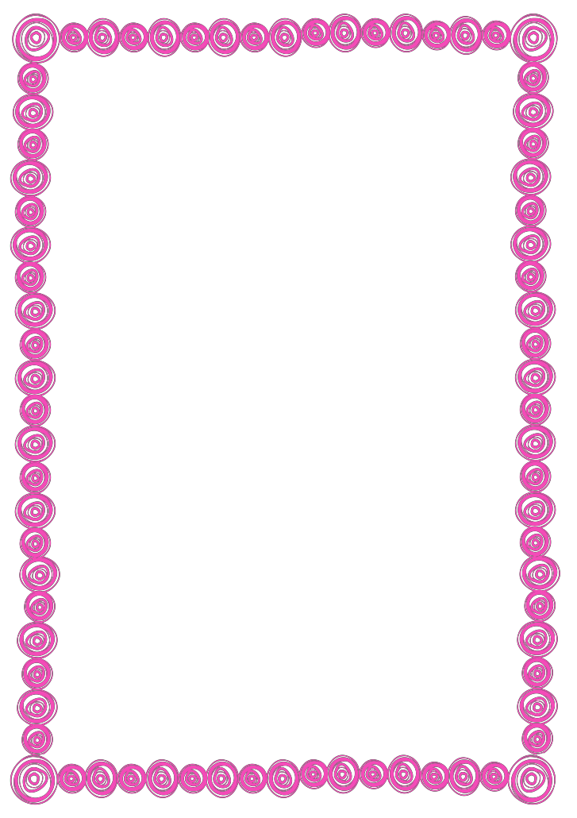

# In Math

We have been working with the numbers 0-5 in a variety of ways. Efficiently counting with one to one correspondence has been a huge focus. We are also learning how numbers within five can be taken apart into 2 and 3, and 4 and 1 as we work toward the concept of addition. Time spent practicing writing the numbers 0-5 at home would be beneficial.