Name______________________________________ Circle Your Number Chapter 7 Review Stations 1 2 3 4
Card #1  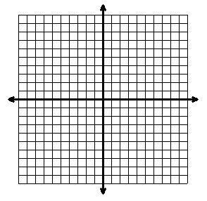 | Card #2
Card #3

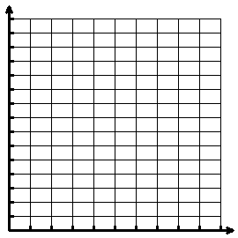Card #4 Use If Needed

Card #5 | Card #6
Card #7
Graphically Algebraically

Card #8

