August 2018

Dear 2nd Grader and Parents,

Hello and welcome to 2nd grade! I am Mrs. Agness and I’m excited to be your teacher and seeing you very soon. Second grade is filled with fun things to learn and do as you get to know your classmates and make new friends!

I hope you have been enjoying the summer with your family and friends doing the things that put a smile on your face. I’ve enjoyed time with my husband, son, and our dog, Rockie. I love the warm weather, swimming, biking, reading a good book, scrap booking ... and the fun things summer has to offer. Throughout the upcoming school year, I hope to get to know more about you and your interests, along with your family.

Enjoy the rest of your summer. I look forward to meeting you soon and starting the new school year!

Your Second Grade Teacher,

Mrs. Barbara Agness

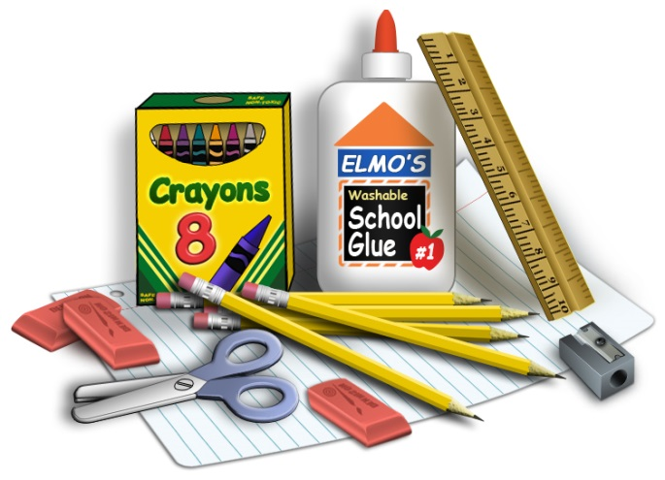

Mrs. Agness

P.S. Don't forget your school supplies!

*(Kindly* ***label*** *them with your name.)*