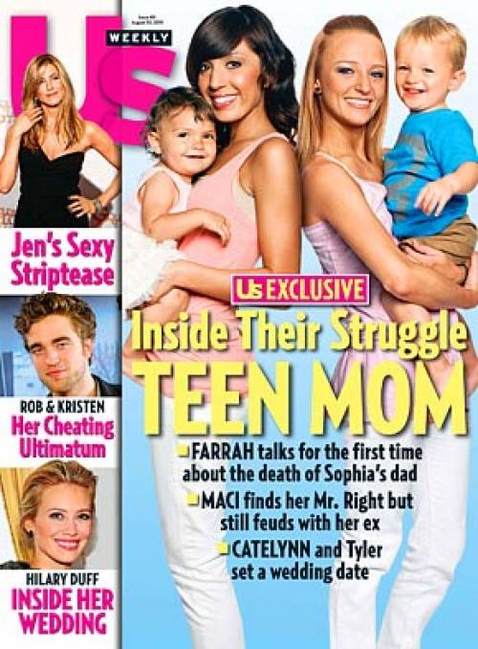

**SOURCE THREE**

**MTV's 'Teen Mom' documents lives interrupted for teens having babies**

**By: ALICIA RANCILIO**

NEW YORK — Amber Portwood's lunch with a friend keeps getting interrupted by a crying baby. The problem is, the baby is Amber's. She packs up and leaves the restaurant before she can finish eating.

Quieting a fussy baby is all in a day's work for the 19-year-old and her co-stars on MTV's new reality show, "Teen Mom" (10 p.m. EST Tuesdays). The show premiered to the highest rated series on the network in more than a year.

The girls on the show aren't strangers to cameras — they were also on MTV's "16 and Pregnant," which aired last summer. "Teen Mom" revisits the young mothers several months after giving birth.

"I really just wanted to show girls how hard it was to be a teen parent," says Maci Bookout, 17, of her decision to let her experience be filmed for TV.

Bookout was a popular high school student with good grades and plans to go to college. Her path changed when she got pregnant by her boyfriend and gave birth to a son named Bentley. Instead of going away to college, Maci's priority now is taking care of her baby.

"I wanted girls who might get pregnant to see there are options out there to move forward with your life and still have goals," says Bookout, who plans to marry her baby's father and would like to have another child.

Not all the young women on "Teen Mom" chose to keep their babies. Catelynn Lowell, 17, for example, gave her daughter up for adoption last May.

"It was difficult because that's my daughter. ... I knew in my heart it was the best (decision) so I just went forward with it," she says. Catelynn and the baby's father, Tyler Baltierra, are still together and live with Tyler's mom.

Lowell says she definitely wants to have children but wants to wait until she has finished with college, has a career and is married.

Dr. Jenn Berman, a psychotherapist, says that teen relationships usually do not last.

"I think that it is a beautiful idea and I think the love and passion we feel when we are teenagers is so intense we believe it will last forever, but statistically speaking the odds are not in their favor that their relationships will last," says Berman, who worries that teens might think reality TV stars are celebrities and the show celebrates teen pregnancy.

"As a professional, I'm a little uncomfortable," she says. "There's a certain amount of glorification that goes along with having an MTV show even though it's a show that shows you having a difficult time raising your child. Still, you're in the spotlight and to some degree that does send a positive, pro-teen parent message even though that's not the intention."

Berman believes the thoughtfulness inspired by "Teen Mom" could be a positive thing.

"I think the show has a potential to open up some really important dialogue," she says.