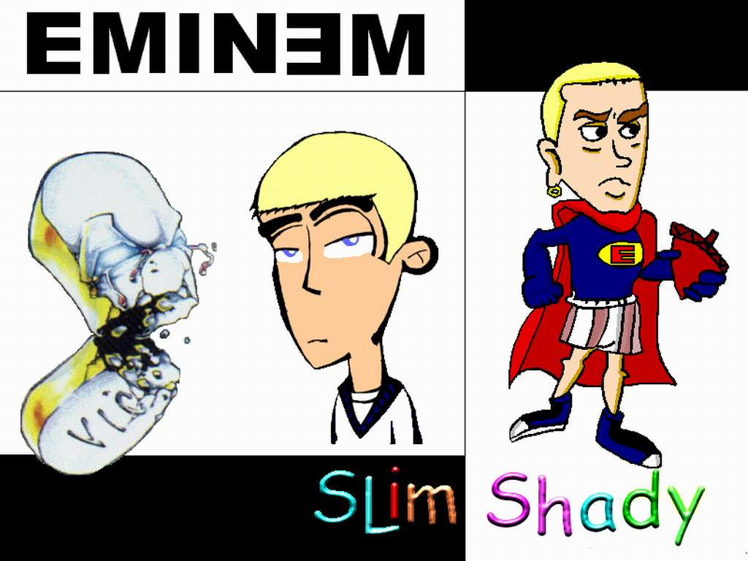

Everyone embodies their own stereotype. While most people like to consider themselves as unique, we’re little more than a typecast version of some “other” being that is rooted in the muck of cliché and all that is unoriginal. The kid who reveres the unsigned talent of the unknown band, in someone else’s eyes, perhaps, is nothing more than an “emo” poseur. The gentleman in his early fifties that cruises in the left lane with his fancy red convertible with the top down is nothing more than some middle age crisis, some personified version of a desperate Viagra commercial unfolding itself down the highway. We all fall prey to the trappings of stereotypes. In fact, some of us are rendered vulnerable by the manipulation and deceits of these preconceived biases. This idea is especially true of the principal characters in “Doubt” and the prominent rapper Eminem.

The stereotypical underpinnings of an individual can often leave them exposed to manipulation and deceit. Donald Muller, for example, is the first African-American student to attend St. Nicholas Academy. Set within the racial tension of 1964 and the onslaught of the church sex scandal, Muller is vulnerable on many levels. In one of the pivotal scenes of the play, Sister Aloysius launches her character assignation against Father Flynn in her office. Since she views the world through the cynical lens of “Doubt,” her evidence can only prove one thing: Father Flynn took advantage of the school’s most susceptible pupil. According to Aloysius, the issue is clear – Donald Muller had alcohol on his breath; he was alone with Father Flynn in the rectory; he is the only African-American student who is disliked and isolated merely because of the color of his skin; as such, Father Flynn took advantage of his role as the “protector” of this child. In this instance, Father Flynn is rendered defenseless because of what his stereotype represents. Without question, Muller drank wine. With certainty, Muller was called into the rectory for a “private” meeting with Father Flynn. And it also goes without argument that Muller is the most vulnerable student attending the school. Father Flynn’s stereotype has him cornered and against the ropes. His justification, at least to the doubting skepticism of Sister Aloysius, also opens him up to a self-manufactured “guilt” that is deeply rooted in the stereotype he embodies. In his own defense, Father Flynn suggests that “Donald Muller served as altar boy last Tuesday morning. After Mass, Mr. McGinn caught him in the sacristy drinking alter wine. When [Father Flynn] found out, [Flynn] sent for him. There were tears. He [Muller] begged not to be removed from the altar boys. And [Flynn] took pity on him. [Flynn] told him if no one else found out, [Flynn] would let him stay on” (54). The explanation is very rationale and logical, but Father Flynn’s stereotype prevents Aloysius from buying into it. There are all sorts of stereotypical assumptions that lead Sister Aloysius to the conclusion that Father Flynn sexually molested Donald Muller: to begin with, Flynn is a man of excess – he takes three sugars with his tea, has very long finger nails, and writes with modern day Ballpoint pens. Such a man of extravagance, according to Aloysius - especially in light of the 1964 church sex scandal - can only be up to one thing with the school’s only African-American male, alone in his rectory. Any lingering “doubt” that Aloysius may have at this juncture of the play is nullified with Mrs. Muller’s manipulation of a sexual and racial stereotype that her son personifies. As the meeting between the two ladies progresses, Aloysius announces that she suspects misconduct. Despite this allegation, Mrs. Muller deflects blame away from Father Flynn and places it on her son. With utmost sincerity, Mrs. Muller thinks that “Well, maybe some boys want to get caught. Maybe what you don’t know maybe is that my son is … that way. That’s why his father beat him up. Not the wine. He beat Donald for being what he is” (48). What Donald “is,” is gay. While Mrs. Muller accepts this possibility, what she doesn’t accept is that Father Flynn acted alone. Her stereotypical notion of how homosexuals interact with each other is pretty preposterous, but it draws her to the conclusion that her son actively sought the attention of Father Flynn. In other words, that Donald somehow rigged the misconduct – that he actually wished it upon himself. For both characters, Father Flynn and Donald Muller, their stereotypical representations ultimately damn them to the mercy of other’s “Doubt.” No matter how innocent their intentions are, the stereotypes they embody place them in dire predicaments.

Eminem, just like the principal characters in “Doubt,” has often found himself at the mercy of the stereotype he embodies. As the most preeminent white rapper in the music industry, a niche largely controlled by African-American males, Eminem has frequently been brandished as a racist and a poseur. In a recent interview on 60 Minutes, he addressed head-on the claims that he is a racist. To provide a little bit of context, Eminem writes lyrics that fall within the topics of the musical genre: growing up and surviving the tough ghetto neighborhoods of Detroit; he raps about “bitches,” “booty,” and “bling-bling.” Just like his contemporaries in the industry, Eminem also raps about “niggas” – in fact, just like other rappers, he straight up disrespects and “calls out” certain rappers in his work. This is not atypical – rappers from 50 Cent to Public Enemy have been doing this for decades. During his public interview with Anderson Cooper, Eminem responded to his critics by saying: “I felt like I was being attacked,…. was being singled out. I felt like, ‘Is it because of the color of my skin? Is it because of that that you’re paying more attention?’ There are certain rappers that do and say the same things that I’m saying and I don’t hear no one say anything about that” (60 Minutes). What’s ironic is that Eminem’s new album is so topically different than other albums within the genre. As his producer puts it, “three songs are about [his] recovery and addiction, two songs are about his broken marriage, one song is about his daughter, and the others deal with social and political issues” (Diesel Nation, 2). The objections, therefore, stem from what Eminem stereotypically represents. To illustrate this claim, consider Lil’ Wayne’s latest album. Like Eminem, he occupies the space of the hip-hop/rap genre but is African-American. In this album, he degrades homosexuals, sexually objectifies women, and glorifies the killing of “thugs.” Lil’ Wayne understands how the racial stereotype works. In a recent interview he went on record to say:

Kill the double standard. Hip-hop embraced Eminem even though he made songs dissing his mother, killing his wife, and beating up gays. Should we be offended now that this White emcee has said something many other Black emcees have said without reprimand? Listen- lyrics that degrade are not cool, no matter who's saying them. We grown folks *within hip-hop* need to take a second look at what we condone in our songs. We've spent so much time defending ourselves from the powers that be that we've neglected to police ourselves. I'm not saying hip-hop is destroying the Black community or America or something dumb like that. But dag...you have to admit that 90% of the stuff pumping out of the industry is emotionally immature. Let's at least have an alternative for all of us over the age of 15 (Diesel Nation, 4).

Behind the corners of Lil’ Wayne’s statement is this fact – Eminem is being attacked because of the color of his skin. Implicit in his remarks is a stereotypical assumption that a lot of people maintain – the rap and hip-hop industry is for Black artists alone. Moreover, when it comes to matters of race, and Lil’ Wayne acknowledges this, a lot of people entertain the belief that if one is white, they therefore do not have license to discuss the topics that frequently arise in this genre of music. Eminem has combated this stereotype ever since he entered the scene in the early 1990s. As he puts it, not only does he need to downplay the “stupid ass” stereotypes left by such white rappers such as Vanilla Ice, but he needs to create a space in an industry that stereotypically has excluded rappers such as him because of the color of his skin (Diesel Nation, 4). Unlike the characters in “Doubt,” however, Eminem has been able to cast away the doubt of the music industry and dominant when others suggested that he didn’t stand a chance.

Stereotypes are a lot like ancient tableaux – the writing left on them are impressions of the real thing, just indentations and scratchings – the message, therefore, is left to the mercy of the interpreter. When we embody a stereotype that rests in the eyes’ of the beholder, we are vulnerable in the sense that they can manipulate us and deceive us to the extent that our stereotype allows – to the extent that our indentations and scratchings permit.

**Works Cited**

**Cooper, Anderson. Eminem 60 Minutes Interview**

**14 October 2010. State of California. Dept. of Fish**

**and Game. 24 Mar. 1999 <http://www.dfg.ca.gov/**

**lion/outdoor.lion.html>.**

**“Doubt.” John Patrick Shanley, 2007. Theater Communications Group: New York.**

**Perry, Tony. “Diesel Nation.” Los Angeles Times 8 Mar.1996, home ed.: B1+.**