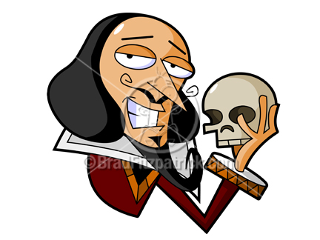

**Directions:**

*Hamlet* unquestionably has a handful of memorable scenes. In this log, you need to capture the key scenes that are rife for a Critical Lens essay. As you know, the Critical Lens requires you to recall and describe scenes vividly as you offer forth your textual support to illustrate how the lens statement functions in a work of literature. You may draw, caption, and/or write in the spaces below. Whatever you choose, make sure to thoroughly depict the scene.

|  |  |  |  |
| --- | --- | --- | --- |
|  |  |  |  |
|  |  |  |  |