Frequency Histograms

A histogram is a special type of bar graph that shows the frequency a data item occurs. Histograms often combine data into intervals of equal size.

The histogram below shows the amount of money customers spent in a supermarket.

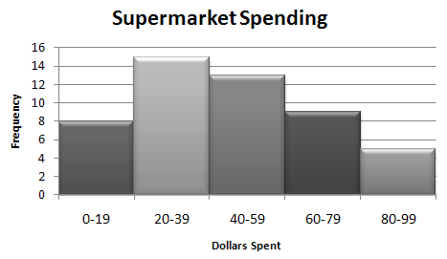

Based on the histogram, how many people were surveyed? _________________________

What is the greatest amount of money that any customer spent? _________________________

Which interval represents the greatest number of customers? _________________________

How many customers spent less than $60? _________________________

The data below shows the number of winning points scored at 15 NCAA Division I Women’s Basketball Championship games from 1991to 2005.

84, 70, 73, 82, 68, 71, 62, 93, 68, 83, 70, 75, 84, 78, 70

|  |  |  |
| --- | --- | --- |
| Winning | Tally | Frequency |
| 59-64 |  |  |
| 65-70 |  |  |
| 71-76 |  |  |
| 77-82 |  |  |
| 83-88 |  |  |
| 89-94 |  |  |

Scatter plots display the relationship between two groups of data or **bivariate data**. Histograms display only one set of data called **univariate data**.

Let’s Try One More Example!

The following data consists of the weights, in pounds of 24 high school students.

195, 206, 100, 98, 150, 210, 195, 106, 195, 108, 180, 212, 104, 195, 100, 216, 99, 206, 116, 142, 100, 135, 98, 160

a. Complete the tally and frequency table.

|  |  |  |
| --- | --- | --- |
| Interval | Tally | Frequency |
| 51-100 |  |  |
| 101-150 |  |  |
| 151-200 |  |  |
| 201-250 |  |  |

b. Construct a frequency histogram.

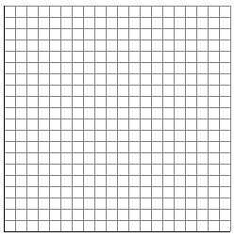

How many students weigh less than 151 pounds? _________________________

Practice: Histograms Name _____________________________

1. The accompanying histogram shows the height distribution for students in a high school mathematics class.

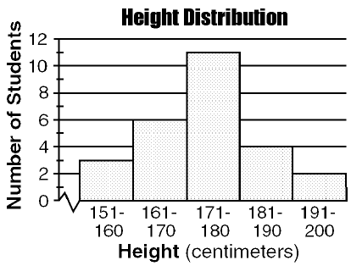

a. How many students are in the mathematics class? _________________________

b. How many students were between 171 and 180 centimeters? _________________________

c. How many students were between 151 and 170 centimeters? _________________________

2. The test scores for 20 students in a Spanish class are shown in the frequency table below. Construct a frequency histogram with the data.

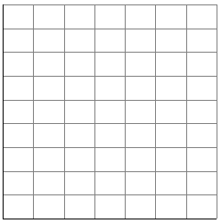

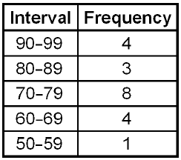

3. Below is the number of siblings each student has in an Algebra class.

4, 1, 2, 3, 2, 7, 2, 9, 2, 0, 1, 8, 6, 6, 2, 2, 1, 0, 0, 3

a. Complete the tally and frequency table.

|  |  |  |
| --- | --- | --- |
| Interval | Tally | Frequency |
| 0-1 |  |  |
| 2-3 |  |  |
| 4-5 |  |  |
| 6-7 |  |  |
| 8-9 |  |  |

b. Construct a frequency histogram.

