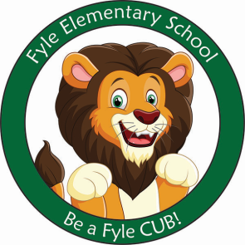

Mrs. Janofsky’s Weekly Update

May 3, 2019

Math

This week we began our new unit on teen numbers. We are learning that teen numbers are a group of ten ones and a group of ones ie., 19 is ten ones, 9 ones. This is the beginning of place value and understanding numbers. Attached to this, we have begun discussing money. This week we learned about the dime and the penny. Ask your child to count coins at home. We will work with nickels next week.

ELA

This week we began to focus on non-fiction reading. We have begun to look at the features of a non-fiction book such as table of contents, labels and diagrams, and glossary. If you are reading a non-fiction book, point these features out to your child. We will continue to read fiction also and talk about the features of this genre too. In Fundations, we continue to work to tap words and read and write them. We have also began to discuss the silent e making the vowel say its own name. This is called a long vowel sound. We will continue to do a variety of writing and continue to work to edit our own work.

Science

The eggs have arrived!!!!! This is a very exciting time in Kindergarten. Our classroom has an incubator with 12 eggs in it. We are discussing daily that all 12 eggs will probably NOT hatch. We will learn about the life cycle of the chicken as we wait 21 days for them to hatch. We will also be continuing to learn about the plants. I hope you have been having success growing the plants that were sent home!

Important Information

* Specials next week
  + Monday: D
  + Tuesday: A
  + Wednesday: B
  + Thursday: C
  + Friday: D
* Library on Wednesday next week. Please help your child remember their book!
* Reading bags come home every Tuesday, Wednesday, AND Thursday. Please be sure to return them completed the next day.
* Sight word checks have been started. New words coming next week.

Sight Words

or, for, some

