**Memorize It & Know It List!**

1. **Element Types**

* Metals → to the left of the staircase on the periodic table
* Non-metals → to the right of the staircase on the periodic table
* Metalloids → along the staircase: Si, Ge, As, Sb, Te

1. **The Diatomic Elements**

* “The Diatomic 7”
* HOFBrNICl
* H, N, O, F, Cl, Br, I

1. **Physical state of elements at STP (STP defined on Table A as… 273 K and 1 atm)**

All elements are solids except:

* 2 liquids – Br (bromine) and Hg (mercury)
* 11 gases – the 6 Noble Gases (He, Ne, Ar, Kr, and Xe) plus H, O, N, F, Cl

1. **Phases and Phase Changes**

* Melting (Fusion): S → L
* Boiling/Evaporation/Vaporization: L → G
* Condensation: G → L
* Freezing: L→ S
* Sublimation: S → G
* Deposition: G → S
* Ideal Gases have HIGH TEMP and LOW PRESSURE
* Kinetic Molecular Theory states that gases move in random, straight- line motion, with no attractive forces (not attracted to each other).

1. **Mixtures**

* Homogeneous: uniform (even distribution)- SOLUTIONS! (aq)
* Heterogeneous: not uniform (uneven distribution)
* Separated based on physical properties (size, solubility, boiling point, etc.)

1. **Subatomic Particles**

|  |  |  |  |
| --- | --- | --- | --- |
| **Particle** | **Charge** | **Mass** | **Location** |
| Proton | +1 | 1 | Inside nucleus |
| Neutron | 0 | 1 | Inside nucleus |
| Electron | -1 | 0 | Outside nucleus |

1. **Periodic Table Trends**

* Elements are arranged in order of INCREASING atomic number (# of protons)
* Elements in the SAME Group (Column) have similar chemical properties = same # valence e-

1. **Special Periodic Table Group Names**

Group 17 = Halogens

Group 18 = Noble Gases

1. **Bonding Basics**

ONLY 2 Types of Bonding!

1. Ionic -> Metal /Nonmetal bonding, *valence* *e- transferred,* Lewis dot diagram uses brackets like:

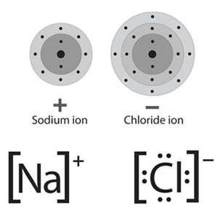

1. Covalent 🡪 nonmetal/nonmetal bonding, *valence e- shared,* Lewis diagram does not use brackets, like: H**:**H or H–H

* Not a “real” bond: Metallic 🡪 metals only, *valence e- in a “sea” of mobile e-*
* When you break bonds you ABSORB energy; when you form bonds you RELEASE ENERGY

1. **Naming Compounds**

Check metal… if it has more than one charge (oxidation number) must use Roman numeral, then just write nonmetal name, with the “ide” ending… if polyatomic ion, use Table E to get name.

Ex: MgCl2 = magnesium chloride

Fe2O3 = iron (III) oxide

CaSO4 = calcium sulfate

Cu(NO3)2 = copper (II) nitrate

NH4NO3 = ammonium nitrate

1. **The following Lewis dot diagrams and their resulting molecular polarities:**

* All 7 diatomic elements
* H2O
* CO2
* HCl
* NH3
* CH4

1. **Four types of chemical reactions:**

* **S**ingle **R**eplacement
* **D**ouble **R**eplacement
* **S**ynthesis
* **D**ecomposition

1. **Organic Reactions Types**

* Addition (add something- multiple bond becomes single bond)
* Substitution (swap 2 elements)
* Combustion (burn in the presence of O2)
* Fermentation (sugar with an enzyme/catalyst = alcohol + CO2)
* Saponification (make SOAP!)
* Polymerization (link short hydrocarbons to make a big long chain- PLASTICS!)
* Esterification (acid + alcohol = ester + H2O)

1. **Acids and Bases and the pH Scale:**

* Acids: pH = 0 - 7
  + Have an H+ ion

OR

* + H+ donor
* Bases: pH = 7- 14
  + Have an OH- ion OR
  + H+ acceptor
* Neutral: pH = 7
  + Pure Water is neutral
* A change of 1 pH to a unit lower = 10x more acidic (10x more concentrated in H+ ion)
* A change of 1 pH to a unit higher = 10x less acidic (10x less concentrated in H+ ion)

1. **Redox**

* “LEO says GER”
  + Loss of electrons = oxidation → charge goes up
  + Gain of electrons = reduction → charge goes down
* An OX and a BIG RED CAT
  + Anode = oxidation, mass of electrode decreases
  + Cathode = reduction, mass of electrode increases
* Voltaic = spontaneous = chem. 🡪 electrical
  + Anode is higher on table J
* Electrolytic = forced by a battery/power source = non-spontaneous = electrical🡪 chem.
  + Cathode is higher on table J

1. **Conductivity**

* **there must be MOBILE (movable) charged particles (ions or electrons) present**
  + For solutions, the solute must dissolve to produce IONS
  + For liquids, only melted ionic materials conduct
  + For metals, conductivity in any phase because of the mobile sea of valence e-

1. **Properties based on Bond type – Know this chart!**

|  |  |  |  |
| --- | --- | --- | --- |
| Type of bonding | Conductivity | Hardness | Melting points |
| Ionic (salts) | Only when melted of dissolved | Brittle | High |
| Molecular (covalent) | None | Soft | Low |
| Metallic (pure metals and alloys) | Solid and liquid states | Malleable | High |

1. **Endo vs Exothermic**

Endo:

* +H,
* heat ENTERS (added as a reactant)
* heat written into equation as a reactant
* if touched, feels cold (draws heat out of you, entering reaction)
* Temp of surrounding air or solution decreases

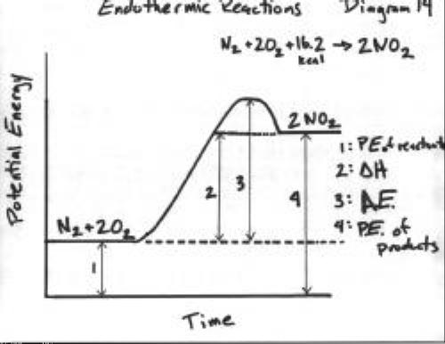

Exo:

* -H,
* heat EXITS (released as a product)
* heat written into equation as a product
* if touched, feels warm (releases heat to you, from the reaction)
* Temp of surrounding air or solution increases

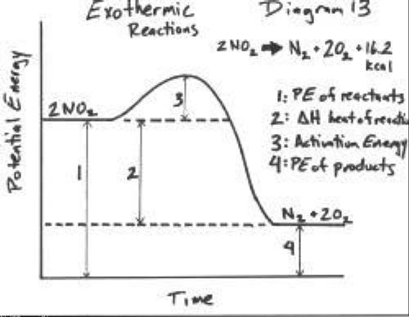

* **Memorize the meaning of all 4 arrows on these diagrams!**
* Use of Table I, hint about endo/exo at bottom
* Know how a catalyst changes PE diagrams