**Unit 3 Practice Multiple Choice Questions** Name: _________________________

**1 As a result of the Russo-Japanese War, Japan came to be seen by Europeans as**

(1) a likely area for colonization

(2) the strongest of the imperialist countries

(3) a leader in the movement for nonalignment

(4) an emerging global threat

________________________________________________________________________

Speaker A: The British East India Company does not respect my beliefs. I cannot follow dharma and remain their soldier. I will return to my family in a Tamil village.

Speaker B: My rebellious countrymen cannot accept my new religion and so they hate me and my “foreign devil” friends. The missionaries leave Beijing tomorrow for England. I must join them before the church compound is surrounded.

Speaker C: The czar’s soldiers came again today, looted our village, drove off our livestock, and trampled anyone in their way. They even burned our synagogue. Our way of life is gone. It is time to emigrate to Palestine.

**2 What is the primary focus of these speakers?**

(1) civil war

(2) economic reforms

(3) religious persecution

(4) colonial oppression

______________________________________________________________________

**3 During the 1800s, many Latin American countries were characterized by a**

(1) reliance on cash crops

(2) transition to command economies

(3) redistribution of land to the peasants

(4) withdrawal from the world market

______________________________________________________________________

Base your answer to question 4 on the poem below and on your knowledge of social studies.

**Colonizer’s Logic**

These natives are unintelligent —

We can’t understand their language.

Chinweizu (Nigeria)

— Voices from Twentieth-Century Africa Griots and Towncriers

**4 The “logic” of the colonizers described in this Nigerian poem reflects their**

(1) utopian plan

(2) educational goals

(3) militaristic behavior

(4) ethnocentric attitude

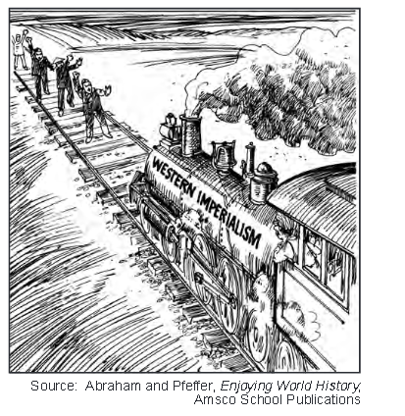

**5 This cartoon suggests that political power is often acquired through**

(1) the inheritance of land

(2) market demands

(3) religious conversion

(4) the use of technology

­________________________________________________________________________

**6 Which description of trade patterns best represents the relationship between Africa and Europe during the late 19th century?**

(1) Trans-Saharan trade caravans led by Europeans were the most profitable.

(2) South Africa was of no interest to European traders.

(3) Raw materials were shipped from Africa to European industries.

(4) Rivers were the key highways connecting Europeans to much of the African interior

**7 One major reason European countries engaged in imperialism in the late 19th century was to**

(1) gain a better understanding of unknown territories

(2) ease tensions with their rivals

(3) develop treatments for diseases

(4) obtain markets for their manufactured goods

**8 One way in which the rule of Peter the Great in Russia and the rule of Emperor Meiji in Japan are similar is that both leaders**

(1) emancipated serfs

(2) granted equality to women

(3) encouraged modernization

(4) ruled according to a constitution

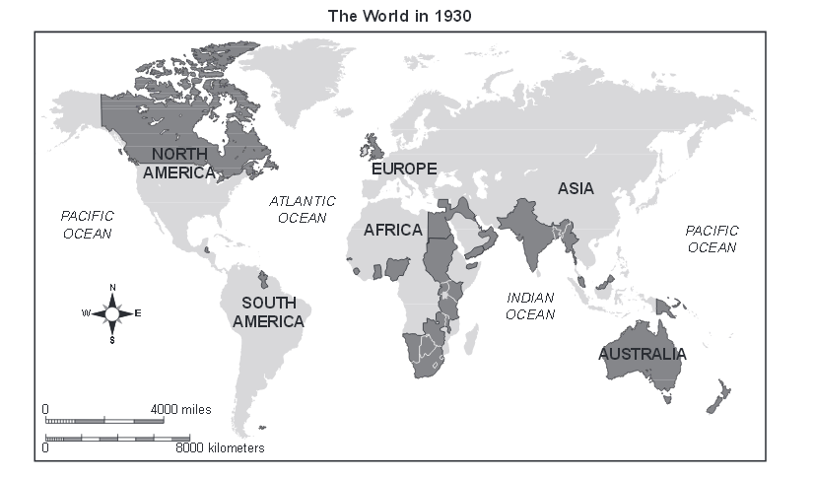

**9 What do the dark-gray areas on this map represent?**

(1) the British Empire

(2) countries attending the Congress of Vienna

(3) newly independent French colonies

(4) members of the Hanseatic League

__________________________________________________________________

• Opium War (1839–1842)

• Taiping Rebellion (1850–1864)

• Boxer Rebellion (1898–1901)

**10 This series of events is most closely associated with the**

(1) spread of communism to China and Korea

(2) growing concerns about the influence of the West in China

(3) alliance formed between Vietnam and China

(4) increasing expansion of civil and political rights in China

__________________________________________________________________

**11 The Berlin Conference is most closely associated with the colonialization of**

(1) South Asia (3) Latin America

(2) East Asia (4) Africa

**12 Commodore Matthew Perry is best known for taking which action?**

(1) leading the British East India Company

(2) rescuing Europeans during the Boxer Rebellion

(3) justifying European spheres of influence in China

(4) opening Japan to American and European influences

... The Opium War of 1839–42 was short and one-sided, due to the superiority of European

weapons, which came as a complete surprise to the Chinese. In the first skirmish alone, in July

1839, two British warships defeated twenty-nine Chinese ships. On land, the Chinese and their

medieval weapons were no match for British troops armed with state-of-the-art muskets. By

the middle of 1842 British troops had seized Hong Kong, taken control of the key river deltas,

and occupied Shanghai and several other cities. The Chinese were forced to sign a peace treaty

that granted Hong Kong to the British, opened five ports for the free trade of all goods, and

required the payment of reparations to the British in silver, including compensation for the opium

that had been destroyed by Commissioner Lin....

— Tom Standage

**13 Which term best characterizes the events described in this passage?**

(1) industrialization (3) containment

(2) imperialism (4) cultural diffusion

**14 What was an immediate result of the Opium War described in this passage?**

(1) signing the Treaty of Nanking

(2) forming the Guomindang

(3) beginning the Boxer Rebellion

(4) organizing the Taiping Rebellion

___________________________________________________

**15 Which geographic characteristic of Japan most influenced its decision to engage in imperialism**

**in the early to mid-20th century?**

(1) mountainous terrain

(2) lack of natural resources

(3) abundance of rivers

(4) island location

**16 Some of the ethnic strife in Africa today can be traced back to the European division of Africa resulting from the**

(1) Treaty of Tordesillas (3) Berlin Conference

(2) Congress of Vienna (4) Yalta Conference