1-5 Scatter Plots

Two number lines that intersect at right angles form a **coordinate plane**. The *horizontal axis* is the **x-axis** and the *vertical axis* is the **y-axis**. The axes intersect at the **origin** and divide the coordinate plane into four sections called **quadrants**.

An **ordered pair** of numbers identifies the location of a point.

A ( , ) E ( -10 , 3 )

B ( , ) F ( -3 , -5 )

C ( , ) G ( 7 , -7 )

D ( , ) H ( 0 , 3 )

( -4 , 5 )

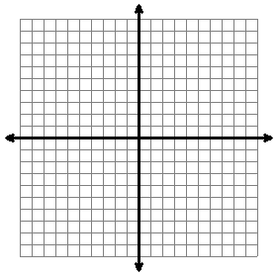

D

A

C

B

A **scatter plot** is a graph that relates two groups of data. This type of data is called **bivariate data.** Let’s look at an example!

Mrs. Bennett wanted to see if the time her fourth grade students spent studying for their 20-word spelling test would affect their grade on the test. The data is shown below.

|  |  |
| --- | --- |
| **Time Spent Studying (minutes)** | **Number of Words Spelled Correctly** |
| 40 | 20 |
| 35 | 18 |
| 32 | 16 |
| 30 | 16 |
| 20 | 15 |
| 15 | 15 |
| 10 | 10 |
| 10 | 8 |

The relationship between the two groups of data, describes the **correlation** of the data. There are three types of correlation the data can have.

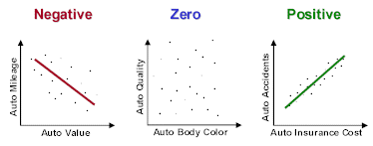

If we can say that a change in one group of data causeschange in the other, the data can be described as **causal**.

Below is a list of Major League Baseball team’s number of wins and average runs given up per game during the 2002 season.

|  |  |  |  |  |  |  |
| --- | --- | --- | --- | --- | --- | --- |
| **Team** | **Wins** | **Runs Given Up** |  | **Team** | **Wins** | **Runs Given Up** |
| Anaheim | 99 | 3.7 |  | Montreal | 83 | 4.0 |
| Arizona | 98 | 3.9 |  | Pittsburgh | 80 | 4.2 |
| Boston | 93 | 3.8 |  | St. Louis | 97 | 3.7 |
| Chicago | 81 | 4.6 |  | Seattle | 82 | 4.1 |
| Cleveland | 74 | 5.0 |  | Tampa Bay | 62 | 5.2 |
| Houston | 84 | 4.0 |  | Texas | 72 | 5.2 |

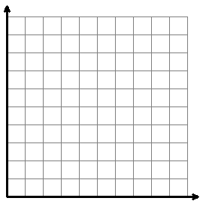

1. Draw a **Best-Fit-Line**.

2. What type of correlation?

____________________________________

3. Conclusion based on the graph?

____________________________________

____________________________________

____________________________________

____________________________________

____________________________________

Practice 1-5 Name ___________________________________

Tell whether each scatter plot has positive, negative, or zero correlation.

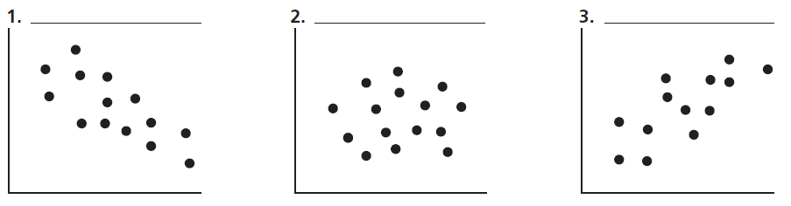

4. The ages and heights of 20 children were measured at an after school program. Create a scatter plot of the following data.

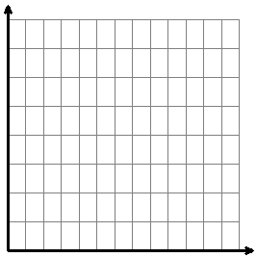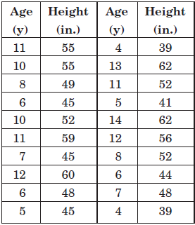

Draw in a trend line. Describe the correlation between age and height. ____________________

Based upon the trend line, how tall would you expect a 9-year-old to be ___________________

What conclusion can you draw about the relationship between age and height of the children?

__________________________________________________________________________________________

__________________________________________________________________________________________