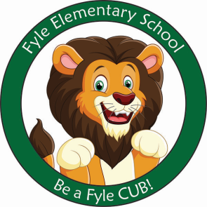

Mrs. Janofsky’s Weekly Update

May 23, 2019

Math

We continue to focus on solving story problems that are mixed with both addition and subtraction. This makes us be a good listener and to focus on being flexible. At home, please continue to practice the addition and subtraction facts and recognizing all numbers to 100.

ELA

This week we have been busy reading both fiction and non-fiction books about the farm. The children have enjoyed learning about real animals and seeing how funny animals are created in fiction books. We have been working to finish our books about the chicks. Unfortunately, we were not able to complete a few of the pages because of not having any chicks. We are almost finished with Fundations for the year. We are focusing on “fixing up” our writing. This means proper letter formations and making sure to have upper and lower case letters and punctuation where it is needed.

Science

What a disappointing week! We had no chicks hatch this year in our room. There were only 7 chicks in the entire building. The Science Department is working to find out why such a low rate. We were able to borrow a couple of the other chicks in order to observe them. It is never easy when this happens!

Thank you to the parents who chaperoned the trip to Springdale Farms.

Important Information

* Specials next week
  + Monday: No School
  + Tuesday: B
  + Wednesday: C
  + Thursday: D
  + Friday: A
* Library on Wednesday next week. Please help your child remember their book! May 30th will be the last time we take out a book for the year.
* ***Next week we will take our MAPS assessment on Tuesday morning. Please be sure your child has a good breakfast and a good night’s sleep.***

Sight Words

By, my

