**Reference Table Review**

**Regents Chemistry**

**Name:**

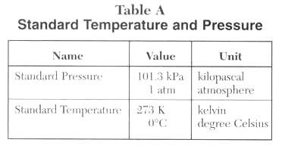

**Table A Questions:**

1. Convert 2 atm in kPa.
2. Convert 303.9 kPa in atm.
3. What is the difference between 1 K and 1oC?
4. What is the 0 K temperature called?
5. Describe the volume and the movement of the particles in a sample of H2 gas at -273oC.
6. What does STP stand for?
7. What are the two units of pressure represented in the table?
8. What are the two units of temperature represented in the table?
9. How many pascals are in 10 kPa?

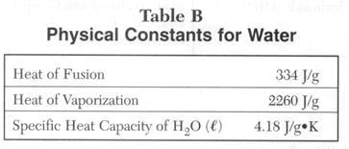

**Table B Questions:**

1. What is the definition of the Heat of Fusion?
2. Based on the definition of the Heat of Fusion make up a problem.
3. Convert the units of the Heat of Fusion into cal/g  and kcal/g (1 cal = 4.18 J)
4. Give a synonym for the word fusion.
5. What is the definition of the Heat of Vaporization?
6. Based on the definition of the Heat of Vaporization make up a problem.
7. Convert the units of the Heat of Vaporization into cal/g  and kcal/g (1 cal = 4.18 J)
8. What is the definition for the Specific Heat Capacity of H2O (l).
9. Based on the definition of the Specific Heat Capacity of H2O (l) make up a problem.
10. Convert the units of the Specific Heat Capacity of H2O (l) into cal/g and kcal/g (1 cal = 4.18 J).
11. Relate the heat of fusion with energy and bonding.
12. Relate the heat of vaporization with energy and bonding.

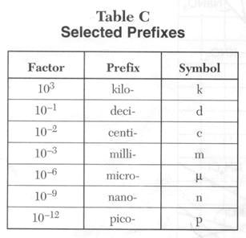

**Table C Questions**

1. What is a prefix?
2. How many grams are in 10 kg?
3. How many meters are in 100 micrometers?
4. Convert 45 pm to cm.
5. Convert 1 kg  to pg.
6. How many decimeters, centimeters, millimeters, micrometers, nanometers, and picometers are in 1 meter?
7. What is the name of this unit system and what is it based on?

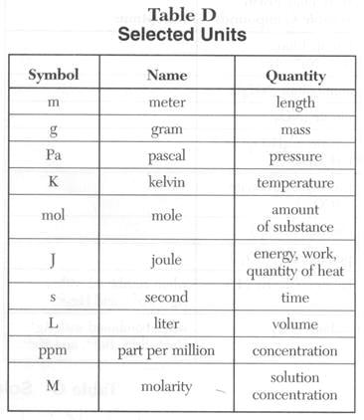

**Table D Questions:**

1. What are units?
2. What units could be used to calculate the density of a solid?
3. What are the units for molarity?
4. What units could be used to measure the velocity of a molecule of gas?
5. What is the numerical value of a mole?
6. A calorimeter is used to measure the amount of heat released in chemical reactions, what units are used?
7. The concentration of pollutants can be measured in ppm. Write the fraction that ppm represents?
8. What are the units quantities used in STP?

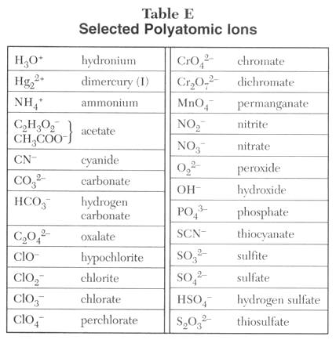

**Table E Questions:**

1. What is a polyatomic ions?
2. What is the charge of carbonate?
3. What is the charge of permanganate?
4. Why does acetate has two different ways of writing it?
5. What does the Roman numeral “I” on dimercury (I) stand for?

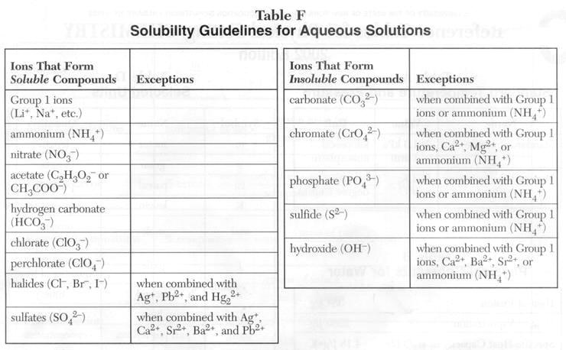

**Table F Questions**

Write the products and balance the reaction for the following double replacement reactions including the phase to describe the solubility of the products.

1. MgSO4 (aq) +  BaCl2 (aq) -->
2. Ca(OH)2 (aq) + H2SO4 (aq) -->
3. Al2(SO4)3 (aq) + ZnCl2 (aq) -->
4. AgNO3 (aq) + MgCl2 (aq) -->
5. AlBr3 (aq) + K2SO4 (aq) -->
6. FeCl3 (aq) + NaOH (aq) -->
7. AgNO3 (aq) + NaCl (aq) -->



**Table G Questions:**

1. What compounds show a decrease in solubility from 0 to 50oC?
2. Which salt is most soluble at 60oC?
3. Which compound is least soluble at 100oC?
4. Which salt is least soluble at 70oC?
5. How many grams of KCl can be dissolved in 500 g of H2O at 30oC?
6. At 50oC, how much KNO3 can be dissolved in 200 g of H2O?
7. Which salt shows the least change in solubility from 50 to 100oC?
8. At 30oC, 90 g of NaNO3 is dissolved in 200 g of H2O. Is the solution saturated or unsaturated?
9. A saturated solution of KClO3 is formed from 50g of water. If the solution is cooled from 90oC to 70oC, how many grams of precipitate are formed?

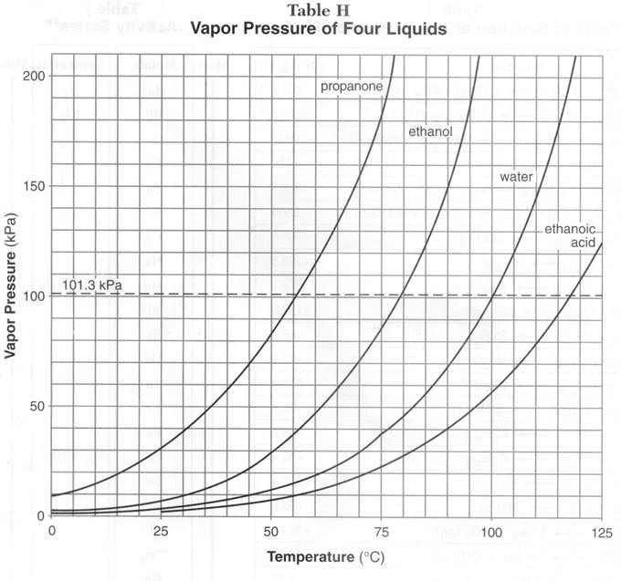

**Table H Questions:**

1. Define the term vapor pressure.
2. What is the vapor pressure in kPa and atm of water at 100oC?
3. What is the vapor pressure in kPa and atm of ethanoic acid at 120oC?
4. What is the vapor pressure in kPa and atm of propane at 75oC?
5. Compare the vapor pressure of the four liquids at 70oC.
6. Liquids boil when the vapor pressure is equal to the pressure on the system. For instance, water boils at 100oC at 1atm but when the pressure is 2 atm water boils at 118oC. Consider the four liquids boiling at 70oC, what is the pressure on the system for each liquid?

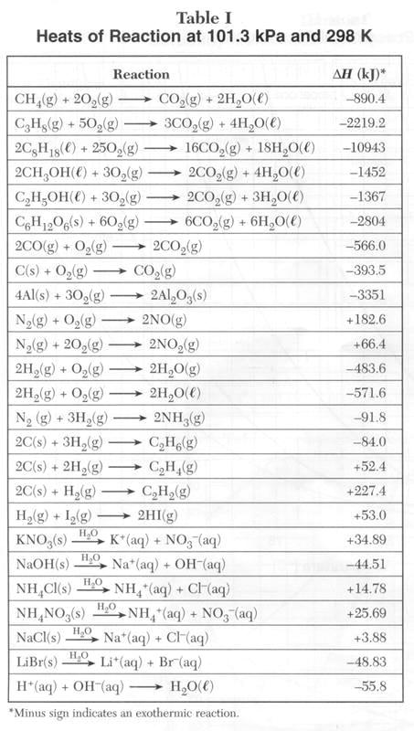

**Table I Questions:**

1. Draw a potential energy diagram for each reaction.
2. What is the formula for Heat of reaction (ΔH)?
3. What is the sign of ΔH when the Heat of reactants is more than the Heat of the products?
4. What is a exothermic reaction?
5. What is the sign of ΔH when the Heat of reactants is less than the Heat of the products?
6. What is an endothermic reaction?
7. What is the pressure and temperature at which ΔH was calculated for the reactions in the table?

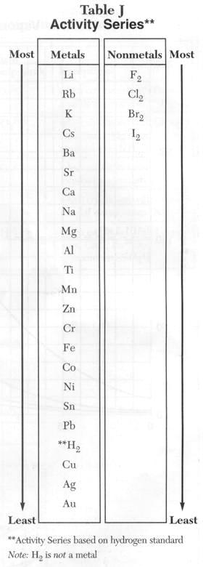

**Table J Questions:**

1. Is a more active metal easier to oxidize or reduce?
2. Is a more active nonmetal easier to oxidize or reduce?
3. A solution of CrCl2 will react with which of the following metals?

Ag Al Cu Mg Ni Zn

1. Write the oxidation and reduction half-reactions (if they occur) for
   1. A copper penny placed in a silver nitrate solution.
   2. A zinc bar is placed in a solution of NiCl2
   3. An aluminum nail is placed in a solution of MgCl2
2. Draw a voltaic cell with a copper electrode and a nickel electrode. Include ions in solution. Label the anode and the cathode. Don’t forget the salt bridge! Show the direction of current flow. Write equations for the oxidation and reduction half-reactions.
3. Which one of the following pairs represents a spontaneous reaction?

a. Ni, Zn2+ b. Ag+, Cu c. Al, Mg2+

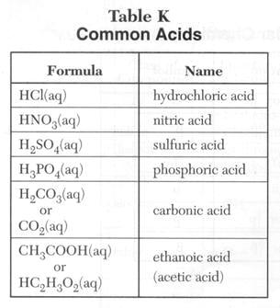

**Table K Questions:**

1. What are Arrhenius acids?
2. Write the dissociation reaction for each acid in the table. Example: HCl(aq) -->  H+(aq) +  Cl- (aq)
3. Are acids electrolytes? Why?
4. What is the alternate theory for acids?
5. Given this reaction: H2SO4(aq) + H2O(l) <--> HSO4-(aq) + H3O+(aq) find the acids in the forward and reverse reaction.
6. What are the possible pH for acidic solutions?

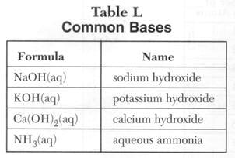

**Table L Questions:**

1. What are Arrhenius bases?
2. Write the dissociation reaction for each base in the table. Example: NaOH(aq) --> Na+(aq) + OH-(aq)
3. Are bases electrolytes? Why?
4. What is the alternate theory for bases?
5. Given this reaction: CH3COO-(aq) + H2O(l) <--> CH3COOH(aq) + OH-(aq) find the bases in the forward and reverse reaction.
6. What are the possible pH for acidic solutions?
7. In the process of neutralization, an Arrhenius acid and an Arrhenius base react to form a salt and water. Write 5 neutralization reactions.

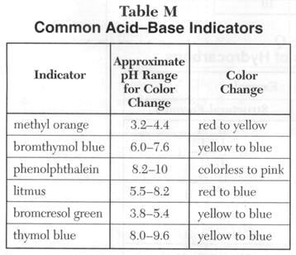

**Table M Questions:**

Describe the color of the indicators in the solutions given below.

|  |  |  |  |  |  |  |  |
| --- | --- | --- | --- | --- | --- | --- | --- |
| pH | Solutions | methyl orange | bromthymol blue | phenolphthalein | litmus | bromcresol green | thymol blue |
| 1 | gastric juices |  |  |  |  |  |  |
| 2 | lemons, vinegar |  |  |  |  |  |  |
| 3 | apples, oranges, carbonated soft drinks |  |  |  |  |  |  |
| 4 | tomatoes |  |  |  |  |  |  |
| 5 | potatoes |  |  |  |  |  |  |
| 6 | milk |  |  |  |  |  |  |
| 7 | pure water, blood, saliva |  |  |  |  |  |  |
| 8 | baking soda, eggs |  |  |  |  |  |  |
| 10 | milk of magnesia |  |  |  |  |  |  |
| 11 | ammonia |  |  |  |  |  |  |
| 12 | soda ash (sodium carbonate) |  |  |  |  |  |  |
| 14 | caustic soda (lye, sodium hydroxide) |  |  |  |  |  |  |

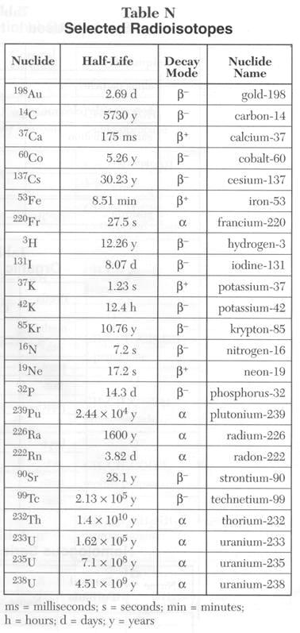

**Table N Questions:**

1. What is the half-life of neon-19?
2. What is the decay mode of plutonium-239?
3. Which radioisotope decays the fastest?
4. Which radioisotope decays the slowest?
5. How many decay modes are included in the table?
6. Write the nuclear reaction of each radioisotope.
7. List all the radioisotopes that undergo beta decay and compare their atomic mass with the relative atomic mass of the respective element. What do you notice and can you find an explanation for the trend?
8. List all the radioisotopes that undergo positron decay and compare their atomic mass with the relative atomic mass of the respective element. What do you notice and can you find an explanation for the trend?
9. Alpha decay occurs mainly in isotopes with atomic numbers larger than 60. List all the radioisotopes undergoing alpha decay and verify the statement.

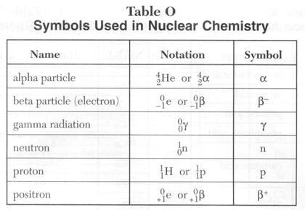

**Table O Questions:**

1. What is the charge and mass of an alpha particle?
2. What is the difference between a beta particle and a positron?
3. What is the result of adding a positron and a beta particle together?
4. Why is a proton the same as hydrogen-1?
5. What is the charge and mass of gamma radiation?
6. What is another term for an electron?
7. Which particle has the most matter?
8. What is the symbol for beta particles?
9. Which particles will be deflected towards the positive electrode in an electrical field?
10. Which particles will be deflected towards the negative electrode in an electrical field?
11. Which particles will not be deflected in an electrical field?

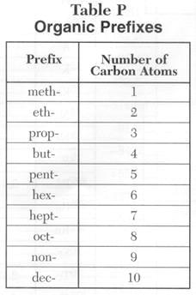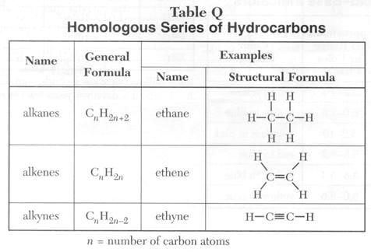

**Table P and Q Question:**

Write the name, molecular formula, and draw the structural formula for five alkanes, alkenes, and alkynes using the table P.

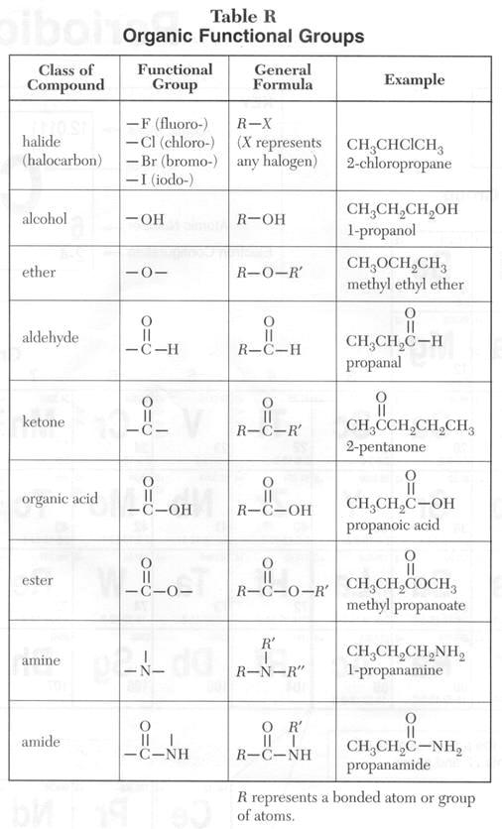

**Table R Question:**

Make up 2 more examples for each class of compounds. Write their names, and draw their structural formulas.

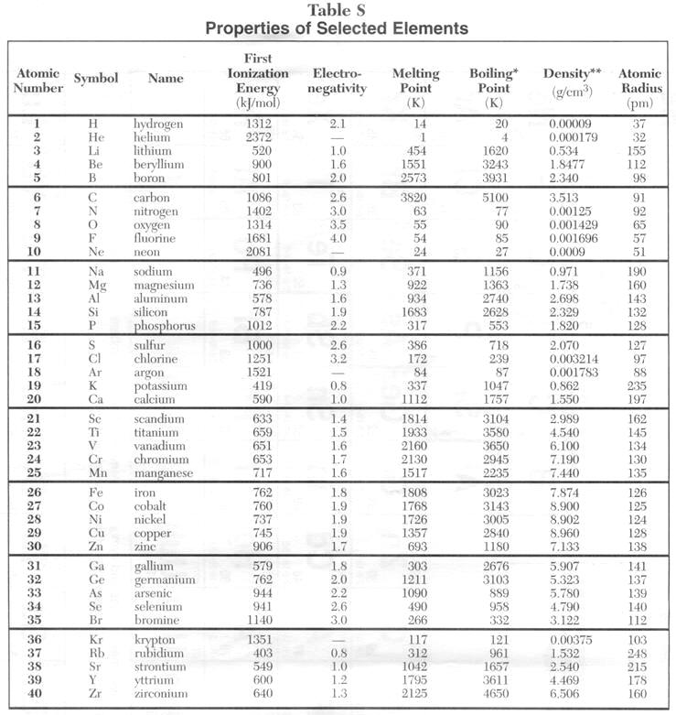

**USE YOUR OWN TABLES: THESE ARE TOO SMALL TO READ!**

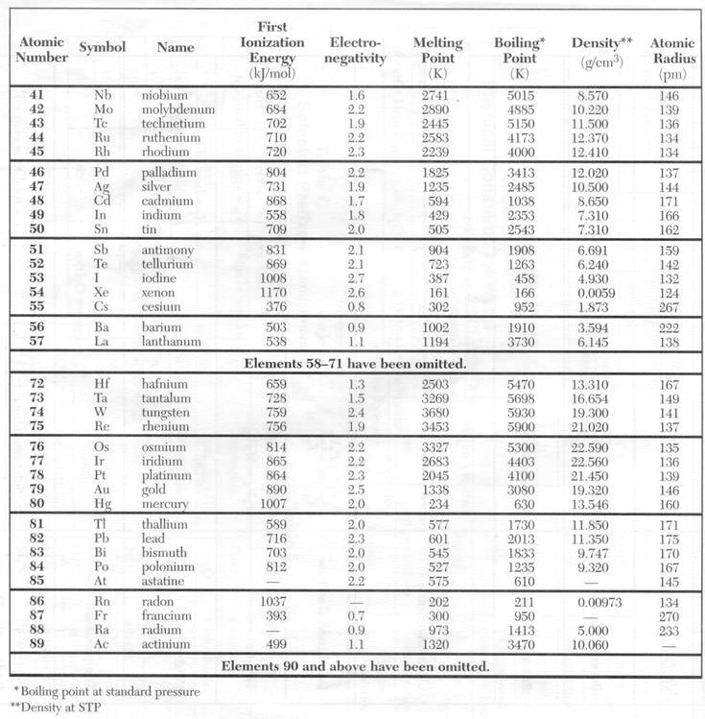

**Table S Questions:**

1. Draw an empty periodic table (omit groups 3-12) and include Symbols, Atomic Number, and Electronegativity value for each element.
   1. Draw a bar graph representing the trend of electronegativity in group 1 and 2. Organize symbols of elements on the X axis and the numerical values on the Y axis.
   2. Draw a line graph representing the trend of electronegativity in period 3 and 4. Organize symbols of elements on the X axis and the numerical values on the Y axis.
   3. In complete sentences, describe the Electronegativity’s general trend in groups and periods.
   4. State the reasons for your observations?
2. Draw an empty periodic table (omit groups 3-12) and include Symbols, Atomic Number, and Ionization Energy value for each element.
   1. Draw a bar graph representing the trend of Ionization Energy in groups 1 and 2. Organize symbols of elements on the X axis and the numerical values on the Y axis.
   2. Draw a line graph representing the trend of Ionization Energy in period 3 and 4. Organize symbols of elements on the X axis and the numerical values on the Y axis.
   3. In complete sentences, describe the Ionization Energy ’s general trend in groups and periods.
   4. State the reasons for your observations?
3. Draw an empty periodic table (omit groups 3-12) and include Symbols, Atomic Number, and Atomic Radius value for each element.
   1. Draw a bar graph representing the trend of Atomic Radius in group 1 and 2. Organize symbols of elements on the X axis and the Atomic Radius on the Y axis.
   2. Draw a line graph representing the trend of Atomic Radius in period 3 and 4. Organize symbols of elements on the X axis and the Atomic Radius on the Y axis.
   3. In complete sentences, describe the Atomic Radius ’s general trend in groups and periods.
   4. State the reasons for your observations?

# Using answers from problems #1 & 2 find any correlation between Electronegativity and Ionization Energy.

1. Using answers from problem #3 find any correlation between Atomic Radius and Atomic Number.
2. Make a bar graph for the boiling points values of the Noble Gases.
   1. Find the correlation between the trend for Atomic Radius and the Atomic Number for the Noble Gases.
   2. Explain your findings.
3. At what pressure the Boiling Points have been calculated?
4. At what temperature and pressure the Densities have been calculated?
5. What is the density of 2 moles of water?
6. Using the density of helium, what is the mass of 2 moles of helium?
7. Would the density of neon be higher or lower if its density were calculated at 2 atm.
8. What is the general correlation between Melting Points and Boiling Points?

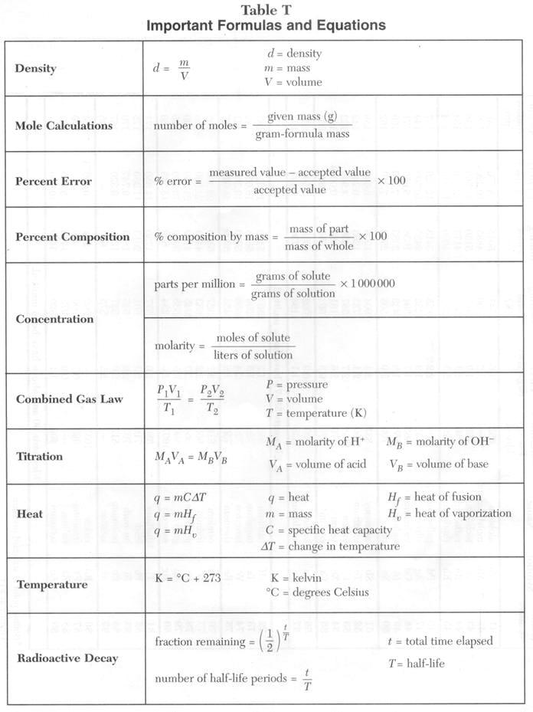

**Table T Questions:**

# Density

1. Calculate m in terms of d and v.
2. Calculate v in terms of m and d.
3. What is the d of an object with a mass of 102.0 g and a volume of 10 cm3?
4. What happened to the d of an object whose v decreases?
5. A nail (m = 2 g and V = 0.5 cm3) is cut in 2 pieces. Explain why the d of each half remains the same as the original nail.
6. An object has a mass of 23 g and a density of 10 g/cm3 what is its volume?
7. What is the density of aluminum?

**Mole Calculations**

1. What is the number of mole in a sample of 45g of H2O?
2. What is the number of mole in a sample of 6g of NH3?
3. What is the mass of 2 moles of H2O2?
4. What is the mass of 4 moles of C2H2?

**Percent Error**

1. Can the Percent Error be less than 0?
2. What is the difference between the measured value and the accepted value if the Percent Error is 100?
3. A Student calculates the density of iron at STP to be 8.956 g/cm3. What is the Percent Error?
4. Why do we have to calculate the Percent Error in scientific experiments?
5. In an experiment a student calculates the atomic radius for iridium. The % error of the calculation is 23 %. What is the experimental value?

**Percent Composition**

1. What is the percent composition by mass of H in H2O2?
2. What is the percent composition by mass of all the elements in (NH4)3PO4?
3. What is the percent, by mass, of water in MgSO4.2H2O?
4. How many grams of O can be produced from the decomposition of 50g of H2O?
5. How much phosphorus can be recovered from 25g of (NH4)3PO4?
6. How much potassium can be produced from 125g of KMnO4?

**Concentration**

1. Describe the laboratory procedure to make a 2 M NaCl(aq) solution.
2. What is the molarity of a solution of KOH if 1000 ml of the solution contains 11.2 grams of KOH?
3. How many moles of KOH are contained in 250 mL of 2.0 M solution of KaOH?
4. A 40.0 milliliter sample of 0.50 M HCl is diluted with water to a volume of 100. milliliters. What is the new concentration of the solution?
5. What is the concentration in parts per millions if a 500 g solution of copper (II) sulfate contains 5 mg of copper (II) sulfate?

**Combined Gas Law**

1. Given the formula for the combine gas law, express every single term in term of the other terms.
2. What will be the new formula if temperature is constant?
   1. What is the name of this formula?
   2. Draw a line graph representing the relationship.
   3. Explain in a sentence the result of the line graph.
   4. Find an example to illustrate your findings.
3. What will be the formula if pressure is constant?
   1. What is the name of this formula?
   2. Draw a line graph representing the relationship.
   3. Explain in a sentence the result of the line graph.
   4. Find an example to illustrate your findings.
4. What temperature scale has to be used for temperature?
5. Do any specific scales have to be used for pressure and volume?
6. At STP, a sample of hydrogen gas has a volume of 10 L. If the temperature is double and the pressure is double, what is the new volume of the gas sample?
7. At STP, a sample of helium gas has a volume of 5 L. If the temperature is quadruple and the pressure is triple, what is the new volume of the gas sample?

**Titration**

1. What is a titration?
2. How many milliliters of 0.50 M NaOH are required to exactly neutralize 20.0 milliliters of 0.20 M HCl?
3. If 100. milliliters of a 3.0 M solution of HCl is exactly neutralized by 80. milliliters of NaOH, what is the molarity of the NaOH solution?
4. What is the molarity of an HNO3 solution if 10.0 milliliters of 0.40 M LiOH is required to exactly neutralize 200 milliliters of the HNO3 solution?
5. How many milliliters of 1.0 M HCl are needed to exactly neutralize 50. milliliters of 0.5 M KOH?
6. Describe the laboratory procedure of titration.

**Heat**

1. What is the definition of specific heat capacity?
2. How is the heat of fusion defined?
3. What is the definition of heat of vaporization?
4. Write the formula for change in temperature.
5. What is the specific heat capacity of water?
6. The temperature of 10 g of water has increased by 10 K, how much heat was absorbed?
7. After an experiment using 2 g of water, 20 J was released in the surrounding and the final temperature is 257 K, what was the original temperature of the water?
8. What is the value for the heat of fusion for water in J/g?
9. What is the value for the heat of vaporization in J/g?
10. How many Joules are required to melt 1000 g of water?
11. How many Joules are needed to vaporize 10 g of water?

**Temperature**

1. Convert the followings: 0oC to K, 373 K to oC, 35oC to K
2. What is the difference in degree Celsius and in Kelvin between the freezing and the boiling point of water?
3. How is temperature defined?
4. Is 1 K equal to 1oC? Why?

**Radioactive Decay**

1. What is the concept of half-life?
2. What is the concept of Radioactive Decay?
3. What is the value of (1/2)0 ?
4. What is the value of (1/2)1 ?
5. When is t/T = 0?
6. When is t/T = 1?
7. After how many half-life periods an original sample of a radioisotope will decreased by ¼?
8. What is the fraction remaining after 5 half-lives have elapsed?
9. What is the half-life of nitrogen-16?
10. A sample of uranium-238 is stored in a safe place, what is the amount remaining after 1.35 x 1010 years and what kind of decay particle are given throughout the years?
11. A sample of an unknown radioisotope has taken 2 weeks and 2/5 of a day to have 1/64 of the original sample remaining. What is this radioisotope?
12. If the initial mass of a sample of cesium-137 is 1.00 g, how much will remain after 151 years?
13. Consider a sample of fossilized wood that originally contained 24 g of carbon-14. It now contains 1.5 g of carbon-14. How old is the sample?
14. A 64 g sample of germanium-66 is left undisturbed for 12.5 hours. At the end of that period, only 2.0 g remain. What is the half-life of this material?
15. If a pellet of cobalt-60 that has been in storage for 26.5 years contains 14.5 g of cobalt-60, how much of this radioisotope was present when the pellet was put into storage?
16. How long will it take for 1.00 gram of strontium-90 to decay to 125 mg?
17. A patient receives iodine-131 as a medical treatment on Sunday October 18 at 8:00:00 am.   
    On what day, date, hour, minute, and second will only 1/8 of the original sample still be radioactive?

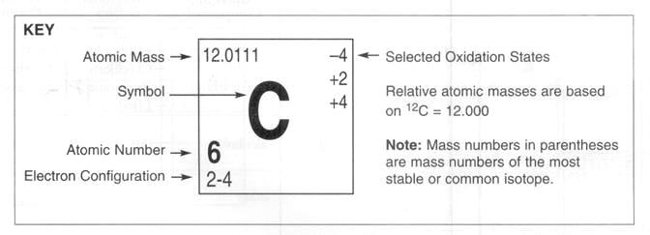

**Periodic Table Questions:**

1. Which elements are in the liquid phase at room temperature?
2. Which elements are in the gas phase at room temperature?
3. What are the 2 main divisions of the periodic table?
4. What are the 7 metalloids?
5. What is the number of e-, p, and n in a neutral atom of nitrogen?
6. What is the Atomic Mass of xenon?
7. What is the Atomic Number of barium?
8. What is the electron configuration of iodine?
9. What are the relative atomic masses based on?
10. What are the Selected Oxidation States of chlorine?
11. What is the Symbol of krypton?
12. Name the 6 Noble Gases?
13. What are the characteristics of metals?
14. What are the characteristics of nonmetals?
15. What are the characteristics of metalloids?
16. Is hydrogen considered a metal?
17. What is the difference between helium and the other Noble Gases?
18. How many groups are in the Periodic Table of Elements?
19. How many periods are in the Periodic Table of Elements?
20. What does the period number indicate in the electron configuration of an atom?
21. What does the group number indicate in the electron configuration of an atom?
22. What is the name of groups 3-12?
23. What is the name of group 1?
24. What is the name of group 2?
25. What is the name of group 17?
26. What is the name of group 18?
27. What does the Selected Oxidation States numbers represent?
28. How many valence electrons are in an atom of cesium?
29. What is the outermost principal quantum number for an atom of arsenic?
30. What element has an electron configuration of 2-8-10-2?