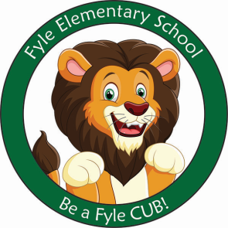

Mrs. Janofsky’s Weekly Update

March 8, 2019

ELA

Fiction/non-fiction is our new focus. We are working to understand the differences in these two types of books. We are looking at the elements of each book and using them to help us identify the type of book. In Fundations, we are working to learn a rule of when to use a c or k at the beginning of a word. The children have learned a song to help them remember the rule. Ask your child to sing it for you. The rule, in case you are wondering, is c goes with the vowels a, o, u and k goes with i and e. In writing, we continue to work to edit our own work. The children are doing well with this skill. This week, we worked to answer a writing prompt where the children had to use evidence from a text.

Math

This week we began to transition from using a picture to create a number bond to solving a story problem using a number bond. We are also beginning to write a number sentence in at least two ways. 6=2+4 and 2+4=6. We will work to be sure to use the signs properly. This can be a challenge initially but I know the children are up to the challenge and will work hard. As always!

Science

Our new unit of study is on Properties of Solids and Liquids. This week we began to look at properties of solids. We are working to compare the solids and group them according to a property.

Important Information

* Specials next week
  + Monday: B
  + Tuesday: C
  + Wednesday: D
  + Thursday: A
  + Friday: B
* Wednesday, March 13-Suessical Assembly
* Library on Wednesday. Please help your child remember their book!
* March Recess: No School March 22nd.
* Reading bags come home every Tuesday, Wednesday, AND Thursday. Please be sure to return them completed the next day.

Sight Words

This as has

Math Flashcards

This week, your child brought home addition and subtraction flashcards. These cards do not need to come back and forth to school. The one minute goal is by the end of the school year.