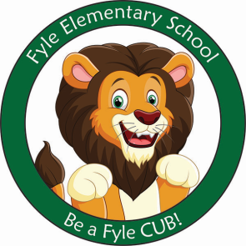

Mrs. Janofsky’s Weekly Update

March 15, 2019

ELA

This week we began our new unit on Traditional Tales. Stories in this genre are well known and loved by kids. We began the week by reading non-fiction books about pigs. We then read different versions of The Three Little Pigs. During this unit, we will focus on understanding the difference between fiction and non-fiction, characters, setting, problem, outcomes, and retelling. We will be doing many sequencing activities. Use these sheets to have your child retell you the story. Ask them questions about the problem and outcome (how the problem was solved).

Math

Story problems continue to be our focus. We are working with two different types of addition problems: determining the whole and solving to find both unknown addends. A review packet was sent home on Thursday that can be used. Next week, we will switch our focus to subtraction. Please continue to work with the flashcards that were sent home.

Science

We continue to work with the solids. We have been exploring them to determine different ways to sort them. We looked mainly at the property of color and shape. Next we will look to see what rolls and what stacks.

Important Information

* Specials next week
  + Monday: C
  + Tuesday: D
  + Wednesday: A
  + Thursday: B
* No School next Friday, March 22.
* Library on Wednesday. Please help your child remember their book!
* Reading bags come home every Tuesday, Wednesday, AND Thursday. Please be sure to return them completed the next day.

Sight Words

Was

\*bags were updated and put in folders this week. Thank you for practicing!

New Friend

On Monday, we will welcome a new friend to our classroom, Hayden. We have discussed how to best welcome him and look forward to him joining us.