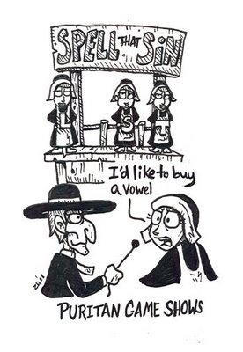

Quiz 3

**Chapter 11: The Interior of a Heart**

1. In the context of the following line, what might the grass and the grave represent – “And, all this time, perchance, when poor Mr. Dimmesdale was thinking of his grave, he questioned with himself whether the grass would ever grow on it, because an accursed thing must be buried” (76)?

**Chapter 12: The Minister’s Vigil**

1. In the first paragraph on page 79 –

a). Answer the rhetorical questions

b). Analyze Hawthorne’s use of light and dark imagery

1. Analyze and interpret the following line – “And thus, while standing on the scaffold, in this vain show of expiation, Mr. Dimmesdale was overcome with a great horror of mind, as if the universe were gazing at a scarlet token on his naked breast, right over his heart (79).
2. Why is it significant that Hester, Pearl, and Dimmesdale stand on the platform together?
3. On page 83, a comet is described. Analyze the significance of this comet (what does it mean?) as well as the light and dark imagery.
4. Explain the irony in the following line – “But by your reverence hear of the portent that was seen last night? A great red letter in the sky, -- the letter A, -- which we interpret to stand for Angel. For as good Governor Winthrop was made an angel this past night, it was doubtless held fit that there should be some notice thereof!” (85).