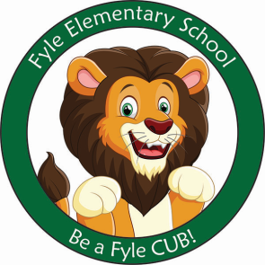

Mrs. Janofsky’s Weekly Update

October 12, 2018

ELA

Nursery rhymes will be our genre study for the month of October and into November. As we learn the rhymes, we will practice sequencing events, retelling, and rhyming. This week we learned “Jack Be Nimble.” The children enjoyed acting out the nursery rhyme. We then drew pictures of ourselves pretending to be Jack. In Fundations, we continued to work with c and o. We then reviewed all the letters we have worked with so far. In writing, we continue to work on adding details to our pictures. We are learning that pictures tell a story. We are also beginning to label our pictures with at least beginning sounds of words.

Math

This week we have continued to practice writing numbers to 9. The children are doing a great job. We have also begun to reflect on our own work looking for reversals of numbers. Next week we will finish working with numbers to 10.

Science/SS

This week nursing students from Nazareth College came in to teach us about the importance of handwashing. There are a lot of germs right now! Be sure to reinforce handwashing at home.

Sight Word

Be

Important Information

* Next week’s letter schedule:
  + Monday: D
  + Tuesday: A
  + Wednesday: B
  + Thursday: C
  + Friday: D
* Library on Wednesday. Please help your child remember their book!
* As a school, we do not celebrate Halloween with costumes. The children are already eagerly talking about this event. However, please do not plan to send in costumes. The Parent Group sponsors a Boo Bash where the children may wear and show their costumes to friends. We will have other special activities to celebrate fall.

Ways to Support at Home

* Go to the Public Library and chose a book to read together.
* Have your child get their own library card.
* Go for a walk and bring a leaf home with you. Create a picture with it or paint it!
* Write letters and numbers on your child’s back with your finger and have them guess what you wrote. Switch places and have them do it to you.