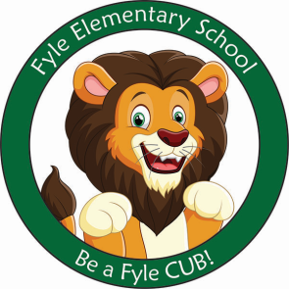

Mrs. Janofsky’s Weekly Update

October 19, 2018

ELA

This week we learned the nursery rhyme “Jack and Jill.” I hope your child has told you this rhyme. We wrote a connection to the rhyme writing about a time we got hurt. The children continue to impress me with their ability to draw a picture to share an idea. Many of the children are labeling their pictures now too!!! Our letters in Fundations this week were a and g. The children are expected to identify both the a and g we print along with “fancy a and g.” We discussed fonts and how letters can look different.

Math

We are now writing all numbers to 10. Reversals continue to be something we will work on correcting. This week we worked to understand the concept of one more. We also worked to understand combinations within five.

Science/SS

Our current SS unit is called Myself and Others. We have been discussing how we are the same but yet different ie., we all have hair but have different color hair.

Important Information

* Next week’s letter schedule:
  + Monday: A
  + Tuesday: B
  + Wednesday: C
  + Thursday: D
  + Friday: A
* Library on Wednesday. Please help your child remember their book!
* As a school, we do not celebrate Halloween with costumes. The children are already eagerly talking about this event. However, please do not plan to send in costumes. The Parent Group sponsors a Boo Bash where the children may wear and show their costumes to friends. We will have other special activities to celebrate fall.
* Book Orders due November 2
* October 26th Boo Bash

Sight Word

Like, In, It, Up

Ways to Support at Home

* Go to the Public Library and chose a book to read together.
* Have your child get their own library card.
* Go for a walk and bring a leaf home with you. Create a picture with it or paint it!
* Write letters and numbers on your child’s back with your finger and have them guess what you wrote. Switch places and have them do it to you.