**Spanish III**

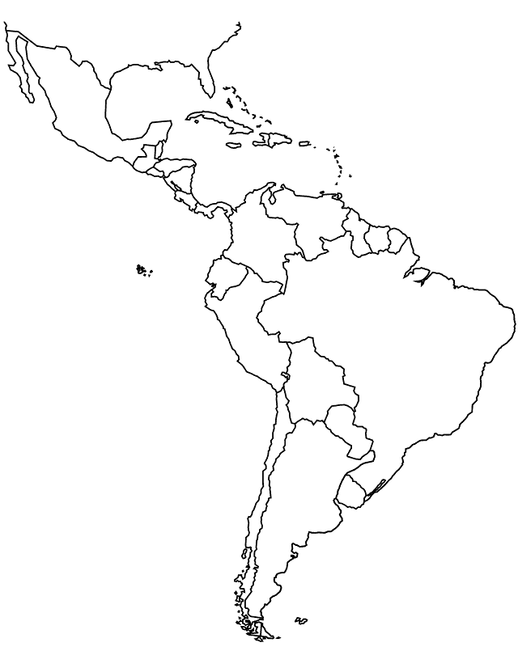

**Classroom: E-203**

**Course Syllabus 2019-2020**

**Señora Marrot**

**Email:** [**fmarrot@rhnet.org**](mailto:fmarrot@rhnet.org)

**Course Description:**

Spanish III is an intermediate course in which students will continue to build upon and strengthen the language skills they acquired in Spanish II. Through the use of speaking, listening, reading and writing activities, students will broaden their vocabulary, grammar and cultural knowledge. Class is conducted primarily in Spanish. Therefore, students should be prepared and willing to hear and speak Spanish in class.

**Course Goals:**

* Students will build on previous experience with the language to increase proficiency in all four areas of language acquisition: speaking, listening, reading and writing.
* Students will expand their knowledge and understanding of the cultures of the Spanish-speaking world.

**Course Curriculum:**

The course includes a review unit and 8 additional units of study:

* Repaso: Personal ID Review
* School: En la escuela
* Leisure: El tiempo libre
* House and Home: Los quehaceres de la casa
* Daily Routine: Mi rutina diaria
* Childhood: Recuerdos del pasado
* Traveling: Cómo ser un buen turista
* Health and Welfare: En las noticias
* Earning a living: Cómo será el futuro
* Current Events: La televisión y el cine

**Required Materials:**

* Three-ring binder
* Loose-leaf paper
* Pens and pencils
* Highlighter

**Classroom Expectations:**

* Students are expected to be Polite, Punctual, Prepared, and ready to Participate.
* Ideally, students are expected to use the bathroom prior to the beginning of class.
* Phones and personal electronics must be OFF and stored OUT of SIGHT prior to class.

**Homework Policy:**

* To be considered on time, homework must be completed by the beginning of class on the due date. All homework will be graded. Partial credit will be given for late work.

**Extra Help:**

Please see me if you need extra help. I am available to help students during study block and after school, when arranged in advance.

**Evaluation/Grading:**

* A variety of assessments will be used including homework, classwork, writing assignments, speaking tasks, quizzes, chapter tests, and individual and team projects/presentations. There will be a Mid-Term Exam in January and a Comprehensive Final Exam in June. To earn a NYS Regents Diploma with Distinction, a student must pass both the course and the Final Exam. An “Incomplete” issued for any Academic Quarter, if not remedied, will convert the course grade in June to an “F,” or Fail.
* “Required Assessments” represent 80% of a student’s grade. These include tests, quizzes, and designated presentations and projects. As a step toward implementing a standards-based grading system, students must complete Required Assessments to demonstrate their level of achievement toward state and district learning standards and to earn course credit.
* “Graded Practice Assignments” represent 20% of a student’s grade. These include graded homework, graded speaking tasks, practice assignments, class activities, and designated presentations and projects.

**Absences:**

* Consistent attendance is essential to learning a foreign language. Absences will adversely affect your progress in this class. Therefore, absences should be avoided whenever possible.
* If you are absent, it is your responsibility to obtain any missed work when you come back. The assignment will need to be completed by the beginning of the following class. However, if you were absent for more than one day, you will have that amount of time to make up the work (Ex: If you missed 2 classes, you will have 2 classes to hand in the missed work).
* If you are absent on the day an assignment is due, it is your responsibility to hand it in on the day you return. Meet immediately with the teacher to address any INCOMPLETE Required Assessments that may have been generated during the absence.
* For extended illness or absence, call your Assistant Principal’s office to arrange for your work to be available for afternoon pick-up in the main office (359-5200).

**Other Information:**

* Spanish Club meets once a month in Room E-203. It is an excellent opportunity to learn about and experience Latin-American culture. All students are welcome to attend!
* There is an opportunity for students to travel abroad. In 2020 students will travel to Perú, and in the summer of 2021 students will travel to Spain, France and Italy. If you/student would like to travel abroad with either trip, please contact Ms. Marrot
* Online translation to prepare assignments is strictly forbidden, with the exception of looking up an isolated word or two. An automatic zero will be entered for any assignment prepared with evidence of online translation.

**Señora Marrot**

**2019-2020 PARENT REVIEW**

**~ SPANISH CLASS SYLLABUS ~**

**Parents –** please review your child’s syllabus for Spanish Class this year. Discuss with them any questions you have and ways in which you may support their studies at home. Below are a few items to keep in mind. Your support is appreciated!

If you have any questions/comments, please make a note of them below or e-mail me. I look

forward to working with your child this year! E-mail: tkingsbury@rhnet.org



**I have read and reviewed the Spanish syllabus with my child. Any questions / comments are noted**

**above. I am aware of these provisions:**

1. My student must complete all “Required Assessments” to earn credit for the course.

2. Help is available to students during homeroom and after school, when arranged in advance.

3. Students receive homework on a regular basis. Regular review and practice is important for language

learning.

4. Support at home can include reviewing vocabulary, watching movies in Spanish, and providing structured time and space for homework, studying, and projects.

5. The RHCSD Parent Portal (access student grades) and Teacher Web-pages (access teaching materials)

are a good source of information on materials and my student’s performance.

6. I may e-mail or telephone Señora Marrot with any questions, comments, feedback or ideas, recognizing that home-school communication is important for my child’s success!

Student Name (print name) _____________________________________________________________

Parent/Guardian signature: ______________________________________________________________

Parent/Guardian – print name: ___________________________________________________________

E-mail address:____________________________________________ Phone #____________________