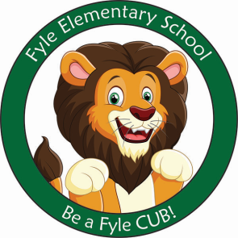

Mrs. Janofsky’s Weekly Update

November 16, 2018

ELA

Creating nursery rhyme videos was a lot of fun! Be sure to check out our class website to watch the videos! In Fundations, we worked on the letters and sounds of l, h, and K. We are working to apply the letter sounds to our writing and reading. Be sure to check out some of our GREAT writing on the board when you visit next week. In computers, we are learning to click and delete along with click and drag. Both skills are challenging but the children are enjoying learning new things about the Chromebooks.

Math

Our second math unit is a short unit on shapes. The unit reviews the names of the shapes. The children are working to explain how they know what a shape is eg., It is a triangle because it has three corners and three straight sides. Our focus this week was on 3D shapes (sphere, cylinder, cube, and cones).

Social Studies

The holiday of Thanksgiving was our focus. We enjoyed reading both fiction and non-fiction books about how this holiday came to be.

Important Information

* Schedule for the week after break:
  + Monday: D
  + Tuesday: A
  + Wednesday: B
  + Thursday: C
  + Friday: D
* Library on Wednesday. Please help your child remember their book!
* Important Reminder! The children will be going outside for recess on days it doesn’t rain. Please be sure your child has hats and mittens as the weather changes.
* Please work with your child over break on putting their boots on and off by themselves. Also, continue practicing zipping, putting on mittens, and hats.
* Writing Journals: In today’s folder, you will find a writing journal for over break. This is NOT mandatory but is a great way to keep in practice on days with no school.

Sight Word

is on

Sight Word Bags

Ziploc bags have been updated. Please practice over break! It is important that the children continue to see the importance of these words. Have fun looking for them in a places you may be!