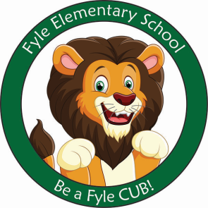

Mrs. Janofsky’s Weekly Update

November 30, 2018

ELA

Putting it all together is a focus for us in both reading and writing. We have been busy learning the letters, letter sounds, and letter formations. Now we work hard to apply it to both reading and writing! This week we switched our writing paper to include the Fundation lines. We are working to remember to put an upper case at the beginning of a sentence and then to use the lower case letters. This will take lots of practice! Already I see improvement! Fundation letters this week were v and w. Only four more to go!

Math

We have finished our second Math Module. It was a short unit on attributes of shapes. Next week we will begin a unit on Measurement. This is always fun! At home, please continue practicing counting to 100, finding shapes and numbers around you, and sorting objects you find at home! Math should be fun!!!!!

Social Studies

Thank you for sending in the timelines! It is always fun to look at how we have grown and changed. Pictures will be returned next week!

Important Information

* Specials next week:
  + Monday: A
  + Tuesday: B
  + Wednesday: C
  + Thursday: D
  + Friday: A
* Library on Wednesday. Please help your child remember their book!
* Please return report card envelopes.
* Sight words: Reminder we are working to both read and write the words.
* Thank you for helping the children with boots and coats. They are doing an AMAZING job!
* New this week! We completed our first community goal setting challenge with collecting 20 CUB cards. This was a short week so next week we will reach for a higher goal! The children establish the goal and the activity we will have if they reach their goal! The stuffed animals enjoyed reading and writing with us today!

Sight Word

love am

Reading Bags

Thank you for returning the reading bags on Wednesday! It is always exciting to get to this point in the year. A reminder….we are new to reading! Be sure to talk about the title and pictures before reading. It is important that the children point to each word as they read also. If your child becomes frustrated, feel free to read the book to your child and then have them read it.