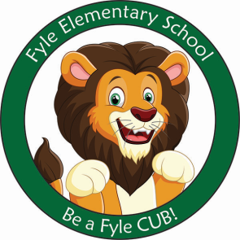

Mrs. Janofsky’s Weekly Update

December 21, 2018

ELA

This week we have continued to enjoy many versions of The Gingerbread Man. It is amazing how many versions there are. We have also enjoyed writing about the stories. The children were even inspired to ask me if they could write about gingerbread animals! I was so excited to hear them excited about our learning! What fun we had! The mini-unit ended with using our five senses to enjoy a gingerbread man cookie! This was a lot of fun! In Fundations, we began to tap words and are working hard to blend sounds to make a real or nonsense word. I am VERY impressed by how quickly they are learning this.

Math

This week we have been learning how to compare the capacity of objects. We have been comparing containers to see which holds more or less. This has been a lot of fun and you can easily practice at home! Give your child different size cups while in the bathtub or have them use dried noodles or rice to fill cups. Allow them to poor the water, rice, or noodles between the cups. Discuss which hold more or less.

Social Studies

Holiday traditions around the world has been our focus again this week. We have learned about Hanukah, Dawali, Ramadan, St Lucia, and Christmas. We have found many similarities between these holidays.

Important Information

* Specials after break:
  + Monday: No School
  + Tuesday: No School
  + Wednesday: D
  + Thursday: A
  + Friday: B
* Library on Wednesday. Please help your child remember their book! This is the FIRST day back!
* Fyle Shirts should be worn on Friday, January 4, 2019.
* No School December 22, 2018-January 1, 2019. School resumes Wednesday, January 2, 2019.

Break

I want to take time to wish each of you a fantastic Winter Break. This break is long! Please continue to have your child practice sight words, read, and write while off of school. I have also included a math review packet. In yesterday’s folder, information was sent home about a website reading program that we use here at school. Your child is familiar with the site. Please have them work on this program as well. Regression of skills is typical over a break but with these strategies, the regression will be less.