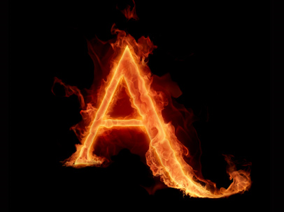

**Chapter 18: A Flood of Sunshine**

1. Why is the title of this chapter significant?
2. Analyze the diction in the following within the context of Dimmsdale’s remark – “The decision once made, a glow of strange enjoyment threw its flickering brightness over the trouble of his breast” (111).
3. On page 111, Hester removes her scarlet letter. Why is this significant?
4. On page 112, the forest fills with sunshine. Why is this significant?

**Chapter 19: The Child at the Brook-Side**

1. After Hester removes her scarlet letter, Pearl is cloaked in darkness, as is evidenced on page 116. Why? In addition, why does Hester put the scarlet letter back on her bosom?

**Chapter 23: The Revelation**

1. The chapter of this title is “The Revelation.” Why is it called as such? Moreover, what is revealed in this chapter?