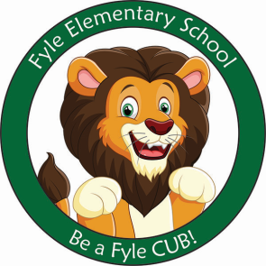

Mrs. Janofsky’s Weekly Update

January 18, 2019

ELA

This week we have been reading and discussing books that discuss perseverance and goal setting. The children are working to understand that it is important to work towards a goal without giving up. We have also talked about always trying your best. This will lead to our goal setting meetings in writing next week. The children will set a writing goal and work towards achieving it. As we begin to write more than one sentence understanding where to place a period will be very important! In Fundations, we are almost finished with learning to write the upper case letters. Next week will end these letters. It is important that the children start their letters in the correct place.

Math

Comparing numbers using the words is “more than” and is “less than” has been our focus this week. We have enjoyed playing a card game to work on this concept. Directions have been sent home on how you can play this game with a deck of cards. The children are continuing to write numbers to 20 and are practicing checking their own numbers for reversals.

Social Studies

Our new unit is Economics. The children are working to identify things that are needs and wants. We are identifying wants as food, clothing, shelter, and air. Love also has been included. Water is part of food. It is hard for children to understand that toys are wants. We also discussed Martin Luther King Jr. this week.

Important Information

* Specials after break:
  + Monday: No School
  + Tuesday: A
  + Wednesday: B
  + Thursday: C
  + Friday: No School
* Library on Wednesday. Please help your child remember their book!
* No School on January 21, 2019
* No School on January 25, 2019
* Sight word bags were updated this week.
* Senses of the Season-Winter will be on Thursday.
* Progress Reports will come home on Friday, February 1st.

Sight Words

has

Reading bags now come home twice a week! Be sure to return them on Wednesday and Friday! The children are doing an excellent job remembering! Thank you for your support!