NAME________________________________________Date__________Block_______

**Directions:** Using your knowledge of Imperialism & its effects on China, answer the following questions about each of the political cartoons shown below. Be sure to cite the cartoon to support your answers.

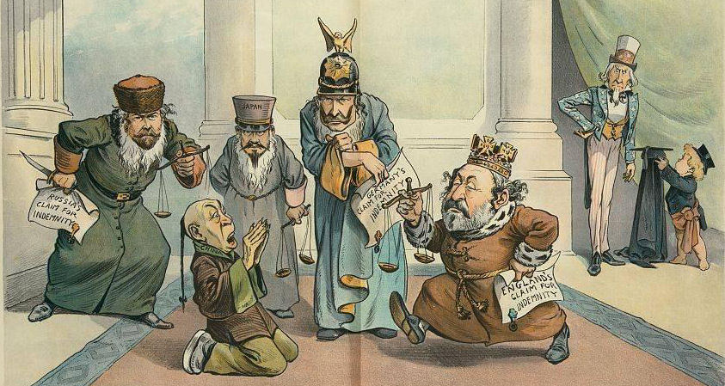

1. Who is shown surrounding the Chinese man on his knees?
2. What are they demanding from him? Why?
3. What is the US (Uncle Sam-in background) role in China? Why is he shown in the background?

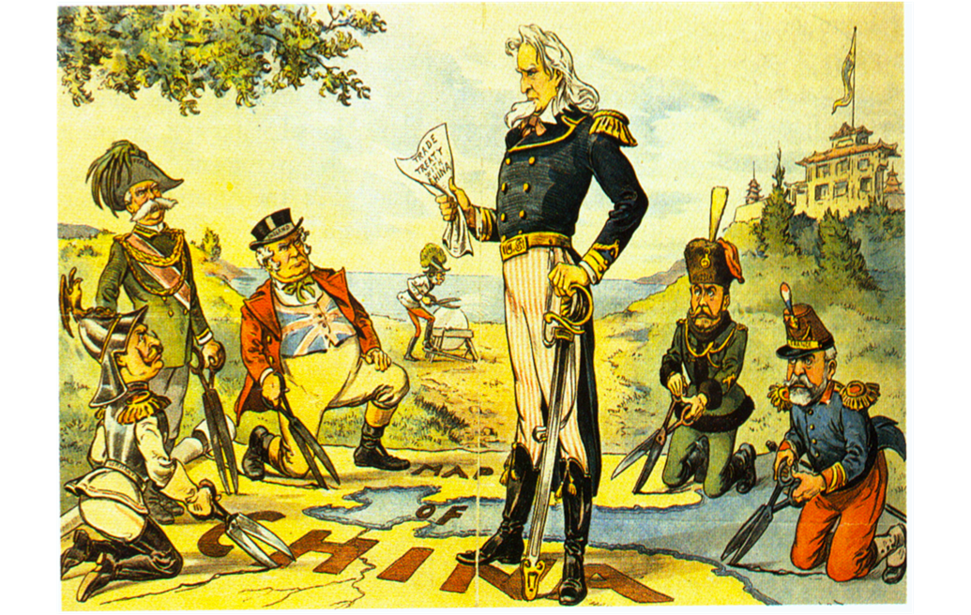

1. What are the European powers attempting to do to China according to this cartoon?
2. Why is Uncle Sam standing in the middle of them? What is he trying to prevent? How?
3. Did the US policy toward China work? Evaluate it.

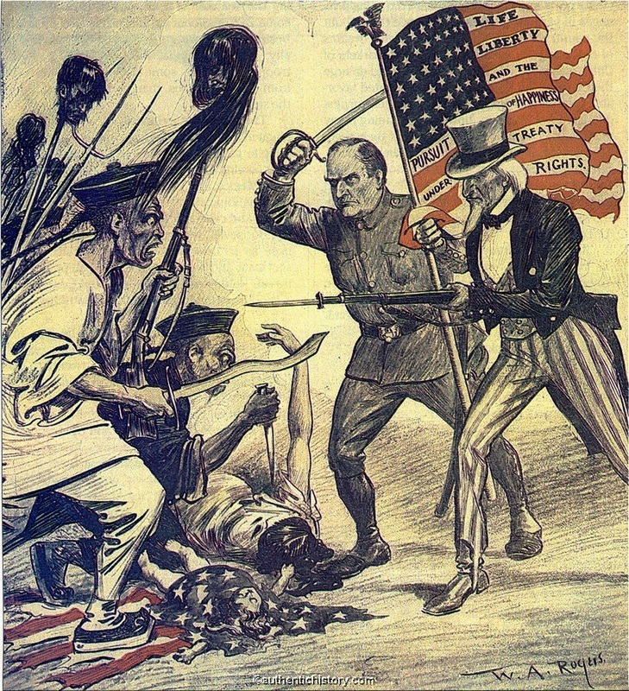

1. According to this cartoon, how did the US respond to the Boxers in their rebellion?
2. How did the US policy toward China change after the Boxer rebellion? Why?

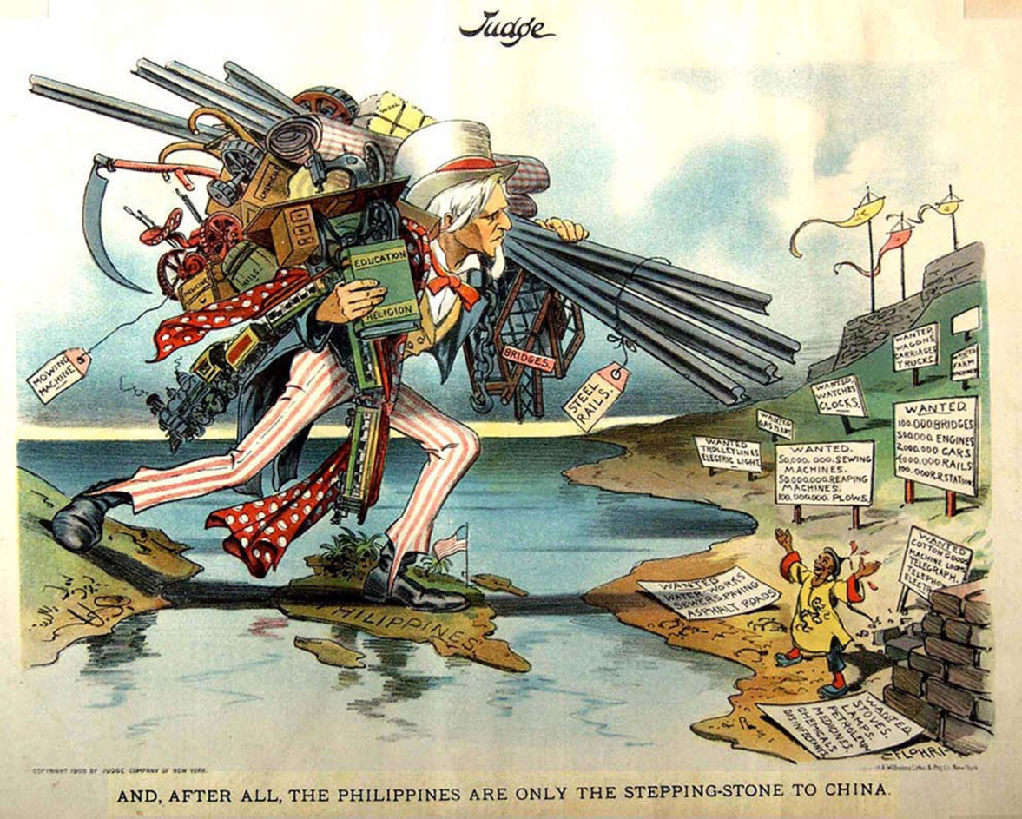

1. According to this cartoon, how did the US acquisition of the Philippines help in our expansion into China?
2. What is the implication of what Uncle Sam is carrying? Who would this be helping, us or China?

