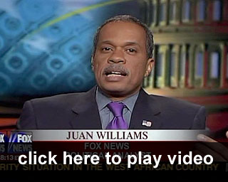

☺ Listen to the following clip that features Juan Williams (a news commentator affiliated with National Public Radio [NPR]) on Fox New’s “The O’Reilly Factor.” His remarks prompted NPR to fire him.

**[LINK] http://www.youtube.com/watch?v=e0Mbe7ErUNI**