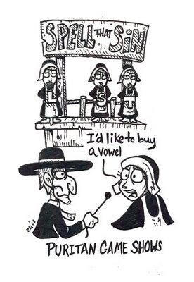

Quiz One

**Chapter 1: The Prison Door**

1. Hawthorne juxtaposes (compares/contrasts) new and old in this chapter. Analyze and interpret his diction regarding these two opposing forces.
2. Hawthorne spends a lot of time describing the prison-door. What symbolic significance might the door serve?
3. Analyze and interpret the rose bush as a symbol.

**Chapter Two: The Market Place**

1. Hawthorne uses a lot of light and dark imagery to characterize Hester. Why?
2. On pages 28-29, Hawthorne refers to Hester as having “the image of Divine Maternity.” Why is this significant?

**Chapter Three: The Recognition**

1. Hester at first does not “recognize” her husband. Why is his characterization important to the telling of the story?

**Chapter Six: Pearl**

1. The name “Pearl” has symbolic significance. Explain.
2. Hawthorne juxtaposes light and dark imagery in describing his characters. How does this imagery characterize Pearl? What do we know about her “nature?”