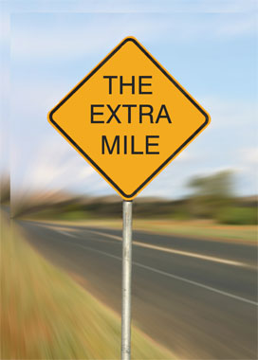

☺ Students seeking to earn an “A” in the 1st Quarter will need to complete an independent book report by October 18th. In my eyes, students who earn the highest marks should go above and beyond the boundaries of the curriculum. For this quarter, I would like for you to choose any non-fiction author listed on the course syllabus (It’s located on my webpage if you misplaced your copy) and carefully read one work by this author. The page length doesn’t necessarily matter to me – just keep in mind that this is your proof of going “The Extra Mile.” In terms of the report, here’s what you need to do:

🖉 Carefully read your selected text

🖉 Write a 2-3 page response on any aspect of the text that falls within the scope of either a Deconstructive or New Critical analysis

🖉 Adhere to the principles of good writing that we’ve discussed in class

🖉 Type your response

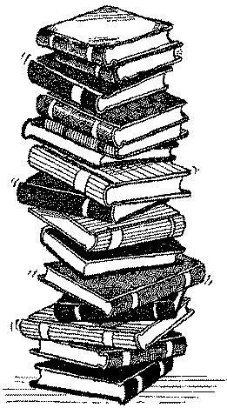 **The Literature (Note: This is a list of representative authors … you’re free to choose others)**

**http://www.margoproductions.com/images/writer.gifAutobiographers & Diarists**

Melba Patillo Beals, James Boswell, Judith Ortiz Cofer, Jill Ker Conway, Thomas DeQuincey, Frederick Douglass, Benjamin Franklin, Stephanie Elizondo Griest, Elva Trevino Hart, Hariet Jacobs, Helen Keller, Maxine Hong Kingston, T.E. Lawrence, Frank McCourt, Samuel Pepys, Richard Rodriguez, Richard Wright, Malcolm X, Anzia Yezierska

**http://www.margoproductions.com/images/writer.gifBiographers & History Writers**

Lerone Bennett Jr., James Boswell, Thomas Carlye, Winston Churchill, Vine Deloria Jr., Leon Edel, Richard Ellmann, Niall Ferguson, Shelby Foote, John Hope Franklin, Antonia Fraser, Edward Gibbon, Richard Holmes, Gerda Lerner, Thomas Macaulay, Francis Parkman, Arnold Rampersad, Simon Schama, Arthur Schlesinger, Ronald Takaki, George Trevelyan, Barbara Tuchman, Laura Thatcher Ulrich

**http://www.margoproductions.com/images/writer.gifCritics**

Paula Gunn Allen, Gloria Anzaldua, Michael Arlen, Matthew Arnold, Sven Birkets, Susan Bordo, Judith Butler, Kenneth Clark, Samuel Taylor Coleridge, Arlene Croce, Ralph Waldo Emerson, Henry Louis Gates Jr., William Hazlitt, Christopher Hitchens, bell hooks, Samuel Johnson, Pauline Kael, Joyce Carol Oats, Walter Pater, John Rushkin, Edward Said, George Santayana, George Bernard Shaw, Susan Sontag, Cornell West, Oscar Wilde, Edmund Wilson

**http://www.margoproductions.com/images/writer.gifEssayists & Fiction Writers**

Joseph Addison, James Agee, Margaret Atwood, Francis Bacon, James Baldwin, G.K. Chesterton, Joan Didion, Ralph Waldo Emerson, Paul Fussell, Mavis Gallant, Nadine Gordimer, Elizabeth Hardwick, Edward Hoagland, Zora Neale Hurston, Barbara Kingsolver, Jamaica Kincaid, Charles Lamb, Philip Lopate, Norman Mailer, Nancy Mairs, Mary McCarthy, N. Scott Momaday, Michel de Montaigne, V.S. Naipaul, Geoffrey Nunberg, Tillie Olsen, George Orwell, Cynthia Ozick, Francine Prose, Ishmael Reed, Adrienne Rich, Mordecai Richler, Sharman Apt Russell, Scott Russell Sanders, David Sedaris, Richard Selzer, Leslie Marmon Silko, Richard Steele, Shelby Steele, Henry David Thoreau, John Updike, Alice Walker, Eudora Welty, E.B. White, Terry Tempest Williams, Virginia Woolf

**http://www.margoproductions.com/images/writer.gifJournalists**

Roger Angell, Dave Berry, David Brooks, Maureen Dowd, Elizabeth Drew, Nora Ephron, M.F.K, Fisher, Frances Fitzgerald, Janet Flanner, Thomas L. Friedman, Ellen Goodman, David Halberstam, John Hersey, Paul Krugman, Alex Kuczynski, Andy Logan, John McPhee, H.L. Mencken, Jessica Mitford, Jan Morris, Donald Murray, Susan Orlean, Rick Reilly, David Remnick, Red Smith, Lincoln Steffens, Paul Theroux, Calvin Tucker, Tom Wolfe

**http://www.margoproductions.com/images/writer.gifPolitical Writers**

Hannah Arendt, Simone de Beauvoir, Wiliam F. Buckley, Jean de Crevecoeur, W.E.B Du Bois, Margaret Fuller, John Kenneth Galbraith, Charlotte Perkins Gilman, Chris Hedges, Thomas Hobbs, Thomas Jefferson, George Kennan, Martin Luther King Jr., Naomi Klein, Lewis Lapham, John Locke, Niccolo Machiavelli, John Stuart Mill, John Milton, Thomas More, Thomas Paine, Olive Schreiner, Jonathon Swift, Alexis de Tocqueville, Gore Vidal, George Will, Garry Wills, Mary Wollstonecraft

**http://www.margoproductions.com/images/writer.gifScience & Nature Writers**

Edward Abbey, Diane Ackerman, Natalie Angier, Wendell Berry, Jacob Bronowski, Rachel Carson, Charles Darwin, Richard Dawkins, Daniel Dennett, Jared Diamond, Annie Dillard, Gretel Ehrlich, Loren Eiseley, Timothy Ferris, Tim Flannery, Richard Fortey, Atul Gawande, Stephen Jay Gould, Evelyn Fox Keller, Aldo Leopold, Barry Lopez, Peter Matthiessen, Bill McKibben, Margaret Mead, John Muir, Steven Pinker, David Quammen, Carl Sagan, Lewis Thomas, Jonathan Weiner, E.O. Wilson