the first part last
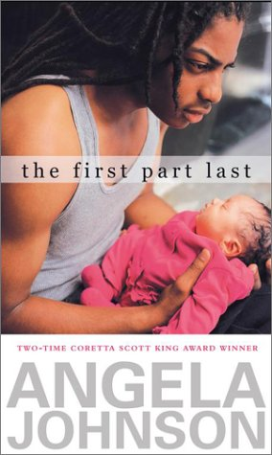
Personal Narrative

Directions
☺ It’s time to wake up your dormant creative juices and tap into the rich stories of your lives. For this personal narrative, I want for you to work on your descriptors and your overall ability to tell captivating stories. Here’s what you need to do:

Choose one of the following prompts and write its story

□ What would you change if you could live the first part last?

□ To what extent does time shape perspective?

□ Between the now and then of our lives, when do we finally realize that we’re not invincible?

□ How right is the “right” thing?

Tell a killer story …

