I.D the Quote

Identify who said the quote below by recognizing if IT is a Marxism or Smithism.

- The workers will rise up and overthrow the privileged class. _____________________

- Government should not interfere in relations between workers and business owners. _________________

- Private property will cease to exist. __________________

- Workers of the world unite; you have nothing to lose but your chains.

- Government must end its ideas of mercantilism. Prices should be determined by the laws of supply and demand, not by government regulation. Free trade and competition are necessary to encourage the production of goods that are of good quality and low in price. _______________________________

- The average worker can never obtain more than a minimum level of living. The worker is deprived of the wealth he himself has created. The state is a committee of the bourgeoisie for the exploitation of the people. ______________________

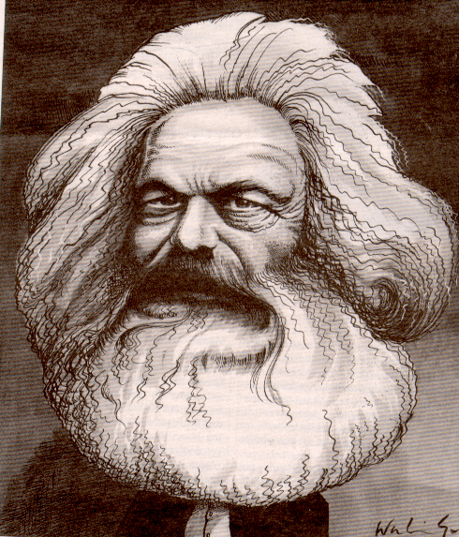 VS. 