Name: ______________________________ Date: ___________
Geometry // Mr. Burke

Chapter 1: Tools of Geometry
Extra Practice

Part I: Place the letter of the correct answer choice in the blank provided. Please show your work.

____ 1. Intersecting lines a and b are in plane R. Line m is perpendicular to both lines
a and b. Line m also satisfies which of the following conditions?

(1) Line m is parallel to lines a and b.
(2) Line m is skew to lines a and b.
(3) Line m is perpendicular to plane R
(4) Line m is parallel to plane R.

____ 2. Point E is on line a. How many planes are perpendicular to line a through point E?

(1) none (2) 1 (3) 2 (4) infinite

____ 3. Plane J and K are each perpendicular to . Planes J and K must be

(1) intersecting (3) parallel

(2) perpendicular (4) skew

____ 4. Two parallel planes E and F are intersected by plane G. What figure is formed by the intersection?

(1) one parallel plane and one line
(2) one parallel line and two intersecting lines
(3) two parallel planes and one line
(4) two parallel lines

5. Based on the pattern, what are the next two terms of the sequence?

2, -4, 8, -16, 32, …

6. Name the ray in the figure.
A
B

7. If EF = 2y + 3, FG = 4y - 3, and EG = 36, find the value of EF. The drawing is not to scale.

8. What is the intersection of plane UVYZ and plane SVWZ?

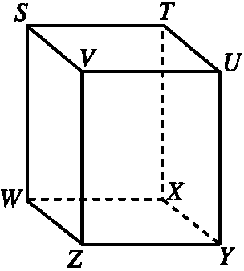

Is the intersection of plane UVYZ and plane SVWZ parallel to ? Justify your answer.

9. Name the four labeled segments that are skew to
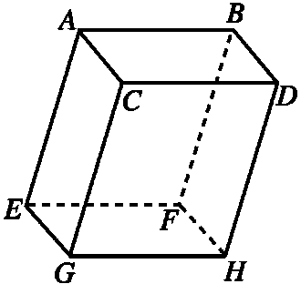
_______________

_______________

_______________

_______________

Are any of the lines you chose perpendicular to ? Explain why or why not.

10. M is the midpoint of The coordinates of A are (-3, 6) and the coordinates of M are (1, 2). What are the coordinates of B?

11. If , , and solve for x and find .

A
B
C

O
D

12. a. Graph ΔABC with vertices A(-2, 9), B(7, -3), and C(-2,-3).

b. Find the perimeter of ΔABC.

13. Explain the similarities and differences between a linear pair of angles and supplementary angles.

_________________________________________________________________________

_______________________________________________________________________

_______________________________________________________________________

_______________________________________________________________________

_______________________________________________________________________

_______________________________________________________________________

14. What are three names for the angle?

_______________
X
_______________
Z
_______________
Y

15. The Rush Henrietta wrestling team has a match at Marcus Whitman. The NGA is at point (3, 5) and Marcus Whitman is at point (7, -9).

a) The map shows a rest stop halfway between the schools. What are the coordinates of the rest stop?

b) If the distance is measured in miles, how far is it from the NGA to Marcus Whitman?
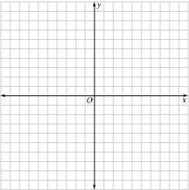

16. Draw a picture of the following situation and answer the question.

is perpendicular to plane X at point G. is perpendicular to plane X at point E. What is the relationship between and .

17. Given , and .

If and find:
A
B
O
E
D
C

18. Points L, M, and N are collinear with M in between L and N. and is one half the length of . If , write and solve an equation to find x.

