DRAWING & PAINTING COURSE OVERVIEW 2016-2017
RHCSD – Ninth Grade Academy– JULIE FLISNIK
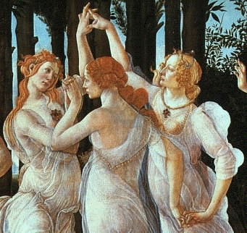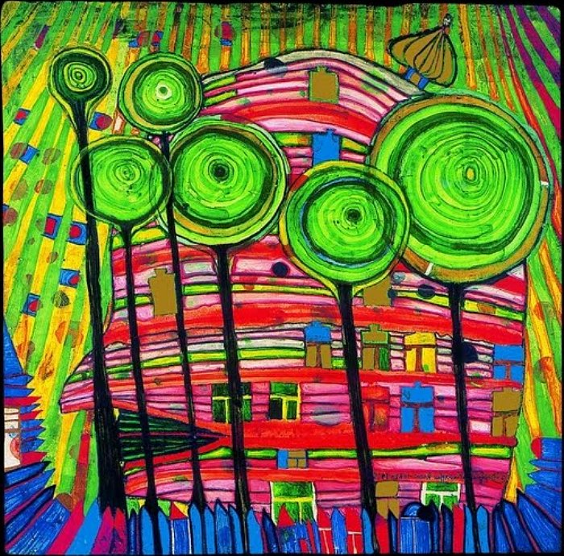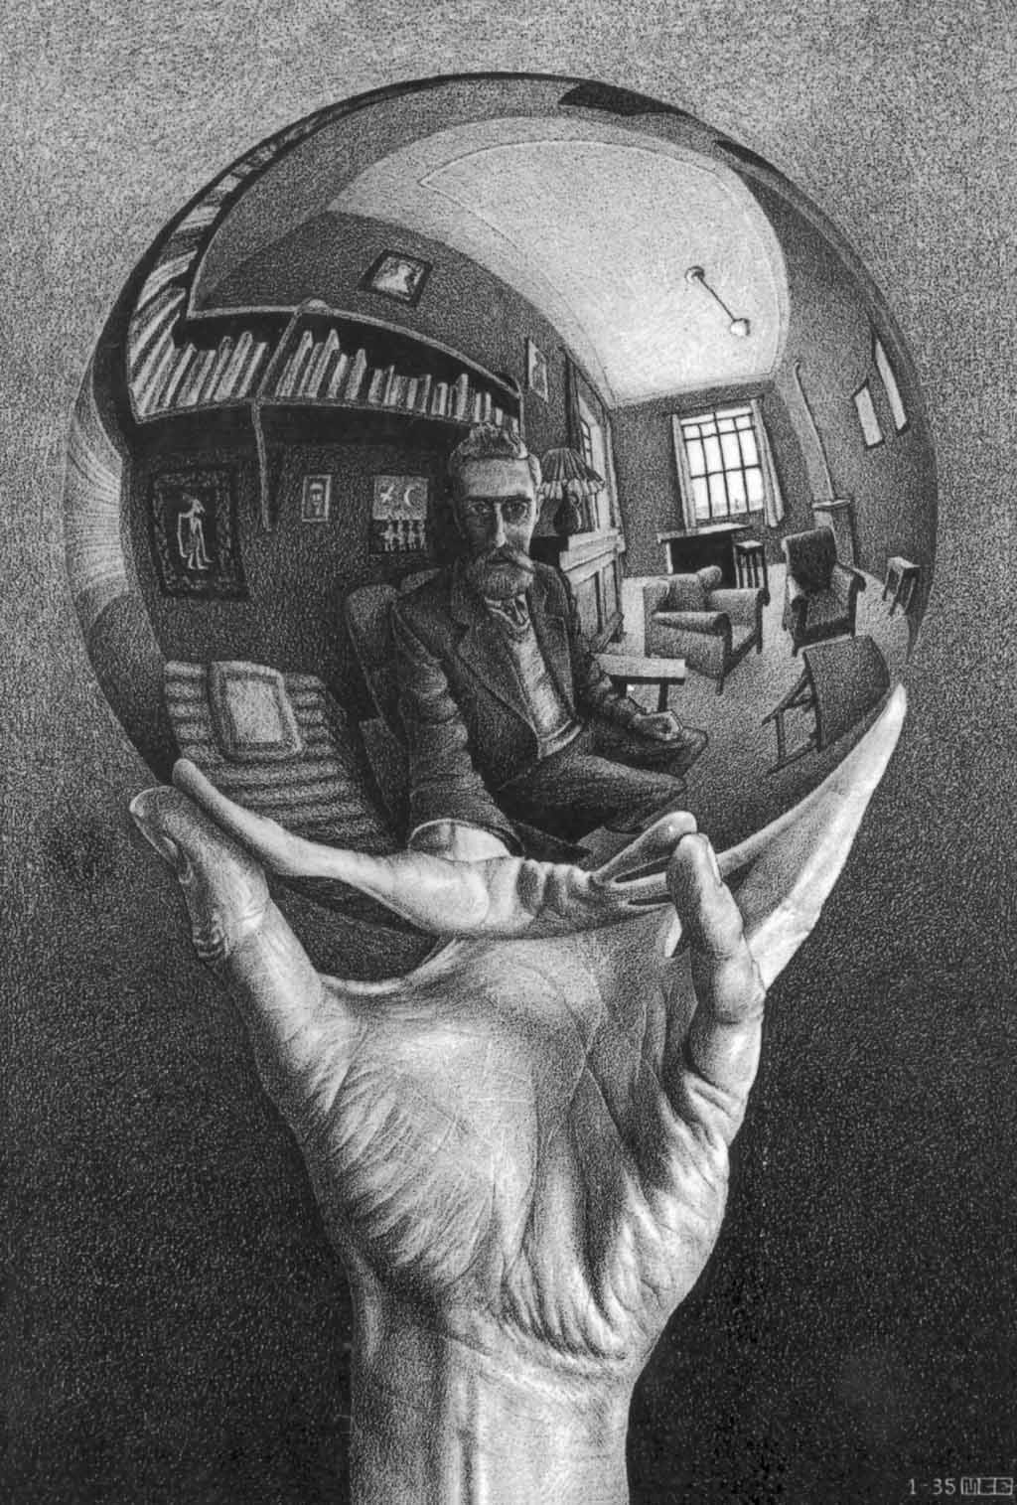
DaVinci Botticelli Hundertwasser Escher

Course Description:
Drawing & Painting is a level II art course. Students may elect to take Drawing & Painting twice for credit. In Drawing & Painting, students will work at a high level to improve their technical drawing and painting skills. In addition to making art students will be participate in art viewing, criticism and writing activities. Art challenges will be introduced and students working independently will develop their personal ideas while perfecting art techniques and craftsmanship. This is an excellent portfolio development course. Student artwork will be displayed in the winter and Spring 2017 district art shows.

My thoughts on learning in my ART Classroom:
EVERYONE can MAKE ART. I have observed this to be TRUE over and over again in my years teaching students of ALL ages. I believe TALENT to be overrated. A student’s attitude, work ethic, perseverance and interest are much more powerful determinates of their ability to be successful.

Sketchbook Assignments:
Every art student is required to have a 9”x12” sketchbook. Regular sketchbook drawing is an essential part of the class. Sketchbook assignments are designed to provide students an opportunity to practice essential drawing skills they learn in class. The type and quantity of sketchbook assignments will vary each quarter. There will be a running list of required sketchbook assignments posted in the art room each quarter. Sketchbooks will be graded at the end of each quarter. Any exercise not completed during the class will become homework. Additionally, the sketchbook will be used for research and planning of the art projects and to keep your assignments and handouts organized. I will provide each student with a sketchbook. If it becomes lost or missing it is the student’s responsibility to replace it.
Finally, the sketchbook is YOURS to use for journaling, writing poetry, sketching, etc! You are welcome to go above and beyond the required assignments.

Course Objectives:
Drawing & Painting students work on a variety of exercises and projects to further develop:
- Technical skills in drawing, painting
- Conceptual and creative thinking
- Personal creative expression
Drawing & Painting classes are engaged and challenged by:
- Structured and directed exercises designed to teach technical skills, art thinking, and personal expression

Classroom Policies:
Assessment: All work will be assessed using the Drawing & Painting rubrics. Students will be made aware of the LEARNING OUTCOMES as they are outlined in the rubrics in the beginning of each instructional unit. Satisfactory completion of all REQUIRED COURSE ASSESSMENTS is necessary to earn a passing grade for this course.
Make – up work: Students are expected to make up all work assigned. Students are responsible for obtaining make-up work the first class day they return to school. If the student’s absence is excused they will have one week to complete outstanding work. If it is unexcused it will be due the following class day.
In the event of an incomplete grade:
Student and Instructor will develop a plan of action to rectify the incomplete in a timely manner.
Overall averages will not be calculated
Academic points will not be rewarded
Student will not be allowed to participate in Sports, Extra-Curricular Activities, and Honor Societies
Attendance: Students are expected to attend class regularly and be on time. The NGA policies in these areas will be enforced and parents/guardians will be notified by phone after the third tardy.
Behavior: Positive attitudes towards one’s work, as well as respect are critical to a successful year in Drawing & Painting. In general, any behavior that is disruptive or disrespectful will be addressed.
Studio Maintenance: There are 5 different classes occurring within this one studio space so it will be critical for each individual artist to maintain any supplies they use as well as the space where they sit. The NGA art supply budget is not infinite. Caring for permanent supplies such as brushes, rulers, erasers, etc. is critical. Keep things clean and take personal responsibility in putting your supplies away! Failure to comply with basic behavioral and supply maintenance will result in a discussion, phone call home and if the behavior persists a discipline referral.
Cell Phones and other Technological Devices: The students will have access to a portable MAC mobile lab in my classroom all other technology including cell phones are not allowed in my class

Additional Information: I have 20+ students assigned to my learning lab daily. I will take a maximum of 6 additional students during that time to work on assigned course work. You must have a pre - signed pass to come to my lab. Passes must be obtained before NOON on the day you wish to come in.
Please feel free to contact me with any questions or concerns at any point during the year. I am very excited to be working with you!
Email: jflisnik@rhnet.org

I have read, understand and have no questions regarding the above document.

Parent Signature & Date

Student Signature & Date

