Critical Lens
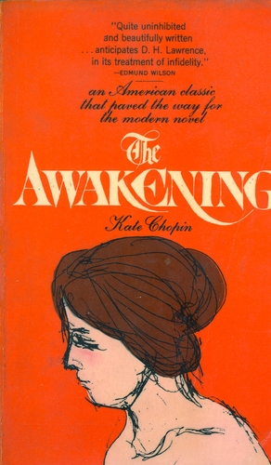

The Awakening

Your Task:
Write a critical essay in which you discuss The Awakening and another text from the particular perspective of one of the statements listed below. In your essay, provide a valid interpretation of the statement, agree or disagree with the statement as you have interpreted it, and support your opinion using specific references to appropriate literary elements from the two works. You may use scrap paper to plan your response. Write your essay on separate sheets of paper:

Critical Lens: ONLY BASE YOUR ESSAY ON ONE OF THE FOLLOWING STATEMENTS
“Change does not roll in on the wheels of inevitability, but comes through continuous struggles.”
OR
“Every step toward the goal of justice requires sacrifice, suffering, and struggle.”

GRADING CRITERIA: MAKING SURE ALL THE ESSENTIAL INGREDIENTS ARE INCLUDED
□ Provide a valid interpretation of the critical lens that clearly establishes your thesis statement and criteria for analysis
□ Indicate whether you agree or disagree with the statement as you have interpreted it
□ Make specific references to appropriate literary terms (theme, conflict, characterization, setting, point-of-view, etc)
□ Include at least 2 super specific textual references per book to illustrate how the lens works
□ Organize your ideas in a unified and coherent manner (Make Flawless Syllogisms!!)

