Go Ask Alice
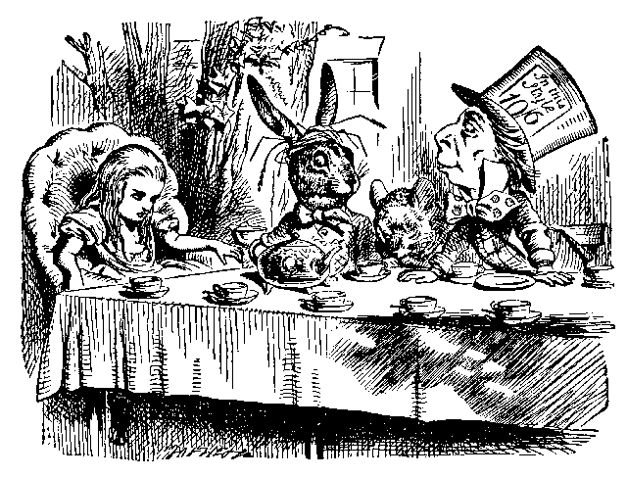
End of Unit Exam

PART I: VOCABULARY
→ Note that each word is followed by a page number. You may use your text for context clues
→ Write your choice in the blank
→ You cannot use a dictionary

- I wouldn’t _____________________ the truth. In this case, honesty is your best approach.
a. retract (169) b. submerge (108) c. compensate (107)
d. distort (165) e. embalm (122)

- I think we should hire him because it’s important for a salesman to be ____________; after all, you can’t make a sale if you’re a lousy communicator.
a. deplorable (108) b. blasé (9) c. seething (149)
d. articulate (167) e. inundated (108)

- I feel like some sort of ___________________ because Beth and Lyndsey won’t even look me in the eye. Every time I pass them in the hall they avoid me like I’m a walking STD.
a. hyperbole b. juvenile (165) c. paltry (108)
d. leper (118) e. prodigal (109)

- My cat is very ________________. Every time people come to the house it hides under the couch.
a. deplorable (108) b. timid (178) c. teeming (149)
d. afflicted (108) e. uninhibited (35)

- She must understand that she cannot __________________ my time. I do have other friends.
a. lament (108) b. monopolize (164) c. distort (165)
d. submerge (108) e. rectify (109)

- Sal is such a(an) ____________________ guy. When I told him that my dog of 17 years, Rufus, died last Saturday he said, “Who the hell cares? That damn dog always smelt like a dirty diaper.”
a. sympathetic b. apathetic c. empathetic
d. impractical (170) e. writhing (149)

- There really isn’t any way I can ________________________ the situation. I kissed Sue’s boyfriend and I can’t take it back.
a. rectify (109) b. lament (108) c. compensate (107)
d. articulate (167) e. monopolize (164)

- I put a marshmallow in the microwave for 5 minutes. It completely _________________.
a. disintegrated (150) b. submerged (108) c. degenerated (108)
d. retracted (169) e. lamented (108)

- I am absolutely ______________________ with jealousy. That harlot Janet kissed Joey.
a. lamenting (108) b. embalming (122) c. rectifying (109)
d. degenerating (108) e. seething (149)

- Richie is such a low-class _____________________. He has no problem selling drugs to elementary kids.
a. prodigal (109) b. hyperbole c. Blasé (9)
d. phosphorescent (149) e. degenerate (108)

PART II: SHORT ANSWER
→ In the space provided below, respond as thoroughly as possible to each question. You may use your notes and book.

- The diary has several settings. Map out each and detail the main events that occur in each setting.

- The narrator’s man vs. self conflict is very repetitious and cyclic. Describe the essence of this conflict and cycle. Use direct textual references in your response.

- What narrative point-of-view is used throughout the book?

- How does the “round peg … square hole” analogy from our essential question apply to the protagonist?

- With regards to the chocolate covered peanut incident, to what extent has revenge come full circle?

- What is hyperbole? In addition to defining this term, give an example from the diary. Why is your example hyperbolic?

- Using quotes to back up your response, analyze these various forms of conflict:
  - man vs. man

b. man vs. self

- Based on the first five diary entries (pages 7-9), summarize how our narrator is characterized. Use textual references to support your answer.

- July 10th is an important entry for our narrator. She says of her experience, “I don’t know whether I should be ashamed or elated” (32). What does she feel with regards to the event?

- In what ways might “Button … Button … Whose got the button” serve as a turning point in the narrator’s life? Refer directly to the July 10th entry to support your answer.

- In the July 14th entry our narrator alludes to Alice in Wonderland. In what ways does she personify or mirror Alice?

- On July 20th our narrator experiments with speed and says, “I felt great, free, …” (38). With regards to her characterization, why would she feel perfected?

- Our narrator says, “Imagine losing my virginity four nights before seeing Roger again. The awful irony of it” (45). What’s the irony (explain the expectation, the reality of the situation, and how the two have a disconnect)?

- The entry indicated ? (page 59) is riddled with the narrator’s insecure suspicion of Richie. Why does she have reason to be concerned? Refer directly to the text.

- Based on the Oct. 19th entry consider the following:
  - Will the grass grow greener on the other side of the fence (In San Fran.)?
  - Analyze what the narrator means by the “giant round robin”
  - What are her true motivations for reporting Richie?
  - What is the true motivation for leaving?

- The past can never be erased. How does this concept apply to the Jan. 6th, 8th, 14th, 15th, and 21st? And based on these entries, will the past become the present again for our narrator?

- The undated entry on pages 101-102 finds our narrator questioning her sexuality. What motivates her confusion and why does she feel so conflicted?

- Based on the entry from 105-108, what symbolic quality does a new diary have for our narrator?

- Based on the entry from 105-109, answer one of our essential questions: why is there such an enormous gap between the adult and teen world?

- The April 24th entry presents many issues
  - Why don’t our narrator’s parents know about her past? Are they oblivious or just uncaring?
  - Describe the interior and exterior conflicts that surround our narrator
  - Why can’t our narrator simply change schools?
  - What place does God have in our narrator’s life?

- The Epilogue asks, “was it an accidental overdoes? A premeditated overdose? Or, was it an act of vindication?” How do you believe our narrator died?

