Mr. Kuhn
AP Language & Composition
Rush Henrietta Senior High School
kristian_kuhn75@yahoo.com
kkuhn@rhnt.org
Classical Rhetoric & Some Nuts & Bolts:
Old School Modes of Becoming Skilled in
Reading, Writing, Speaking, & Thinking

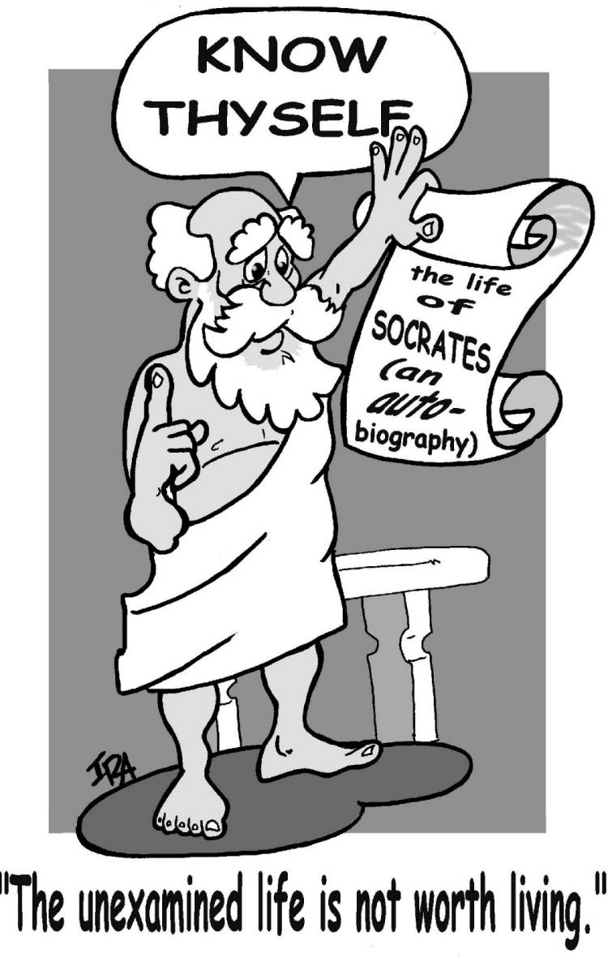
Unit Overview& Grade Breakdown
(The First Few Weeks)

Key Assessments:

All assignments are due at the beginning of class, unless otherwise noted. If you are submitting an assignment through email, please confirm reception. Free-Dumb Passes may only be used once per quarter. Continual neglect to complete assignments on time or not at all will invariably earn you a failing grade for the course.
1. Dialectical Responses 100 points
In preparation for Socratic Seminars and Harkness Discussions, you are to write a one-page response that characterizes your thoughts and reactions to the texts assigned for class. Your responses should demonstrate thoughtful engagement with the texts, be typed, and double spaced. For each text, you might want to consider the following:
 Description of the author’s style and examples

How a particular theoretical lens shapes and informs your interpretation of the text

Quotes and their significance to the text as a whole

Character analysis and their role and significance to the story

Symbols, motifs, recurring images and their significance to the story

Significance of the opening and closing scenes

Passages rife for classroom discussion

Ambiguities, tensions, juxtapositions and contradictions and their significance to the story

List of questions prompted by the reading (confusing passages, associations, predictions
and connections to other texts.
Analysis of the author’s style, technique, and/or form

2. Harkness Discussion & Socratic Seminar 100 points
Both discussion formats are formal speaking activities that help us structure our conversations about texts we will be reading. Over the course of the year, especially once we move into larger bodies of work after this unit, I will place students in groups of 3 and these groups will be responsible for generating and maintaining the fluency of the discussion. Mr. Kuhn will model the criteria and expectations several times before you will be required to perform this activity.

3. Critical Worlds: A Selective Tour (Family Memoir) 100 points
Literary works are, in a way, like places we can visit. Some are foreign, mysterious, puzzling; others make us feel right at home. Although wandering around is always an option, travelers who know what they’re looking for and have a plan for getting there are more likely to have a satisfying, interesting visit. Literary criticism aims to bring such order and organization to our experience of literary works, focusing our attention on this, disregarding that, putting various parts together, making sense of what we see. When you write about literature, you serve as a kind of tour guide, leading your reader (and yourself) through the work. Readers usually can see what’s in front of them, but they don’t necessarily know what to make of it without some persuasive commentary.
Critical theories, then, are like the different travel agencies through which the various tour guides generally work. Different agencies feature different kinds of tours (the theories we’ve learned throughout the course) that provide the general frameworks, the general guidelines for your performance as a tour guide. To write most successfully about a literary work, then, you need not only to have spent some time with the work but also to have some clear idea of the kinds of tours available and how they might be combined or adapted. For this assignment you will need to do the following:
Write a 2-3 page analysis of one family memoir selection. As always your essay is to be typed, formatted, and double spaced

Consider how critical theories (New Criticism, Reader-Response, Deconstructive, Historical, Postcolonial, Cultural, Psychological, Feminist, Queer, etc.) shape your construction of the meaning of the text

Provide ample textual support and textual analysis

Write cogently and thoughtfully

This essay will undergo 2 revisions. Each draft should clearly manifest improvements and consideration of the editor’s suggestions for improvement

Follow MLA format
NOTE: Please do not use external sources such as literary journals, databases, internet cites to help you in shaping your reading of the text.

4. Family Memoir 100 points
After reading several family memoirs and exploring the characteristics of the genre, you will compose your own family memoir. Through our analysis of these texts, you should begin to develop a more sophisticated and theoretical understanding of the complex nuances that shape this particular genre. That being said, this assignment will afford you a chance to dabble within the craft to determine, let’s say, how parallel syntax impacts the creation of meaning. Your family memoir will also center you on the nitty-gritty’s of composition and the elements of style. Final drafts will be 8-10 pages in length, typed, double spaced, and properly formatted.

5. Critical Worlds: A Selective Tour (The Essay) 100 points
This assignment will adhere to the same guidelines and principals of the previous assessment, but for this essay you will focus on the works of an essayist we have discussed in class. Your essay will receive plenty of feedback from me and it is my expectation that this essay will demonstrate your growth and maturation as a writer and thinker of literature.

6. Aristotle’s 3 Rhetorical Appeals & Cailou’s Hidden Agenda 100 points
For this essay of 3-4 pages in length you will discuss how Zumwalt applies Aristotle’s 3 rhetorical appeals (ethos, logos, pathos) in her counterargument against a prominent US senator who purports that Congress should withhold funding to PBS because of its tendency to air children’s programming that corrupts the innocence of children.

7. Deconstructing Advertisements 100 points
For this essay of 3-4 pages in length you will carefully scrutinize a magazine advertisement or TV commercial of your choosing. Your essay will consider such questions as how the advertiser manipulates the target audience, the affect of the advertisement’s rhetoric on the viewer, why the advertiser chose to use certain imagery and how the advertisement makes an emotional appeal, and how the advertisement utilizes Aristotle’s 3 rhetorical appeals.

8. Wolves in Sheep’s Clothing 100 Points
Anais Nin commented that “the possession of knowledge does not kill the sense of wonder and mystery. There is always more mystery.” This is an important adage to come back to, because at this time in the quarter many of you will feel that we are sucking the blood out of everything we read and view. As you develop your critical thinking skills and your ability to analyze text, keep in mind that there is always more mystery. This will be especially true when we breakdown the visual, linguistic, and logical arguments that comprise Dora the Explorer, Handy Manny, and Higgleytown Heroes. This essay will require you to write a 3-4 page analysis of an article by Norma Rogers whereby you bring to the table all the theoretical and stylistic “stuff” that you’ve learned thus far in the course.

9. Political Rhetoric 100 points
Americans are constantly bombarded by political rhetoric, particularly during election years. Much of this rhetoric seems empty and meaningless; what does it mean to say that "I'm for America," or "I'm running on a platform of family values?" The purpose of this project is to help you learn about political rhetoric. You will learn to identify the different types of appeals, analyze political jargon, and consider how politicians use rhetoric to influence voters. A good understanding of political rhetoric is an absolute necessity for citizens in a democracy.
First, visit http://livingroomcandidate.movingimage.us/index.php and select a political commercial. You may select any commercial from any presidential candidate or year. Your 3-4 page essay should do the following: (a) describe the commercial and its historical/political context, (b) determine the intended audience, then identify the types of appeals and issues addressed in the commercial, and (c) evaluate the effectiveness of the commercial. You do NOT need to perform these tasks in the order they appear above. Organize your paper in a logical and readable manner. The commercial will be your primary source; you also need at least two other secondary sources to support your arguments or supply additional material. These secondary sources can be newspaper or magazine articles, political websites, or political or rhetorical texts. You must cite whatever additional materials you use in this project using MLA formatting.

10. Critical Worlds: A Selective Tour (The CW Gossip Girl Campaign) 100 points
This assignment will adhere to the same guidelines and principals of the previous Critical Worlds assessment, but for this essay you will focus on how the CW “sold” their product to their intended target audience. This selective tour will have several artifacts for you to examine and synthesize for your first timed-writing of the year. Your essay will receive plenty of feedback from me and it is my expectation that this essay will demonstrate your growth and maturation as a writer and thinker of literature.

11. The Whole Darn Thing: Taking an AP Exam in its Entirety 100 points
With the hopes of preparing you for your exam in May, assessing what I need to teach in greater detail, and eliminating exam anxiety, I’d like to take a couple of class periods working trough an entire exam.

12. Vocabulary Journal 100 points
As students in a college-level course, it is implicitly understood by me that you are intellectually curious and hungry. To satiate this hunger, I want you to devour the words you encounter in your reading and during the regular course of your day. When you come upon a word in your reading that is unfamiliar to you, place the word, its definition, and a contextualized sentence in your journal. Do this for all the words that baffle you. For example, if you happen to be listening to NPR and hear a commentator use the word bifurcate and you have no idea what it means, get it down in your journal and take ownership of this word. At the end of the quarter I will take a glance at your journal. I will award full credit to those students who are truly satisfying their appetites.

