2010 AP Lang. Free-Response Questions
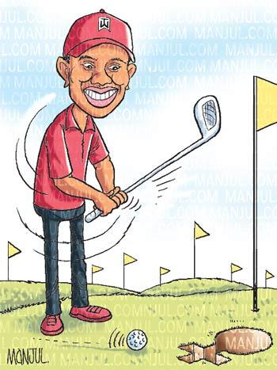
Question 2

(Suggested time – 40 minutes. This question counts for one-third of the total essay section score.)

In the following speech, Tiger Woods addresses the media after maintaining a three-month long hiatus from the public eye. He publically acknowledges, as he puts it, his ‘wrongdoings’ and apologizes to his family and fans. Read and listen to the prepared speech carefully. Then write an essay in which you analyze the language and rhetorical strategies of Woods’s presentation.

“Good morning and thank you for joining me. Many of you in this room are my friends, many in this room know me, may have cheered for me, worked with me or supported me, now every one of you has good reason to be critical of me. I want to say to each of you, simply and directly, I am deeply sorry for my selfish and irresponsible behavior I have been engaged in. People want to know how I could have been so stupid and selfish.
While I have always tried to be private, I have a few things to say. Elin and I have started to work though this. As she has told me, my real apology to her will not be in words but in action, however what we say to each other will be private. I am also aware of the pain I have caused everyone in this room. I have let you down and let down my fans. For many my behavior has been a major disappointment; my behavior has caused considerable worry to my business partners, and everyone involved in my business, but most importantly to the young people we influence, I apologize.
Millions of kids have changed their lives, due to the programs I am involved in, and I am still dedicated to that, but I still know I have bitterly disappointed all of you. I have made you question who I am and how I could have done these things. I am embarrassed that I have put you all in this position, for all I have done-- I am so sorry. I have a lot to atone for, but one issue I want to discuss. It has been said that Elin hurt me (on the night of the wreck) That angers me. There had never been domestic abuse in our marriage; Elin had shown tremendous grace in this ordeal. She deserves praise not judgment. I alone am responsible for this situation.
The issue here is that I cheated; I am the only person to blame. I stopped living according to my core values. I knew what I was doing was wrong but thought only about myself and thought I could get away with whatever I wanted to; I felt I was entitled. I had worked hard. Money and fame made me believe I was entitled. I was wrong and foolish. I don’t get to live by different rules. The same boundaries that apply to everyone apply to me. I hurt my mother, my wife, kids, friends my foundation. This has made me look at myself in a way I never wanted to again. It is time to make amends and that starts by never repeating this behavior again. It’s not what you achieve in life that matters; it is what you overcome. Achievements on the golf course are not what matters, decency and honestly are what matter. Families used to look up to me as a role model to their kids: to those families I am so sorry. I have been in in-patient therapy, receiving guidance.
I have a long way to go but have taken the right first steps. I understand the press wants details, but please know that, as far as I am concerned, all of these questions and answers are between Elin and me. Some have made up things that never happened. They said that I took performance enhancing drugs that has never happened. I still believe it is right to shield my family. They did not do these things; I did. I have always tried to keep my wife and kids separate from my career, however my behavior does not make it right to follow my mom, wife, and follow my 2 yr old daughter to school and report the location. Please leave my wife and kids alone. I have brought this on myself. I have a lot of work to so, and I intend to dedicate myself to doing it.
Part of this for me is Buddhism. It teaches that craving for things outside ourselves causes an unhappy and pointless search for security. It teaches me to stop following every impulse and practice restraint. Obviously, I lost track of what I was taught. Starting tomorrow, I will leave for more treatment and therapy. In therapy I have learned the importance of keeping spiritual life and professional life balanced. I need to regain my balance. I do plan to return to golf one day-- I just don’t know when that day will be. I don’t rule out this year. When I do return, I need to make my behavior more respectful of the game. I have received thousands of letters and emails to encourage me. To everyone who has reached out to me and my family, thank you. Thank you to the PGA tour, its commissioners and players (for your support) and I look forward to seeing my fellow players on the course. Finally to the many people in this room and homes who believed in me, I ask for your help. I ask you to find room in your heart to one day believe in me again, thank you.”

