Synthesis Essay
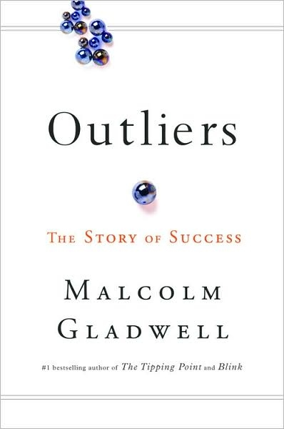

Essential Questions
☺ Is success nothing more than a social construct?
☺ What is the story of success?
☺ Is talent an innate disposition?
☺ To what extent does “group-think” construct worldviews?
Assignment Overview
♦ For this essay you will need to directly respond to one of the above essential questions by drawing from at least four primary sources. Listed below are the texts you can draw from:

□ Outliers by Malcolm Gladwell
□ Episode of Modern Family entitled “En Garde”
□ Article I
□ Article II
□ Article III

In developing your response, synthesize your four sources in a manner that enables you to directly address your selected essential question.

 If you need the link to The Modern Family episode, it is ….
www.hulu.com/watch/105839/modern-family-en-garde

