Mr. Kuhn
11R English
Rush-Henrietta Senior High School
kkuhn@rhnet.org
Kristian_kuhn75@yahoo.com
359-5200 ext. 1125 or voicemail 1826

Doubt
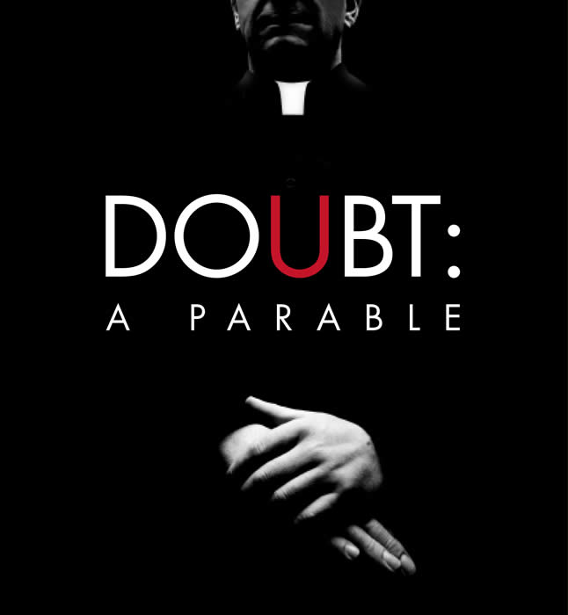
Unit Overview & Grade Breakdown

Essential Questions:
What is the cost of justice?
What is the “something” that is unsaid under any given society?
To what extent is the beginning of change the moment of doubt?
How is it that a stereotype can leave an individual vulnerable to manipulation & deceit?

Individual Tasks

♦Reader’s Response Journal
Keep a Reader’s Response Journal that characterizes your thoughts and reactions to the texts we will be reading throughout the unit. Your responses should demonstrate thoughtful engagement with the text. Although you will receive a grade on your ten (10) best entries, all entries need to be completed. You will be graded in accordance to the Reader’s Response Journal Rubric. Please follow the format and guidelines that are listed in Mr. Kuhn’s examples. (100 points)

♦ Cross Analysis Essay
For this essay of 3 pages in length, you will use Doubt as your primary text for analysis and compare it to one of the following texts:
 Choose any high profile celebrity, as well as the principle characters in Doubt, and examine how the following essential question operates in both instances – How is it that a stereotype can leave an individual vulnerable to manipulation and deceit? In other words, cross your analysis between the play and a celebrity and examine how they are victimized by their stereotype (examples: Michael Jackson, Britney Spears, Barry Bonds, Tom Cruise, etc.).

Quite recently, several satirical cartoons and late show talk hosts have addressed the church scandal. Choose any one of these depictions and cross your analysis between this particular episode and the play Doubt. More importantly, when your cross your analysis between these texts, consider how both pieces of literature operate within any one of our essential questions.

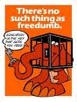 If you have a great idea for a cross-analysis, throw it my way. Just to toss
out some more ideas – how about comparing Doubt to a famous painting? Heck, you
could even compare it to another film. Whatever you decide, I’ll probably be game.

♦ Critical Lens Essay
In order to prepare you for the Regents Exam in January/June, we will write a critical lens essay using a past exam whereby you analyze two texts (Doubt and another text), ground your thesis in the theme of the lens, use textual support from recall, and analyze relevant literary devices. (100 points)

♦ End of Unit Exam
Upon completing the play you will have an exam consisting of multiple choice and essay questions. The exam format will closely mirror that of the ELA Regent’s Exam (100 points)

♦ “The Daily” & Writing Workshop
Mark Twain once said, “The difference between the right word and the almost right word is the difference between the lightning and the lightning bug.” This workshop is intended to help us commit the best words to paper. Several of us have the tendency to place words on paper with the sole focus of cranking an assignment out as quickly as possible. Good writing isn’t a race against the clock. This workshop will focus on the following: dynamic language usage, avoidance of excessive “To Be” verbs and passive voice, sentence variation, organizational strategies, textual support, etc. Graded assignments will fall under the category of the “Daily Points.” And as always, “The Daily” will include things like quizzes, paper-passes, and other in-class activities intended to assess your understanding. (100 points)

♦ Word Slam & Vocabulary Builder
The first few minutes of every class will be dedicated to vocabulary instruction. The format I use is called a “Word Slam” – we will look at 20 frequent flyer SAT words and use them as a group in a contextualized sentence. Once we’ve looked at 100 words, we will have a test. (100 points)

♦Poetic Seventh
Over the course of this unit we will analyze seven poems that thematically relate to the play. Upon completing our read of these poems we will write a formal analysis that juxtaposes two of the seven poems. Since you will perform literary analysis, your essay should proceed syllogistically … (100 Points)

♦ Group Tangible Object Project
This assignment will allow you to demonstrate your understanding of the text in a medium of your preferred choosing. By tangible I simply mean something that can be experienced by any of the five senses. Your project can take any form or shape. Students in the past have composed songs, made short films, constructed collages, or creative writing samples. I will provide you with a packet listing at least 55 options. Since this is a collective enterprise, shoot big … (100 points)

