Hamlet
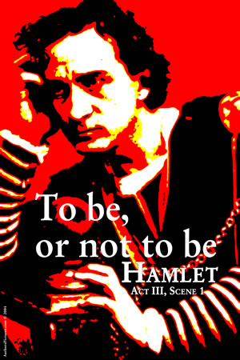
Unit Overview & Grade Breakdown

Essential Questions
What is the virtue of revenge?
How does one live in a world where tears of sorrow, loving smiles, &
friendly words are suspect because all are “actions that a man might play?”
To what extent is love defective?

Individual Tasks

♦Reader’s Response Journal
Keep a Reader’s Response Journal that characterizes your thoughts and reactions to the texts we will be reading throughout the unit. Your responses should demonstrate thoughtful engagement with the text. Although you will receive a grade on your ten (10) best entries, all entries need to be completed. You will be graded in accordance to the Reader’s Response Journal Rubric. Please follow the format and guidelines that are listed in Mr. Kuhn’s examples. (100 points)

♦ “What the Heck is Shaky Boy Saying?” Translations of the Text Journal
Shakespeare’s language is antiquated, and as such, oftentimes we might not understand his meaning. As we read the play you will be assigned 10 passages to translate that will need to be completed before class. This can be done in several ways, but ideally your translations should adhere to the original meaning of the text (100 Points)

♦ “All Art is Imitation” – Aristotle
For this essay we will briefly explore Aristotle’s claim that all tragedies (art) is imitation. By postulating this, Aristotle was asserting that if we breakdown the elemental composition of any tragedy, it follows recurrent plot lines, themes, conflicts, and characterization features. We will view a modern tragedy, The Lion King, and determine how it imitates Hamlet.

♦ Critical Lens Essay
In order to prepare you for the Regents Exam in June, we will write a critical lens essay using a past exam whereby you analyze two texts (Hamlet and another text), ground your thesis in the theme of the lens, use textual support from recall, and analyze relevant literary devices. (100 points)

♦ End of Unit Exam
Upon completing the play you will have an exam consisting of multiple choice and essay questions. The exam format will closely mirror that of the ELA Regent’s Exam (100 points)

♦ “The Daily” & Writing Workshop
Mark Twain once said, “The difference between the right word and the almost right word is the difference between the lightning and the lightning bug.” This workshop is intended to help us commit the best words to paper. Several of us have the tendency to place words on paper with the sole focus of cranking an assignment out as quickly as possible. Good writing isn’t a race against the clock. This workshop will focus on the following: dynamic language usage, avoidance of excessive “To Be” verbs and passive voice, sentence variation, organizational strategies, textual support, etc. Graded assignments will fall under the category of the “Daily Points.” And as always, “The Daily” will include things like quizzes, paper-passes, and other in-class activities intended to assess your understanding. (100 points)

♦ Random Acts of Regents
The beautiful sunshine of spring shines upon us and so does the inevitability of taking the ELA Regents Exam. In order to prepare you for this rite of passage, I will randomly choose a day to pop a Regents-esque exam on you (multiple choice, listening passage, controlling idea, critical Lens, literature analysis). Each Random Act of Regents will be worth … (100 Points)

♦ Word Slam & Vocabulary Builder
Shakespeare’s play contains a level of vocabulary that at times will baffle us due to its complexity. I am requiring you to look up, define, and write an original sentence for each unfamiliar word. Definitions and sentences should be placed in your literary terms notebook. Periodic quizzes will be assigned to assess your understanding of these words. I will model for you how to do “word slams” and you will be graded on your participation with this activity.

