

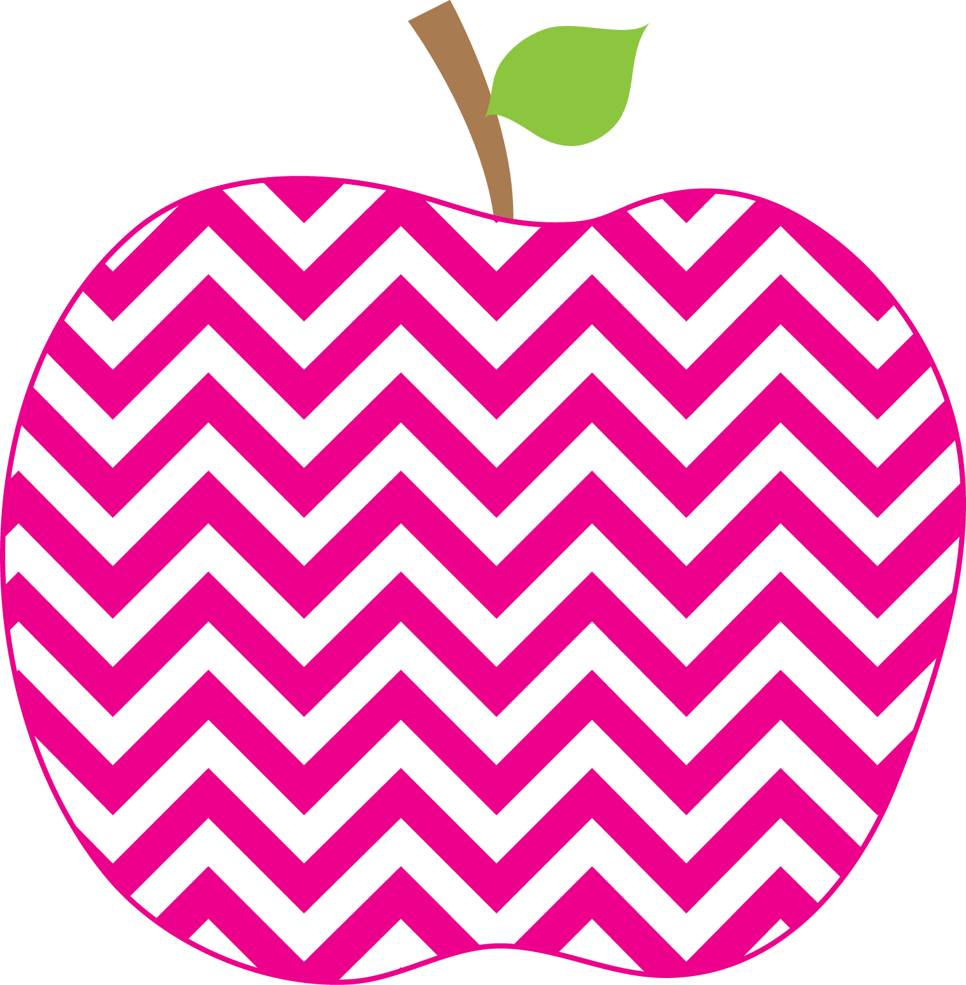



Weeks Weekly
The
September 7, 2018

What a great first week of school we have had together! Despite the grueling heat and humidity, we had lots of fun getting to know one another and getting used to the academic routines of school.

Fundations, our word study program, is up and running! This first part is a review of letter sounds and formation. It is important that letter formation be done correctly and should become automatic.

We have reviewed number bonds in math: in our work, a total is comprised of two parts. For example:
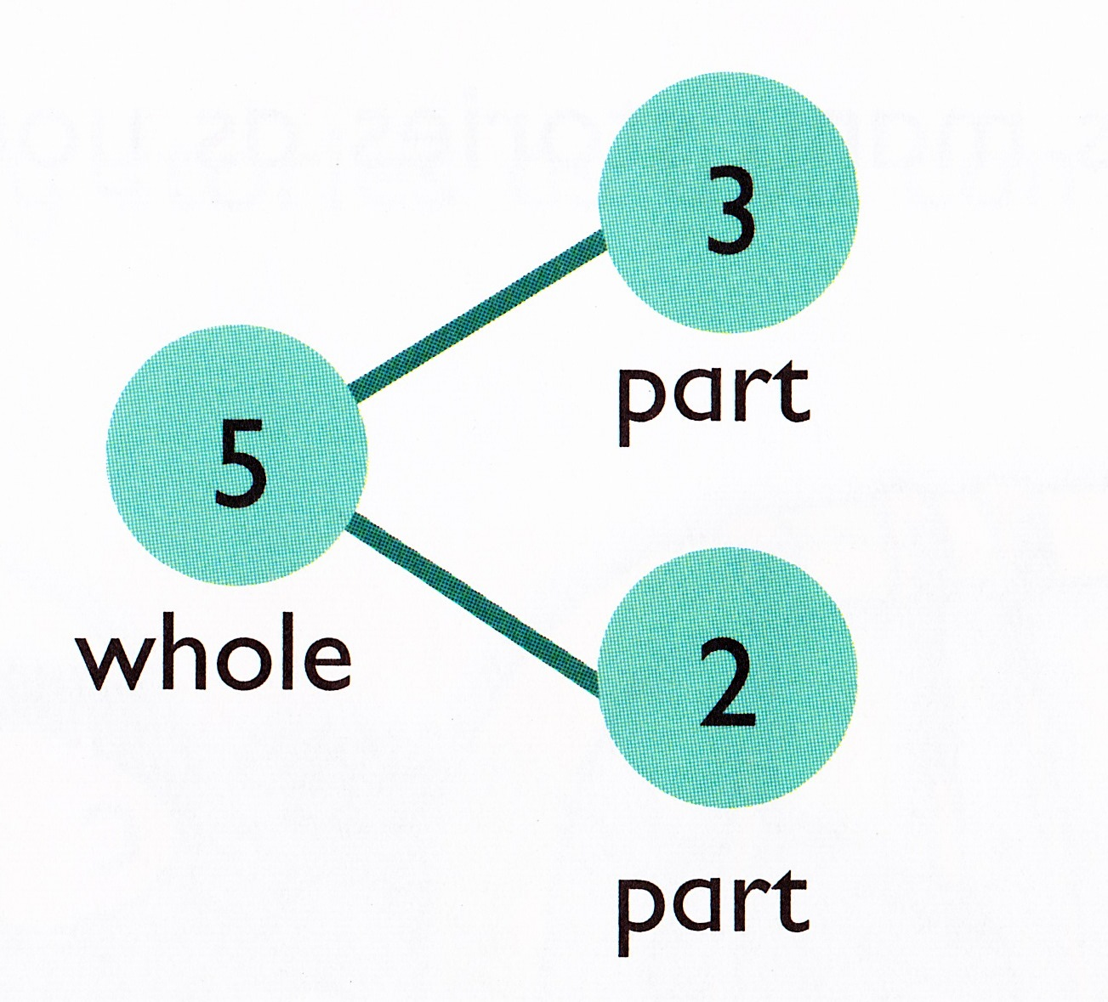
Each day we choose a student to interview during, “Name of the Day.” That way we get to know each person in the class and we practice our writing skills.

Some books we enjoyed this week were:
The Kissing Hand
Pete the Cat: Rocking in My School Shoes
Pete the Cat: Too Cool for School and
The Pout-Pout Fish Goes to School
School’s First Day of School

On Friday we had an assembly and reviewed our school (PBIS) rules. Students learned about being Fyle CUBs: Curious, Understanding, and Strong! The CUB is our new mascot!

I look forward to another wonderful week with my lovely new first graders!

The Week in Review

A Look Ahead…

Mon. 9/10 A Day
Tues. 9/11 B Day
Wednes. 9/12 C Day
Thurs. 9/13 D Day
Fri. 9/14 A Day

**Monday is our library day!**

* Please have your child wear sneakers for P.E. as well as our daily, outside recess.
*Continue sending in a healthy snack each day!

ME = Meeting Expectations
NS = Needs Support
Respectful: _______
Responsible: _______
Ready to Learn: _______
Trustworthy: _______
Caring: _______

Parent Signature: ________________________
Reminders
PBIS: A Note on Behavior

