

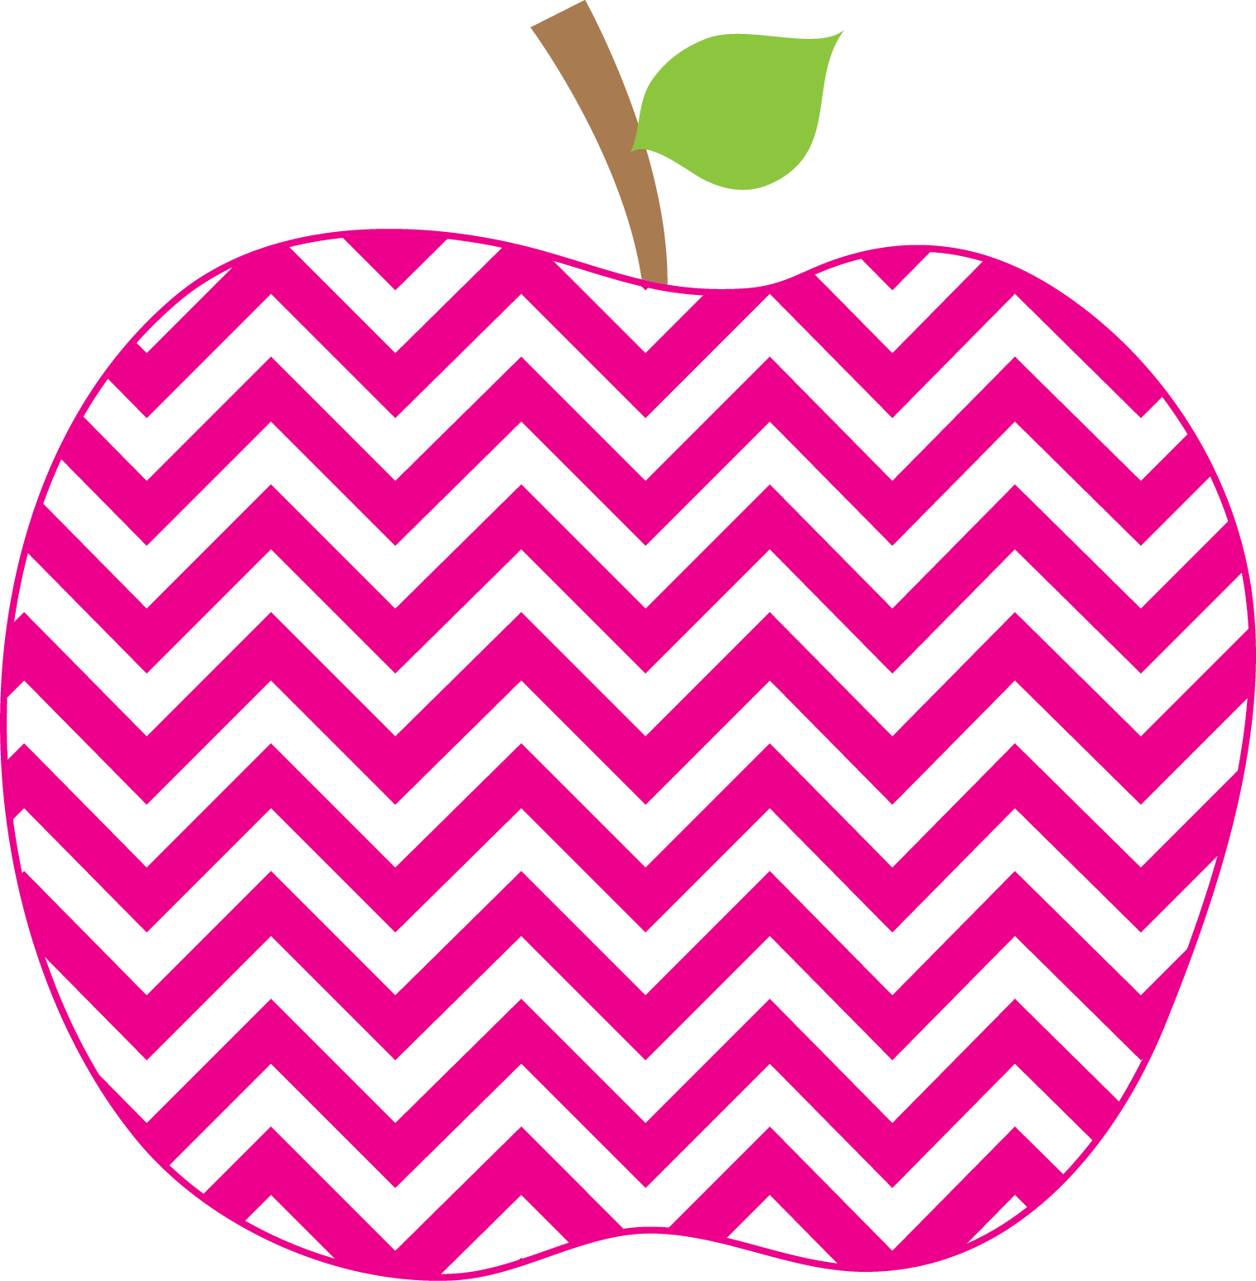



Weeks Weekly
The
September 21, 2018

This week we launched Read to Self. It is hard to sit still and read quietly, but we are working on our reading stamina (ask your child to explain what that means!). In general, we are practicing what it looks and sounds like to work independently. We have almost finished reviewing lowercase letter formation and letter sounds. It looks as though we will need to review how to write uppercase letters as well – please feel free to work on that at home with your child.

Our math work has focused primarily on solving word problems (which we sometimes call application or story problems). Adding numbers fluently to ten is a first grade standard and we work on that daily as well.

In social studies, we have begun learning about communities and citizenship. The students came up with an extraordinary list of rules for our classroom community!

We celebrated Mila and Fenix’s birthdays this week! We even had a lovely guitar sing-along with Mila’s Mom Rebecca! On Friday, Mrs. Mooney came in to learn everyone’s names and talked about her goals and our goals for the year.

Some books we enjoyed this week were:
The Land of Many Colors
What Does it Mean to Be Kind
Don’t Let the Pigeon Drive the Bus!
Don’t Let the Pigeon Stay up Late!
The Pigeon Needs A Bath!

--Kim Weeks
kweeks@rhnet.org
359-5413 x2483 (voicemail)

The Week in Review

A Look Ahead…

Mon. 10/1 D Day
Tues. 10/2 A Day
Wednes. 10/3 B Day
Thurs. 10/4 C Day
Fri. 10/5 NO SCHOOL

**Monday is our library day!**

Mon. 10/1 Mix-Up Monday (wacky clothes,
inside out, backward)
Tues. 10/2 USA Day (red, white & blue)
Wednes. 10/3 Sport Day (favorite jersey/uniform)
Thurs. 10/4- RH Spirit Day (Green & Gold)

Fri. 10/5 – NO SCHOOL (Superintendent’s Conference Day)
Mon. 10/8 – NO SCHOOL

ME = Meeting Expectations
NS = Needs Support
Respectful: _______
Responsible: _______
Ready to Learn: _______
Trustworthy: _______
Caring: _______

Parent Signature: ________________________
Important Dates!
PBIS: A Note on Behavior

