

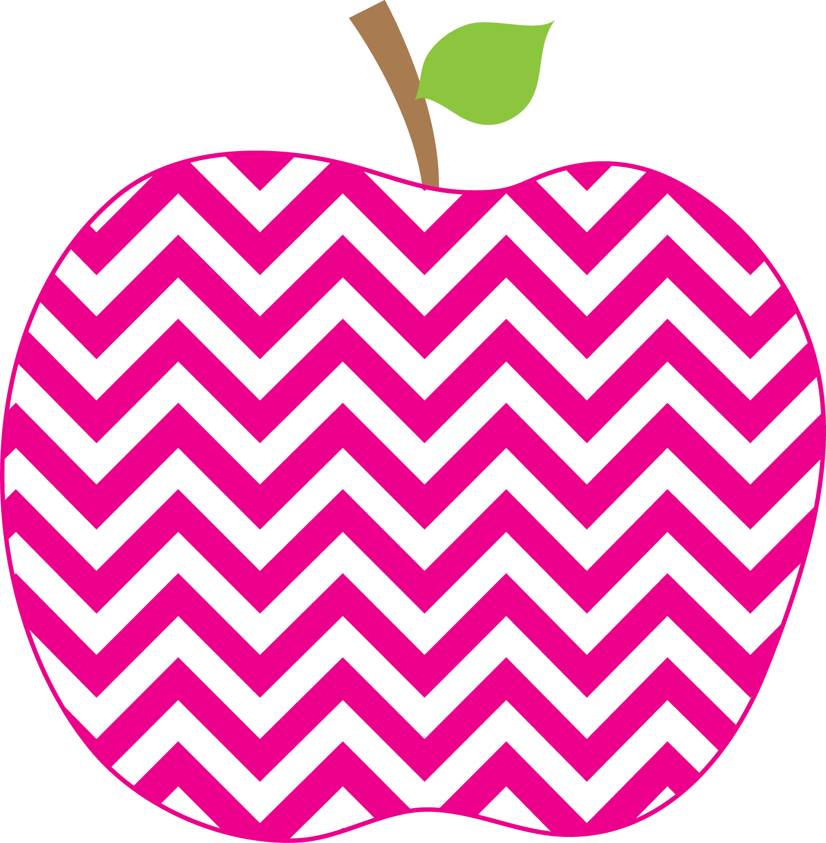



Weeks Weekly
The
September 14, 2018

It has been a great first full week of school! It has also been very busy! The students had a substitute teacher on Wednesday while I did some individual assessing. We also had our MAPs Growth tests in math and ELA on Thursday and Friday. They were completed on our Chromebooks and I was so impressed with how everyone persevered and then stayed quiet while others finished. They were rewarded with some extra outside recess. On Wednesday all students participated in bus safety drills. We got nice new tables in our classroom today so that we only have four students sitting at each table rather than five or six (which led to quite a bit of “chatting”).

In math we have been working on finding all of the ways to make 6, 7, 8, and 9. In Fundations, some students are finding the lowercase ‘d’ to be a challenge, so you may want to practice at home.

Some books we enjoyed this week were:
If You Take a Mouse to School
Amelia Bedelia’s First Day of School
Amelia Bedelia Goes Back to School
There Was an Old Lady Who Swallowed Some
Books

Thank you for signing the reading logs this week. They stay at school over the weekend, but you will see them again each Monday. I have identified a level book at which you child can read independently. More to come on this…

Have a great weekend!

The Week in Review

A Look Ahead…

Mon. 9/17 B Day
Tues. 9/18 C Day
Wednes. 9/19 D Day
Thurs. 9/20 A Day
Fri. 9/21 B Day

**Monday is our library day!**

Please send in a healthy snack every day, all year! Your children are always ready for a snack after specials!

ME = Meeting Expectations
NS = Needs Support
Respectful: _______
Responsible: _______
Ready to Learn: _______
Trustworthy: _______
Caring: _______

Parent Signature: ________________________
Reminders
PBIS: A Note on Behavior

